Berlin Heart Blood Pump Assessment & Exchange Guideline

BACKGROUND
There is significant variability in the management of pulsatile paracorporeal ventricular assist devices (VAD). Typically, management strategies and pump head exchanges are based on a subjective circuit assessment, limited patient risk vs benefit analysis, and non-standardized procedure.

ACTION REVISED DATE: 08/20/2020

OBJECTIVES
To provide a standardized approach to assessing and managing a paracorporeal pulsatile flow VAD, to develop a risk vs benefit analysis patient algorithm, and to complete a protocol for a pump exchange procedure.

PROTOCOL
The decision to change a Berlin Heart VAD pump in a pediatric patient is generally made by a multi-disciplinary team including CT Surgery, Cardiology (HF/VAD specialist), Cardiac Intensive Care, Perfusionists, bedside nursing, & VAD coordinator.
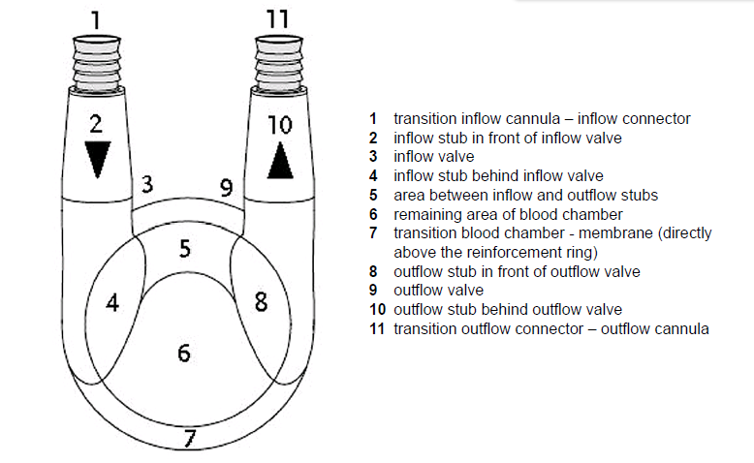
Berlin Heart EXCOR
- Blood Pump Assessment
  - Assess pump hourly to every four hours starting from inflow cannula, pump head, and outflow cannula. Repeat for BIVAD configuration.
    - Recommend checking more frequently when patient inflamed, febrile, infected, or with high fibrinogen.
 | Plaque –  White punctate deposit | 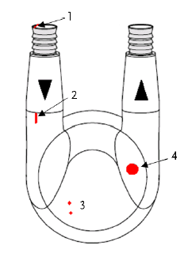 | Thrombus-  darkened red or black clot deposit
1 & 3 Small | Individual specks of white deposit < 2mm |  | Individual specks of deposit < 2mm
2. Strand | Collection of white deposits that extend across and area of pump |  | Collection of darkened clots that extend across area of pump
4. Large | Accumulation of white deposit in one area of the pump >3 mm |  | Accumulation of darkened deposit in one area of the pump >3mm
  - Document clots using a standardized language

- Indications for Blood Pump Change
  - Mobile fibrin or thrombus
  - Thrombus (dark areas > 2mm)
    - Consider change if the location of a smaller thrombus is near the pump outflow
  - Multiple fibrin deposits
  - Risk increased with combination of thrombus or fibrin deposits with inflammation, elevated fibrinogen, fever, or
  - Pump integrity
    - Graphite in air chamber or pitting of pillow concerning for pump pillow rupture
    - Pump pillow rupture
    - Blood, water, or air in membrane between air/blood chambers
    - Damage to pump head
    - Complete absence of membrane movement indicating membrane rupture (emergent)
- Pre Blood Pump Change
  - Discuss augmenting anticoagulation or consider bolus of UFH or Bivalirudin if prolonged pump stasis expected
  - PRN baseline labs (within 24 hours of change): CBC with diff, aPTT*, fibrinogen,
    - Optional labs: TEG with PM, CRP, LDH, HIT screen
  - Document VAD settings, filling/ejecting, clot status per protocol
  - Discuss NPO timing with surgical and CICU team
  - Consider respiratory support management if intubated
  - Discuss whether cardiac anesthesia consult needed
  - Blood available at bedside
  - Ensure adequate line access; create med line
    - Available sedation/analgesia
    - Consider inotropic support syringes in line for labile patients
    - Volume replacement available
    - Sedate patient and remove the chest dressing (optional)
  - Make sure back up IKUS available
  - Pump and Procedure Preparation
    - Reference IFU or center protocol
- Intra-op or Bedside Management
  - New blood pump prepared ahead of time
  - TIME OUT #1: verify patient, procedure (which VAD(s) will be replaced) and cannula position(s); verify cannula/blood pump position with photograph (if available) from patient chart
  - Skin and blood pump(s) prepped appropriately and a sterile field set up as usual
  - TIME OUT #2: sequence for pump change and plan who is managing IKUS for VAD settings will be confirmed by surgeon
  - Select Pause left or Pause right, as required, then press <Enter> to confirm. Respond to the prompt in the dialog window by pressing the <X> key or the <1> key. The selected pump will stop. The view Pump size and single-step mode is displayed.
  - Once pump paused, surgeon will clamp inflow and outflow tubing proximal to patient
    - A needle driver and wire cutter will be used to remove the tube ties
    - Old pump head will be removed
      - Old blood pump will be full of blood
      - Rinse out and consider saving for education
      - If there is a suspected membrane rupture, preserve the pump and send to Berlin Heart for further analysis.
  - Once connected, surgeon will remove clamps and ask for pump to be restarted; press step while surgeon de-airs the pump until pump de-aired and then go on full support.
  - Filling and ejection should be closely monitored; pump will be further de-aired if needed
- Early post blood pump change management
  - Continue bivalirudin peri – pump change
  - Labs ( aPTT, PT/INR, fibrinogen, BMP, CBC) within 2 hours of change
  - Correct with blood product replacement as needed, being mindful of risk of dilutional coagulopathy with multiple PRBC transfusions, and correct any surgical bleeding as needed
  - Sterile dressing placed per Berlin Heart dressing change guidelines
  - Monitor neurologic status closely
  - Document VAD settings, filling/ejecting, clot status per protocol
  - Restart feeds

AUTHORS
Beth Hawkins, RN, MSN, FNP-C, Katrina Fields, BSN, James Reagor, MPS, CCP, FPP,
John Lombardi, CCP, & Zach Wilkes, CCP

CONTRIBUTING CENTERS
Boston Children’s Hospital & Cincinnati Children’s Hospital Medical Center

Disclaimer: The ACTION network is focused on quality improvement efforts such as harmonizing best practice protocols, disseminating them among institutions, and helping centers to improve care practices at the local level. This protocol was developed as a consensus tool for pediatric VAD programs. The information in the protocols are based on center practices, individual opinions, experiences, and, where available, published literature. Centers may choose to adapt this protocol to include in their center-specific protocols with reference to ACTION with the understanding that these are meant as guidelines and not standard of care. (Revised: 08/20/2020)

