Care of DRIVELINE Exit Site for Implantable Continuous Flow Pediatric VADs

BACKGROUND
Ventricular assist device (VAD) dressing integrity is a critical factor for the prevention of device related infection. Inadequate dressing or dressing disruption is a major risk factor for bloodstream infections, device pocket infection and driveline site infections. Enhanced dressing adhesion promotes sterility and saves time as fewer dressing changes are needed.

ACTION REVISED DATE: 03/01/2021

OBJECTIVES
- Describe detailed example of standardized VAD specific dressing change protocol
- Minimize risk of VAD related wound or device infection
- Promote VAD care and dressing techniques to optimize wound integrity and healing

PROTOCOL
In order to prevent infection of driveline sites, the dressing changes must be done in a sterile and consistent fashion. This is a 1-person activity or can include 2 persons. Consider a small group trained and competent (VAD dressing team) as consistency is key to optimize integrity and healing. If the patient or family prefer to change the dressing and have been deemed competent, this is acceptable with RN supervision.

Dressing Frequency
Weeks 0-1 Every day
Weeks 1-2 Every other day, (consider M/W/F to keep consistency in staff changing dressing)
Above Weeks 2 Discretion of the team, (consider once or twice weekly)

Planning & Supplies
- Sterile gloves
- Clean gloves
- Masks for people in room including patient
- Antiseptic swab or scrub (See end of document for specific product considerations)
- Occlusive VAD dressing (See end of document for specific product considerations)
- Antimicrobial disc (See end of document for specific product considerations)
- Sterile scissors
- Securement device (See end of document for specific product considerations)
- Camera to upload picture of exit site

Procedure
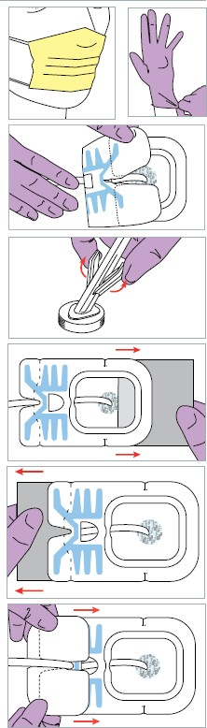
- Clean and clear surface for driveline dressing supplies
- Place masks over mouths (everyone in room and the patient).
- Wash hands
- Don clean gloves
- Remove old dressing; ensure that the driveline does not tug when removing the dressing
- Inspect the dressing site for signs of infection. Take photo of site and upload to EMR.
- Remove gloves and wash hands properly again.
- Open sterile gloves to create sterile field; drop dressing, scissors, antiseptic swab, gauze, onto sterile field.
- Don sterile gloves.
- The dominant hand should be “clean.” Use the “clean” hand to grasp antiseptic swab. Use the “dirty” hand to grasp the driveline using the sterile gauze to pick up and hold up the driveline for ease of cleaning.
- Pinch the wings of antiseptic swab to release the antiseptic solution.
- Use the antiseptic swab, starting at the exit site, then moving outwards and down the driveline. Use the “dirty” hand to lift the driveline as necessary to get around the site. Time and friction disinfects the site. Consider scrubbing site for at least site for 60 seconds.
- Allow the area to completely air dry. At least 90 seconds.
*DO NOT BLOT, BLOW, OR WIPE AT THE CLEANED SITE*
- According to hospital’s protocol, consider applying antimicrobial disk over insertion site. *Avoid if skin breakdown or irritation is present
- Use “clean” hand and apply occlusive dressing to the site, ensuring that the dressing is completely occluded on all 4 sides. Consider a split dressing approach and chevron ends over each other.
- Re-Secure and stabilize the driveline with a driveline securement device with a small amount of slack. Apply new anchor if previous anchor has been on for 1 week or longer; or is not well secured
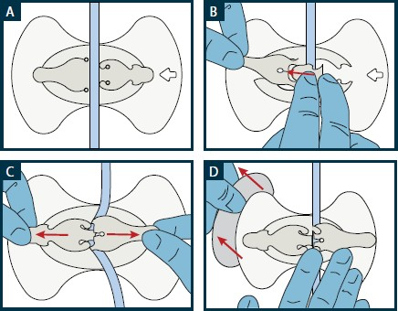

- Waterproof barrier (Example: Press and Seal/AquaGuard) should be placed over driveline site prior to all showers. A dressing change should always be completed after a shower.
- Document photo of dressing change and condition of exit site. Dressing should be assessed per hospital policy, and if it becomes saturated/unocclusive, consider dressing change sooner than determined routine frequency

Product Considerations:
- Antiseptic swab or scrub
  - ChloraPrep Swabstick
  - Hibiclens
  - Iodine (if CHG allergy)
- Occlusive VAD dressing
  - Sorbaview
  - Split gauze and tegaderm
  - Covaderm
  - Tegaderm plus
  - Primapore/Bordered Gauze
  - Silvercel and Hydrofilm
- Antimicrobial disc
  - Biopatch
  - Aegis
- Securement device
  - Foley anchor
  - Centurion anchor
  - K-loc

AUTHORS
Allison Reichhold MSN, CPNP, Erica Mansavage MSN, RN, Katie Burnley BSN, RN, Alexa Harris PA-C.
Laurel Barwick, MSN, CCRN, Christen Williams, BSN, CCRN

CONTRIBUTING CENTERS
UF Health Shands Children’s Hospital, Lucile Packard Children’s Hospital Stanford, St Louis Children’s Hospital,
Boston Children’s Hospital, Cincinnati Children’s Hospital Medical Center, & Stollery Children’s Hospital, &
Lurie Children’s Hospital of Chicago

Disclaimer: The ACTION network is focused on quality improvement efforts such as harmonizing best practice protocols, disseminating them among institutions, and helping centers to improve care practices at the local level. This protocol was developed as a consensus tool for pediatric VAD programs. The information in the protocols are based on center practices, individual opinions, experiences, and, where available, published literature. Centers may choose to adapt this protocol to include in their center-specific protocols with reference to ACTION with the understanding that these are meant as guidelines and not standard of care. (Revised 03/01/21)

References:
- Cannon A, Elliott T, Ballew C, et al. Variability in infection control measures for the percutaneous lead among programs implanting long-term ventricular assist devices in the United States. Prog Transplant 2012; 22:351–9.
- Yarboro LT, Bergin JD, Kennedy JL, et al. Technique for minimizing and treating driveline infections. Ann Cardiothorac Surg 2014; 3:557–62.
- J Heart Lung Transplant 2016; 35:108–14. Continuous-flow left ventricular assist devices and usefulness of a standardized strategy to reduce drive-line infections. .Cagliostro B, Levin AP, Fried J, et al.
- J Heart Lung Transplant 2016; 35:108–14. April 2016 Volume 35, Issue 4, Supplement, Page S350 Site Management Strategies in Pediatric Ventricular Assist Device (VAD) Patients. M.V. Horn et al.

