Compassionate Deactivation of

HeartWare HVAD in Children

**ACTION REVISED DATE:** 06/21/2019

***STEPS FOR POWERING OFF HEARTWARE HVAD***

**Action:** Before proceeding, ensure deactivation of pacemaker or ICD (defibrillation and pacing functions) if applicable (item 1.3 of Checklist)

**Step 1**: Place data/monitor cable to the primary controller

**Step 2**: Login to the monitor using the pump icon on home screen-password **68773 (Nurse)**, **<enter>**

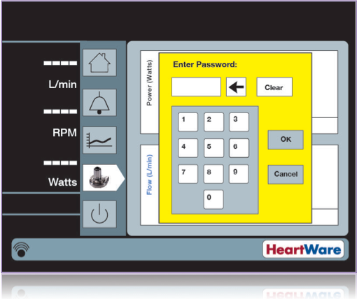

**Step 3**: Go to Speed/Control tab

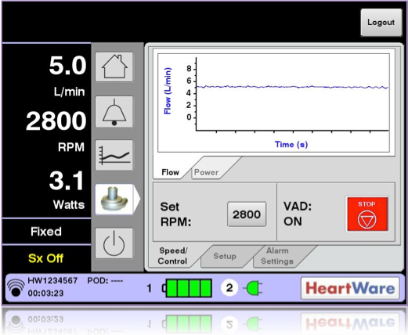

**Step 4**: Press **Red VAD Stop** button

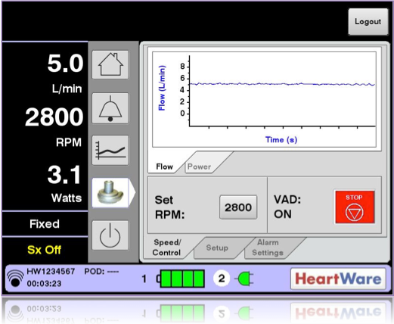

**Step 5**: Press **<Yes>**, to confirm you want to stop the VAD

**Step 6**: Remove data cable, place red alarm adapter to data port

**Step 7**: Remove both power sources to power down the controller, then remove driveline.

**Alternative Steps without monitor:**

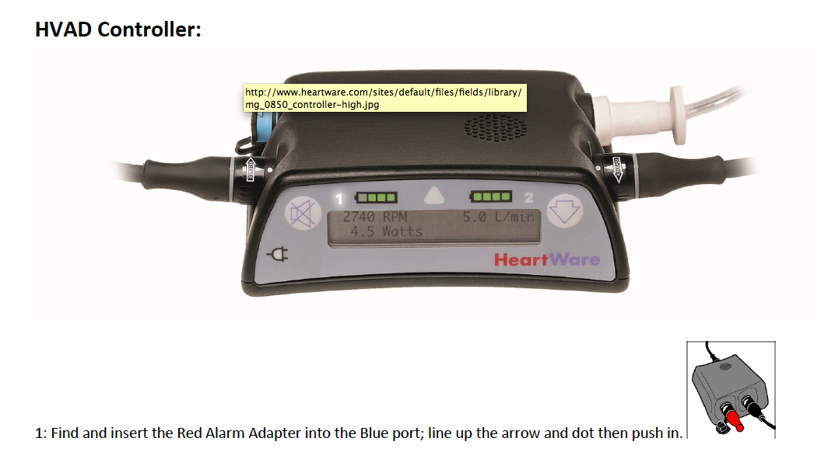

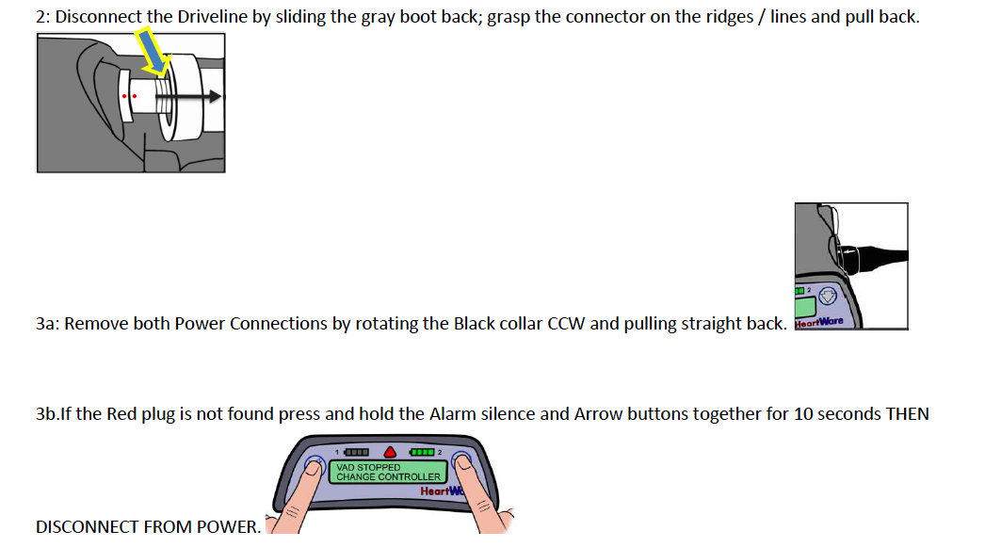

***Disclaimer:*** *The ACTION network is focused on quality improvement efforts such as harmonizing best practice protocols, disseminating them among institutions, and helping centers to improve care practices at the local level. This protocol was developed as a consensus tool for pediatric VAD programs. The information in the protocols are based on center practices, individual opinions, experiences, and, where available, published literature. Centers may choose to adapt this protocol to include in their center-specific protocols with reference to ACTION with the understanding that these are meant as guidelines and not standard of care. (Revised 6/21/19)*