CHECKLIST – ACTIONS TO COMPLETE

* Review this document with your team
* Please email comments, questions, and improvements to: [info@actionlearningnetwork.org](mailto:info@actionlearningnetwork.org)
* Join Global QI Call with questions on October 17, 2019 @ 4 PM ET
* Complete the Commitment Survey (details in Section 1) by **October 25, 2019**

1. PARTICIPATION COMMITMENT

After reading through the following information and discussing with your team, please inform ACTION of your decision to participate in the ACTION Discharge Improvement Project by doing the following: <https://www.surveymonkey.com/r/ACTION_DISCHARGE> and complete commitment survey by October 25, 2019.

1. BACKGROUND AND OBJECTIVES OF THE DISCHARGE IMPROVEMENT PROJECT

**Global AIM:**

* To improve critical outcomes for children with heart failure

**SMART AIM:**

By July 2021:

* Increase percent of patients who are discharged from 66% to 75%
* Decrease median time to discharge from 34 days to 30 days
* Increase the % of patients leaving ICU with a Berlin Heart from 65% to y (TBD)

1. PARTICIPATION EXPECTATIONS

**ACTION COMMITMENTS/SERVICES**

* Analyze data submitted by teams
* Provide team coaching on quality improvement (QI)
* Hold monthly Global QI calls to facilitate learning between teams
* Coordination of events – Learning Sessions, informational events, etc.
* Logistics – of all meetings, events, communication, stakeholders

**SITE/HOSPITAL TEAM COMITTMENTS**

* Commit to entire duration of the improvement project (approximately 12 months)
* Commit to learning and sharing time and resources
  + Participate in monthly Global QI calls
  + Share tools and actively participate in discussions on Basecamp
* Agree to collect, submit, and share data transparently within our collaborative
* Actively test interventions at your site to increase reliability

1. Family of Measures, Operational Definitions*, and Data Collection

|  |
| --- |
| **Family of Measures**   * Outcomes   + Percent of patients who are discharged   + Average length of stay post implant   + Percent of patients/families satisfied with Discharge Journey Map * Process Measures   + Percent of patients with a completed ACTION Plan/Flight Plan   + Percent of patients/families receiving Discharge Journey Map * Population: all patients implanted with a VAD that allows for discharge (ie. HVAD, HM2 and HM3, etc.), which patients get discharged   + Inclusion: children <21 years on durable device   + Exclusion: devices that confine to hospital at this time – berlin heart, centrimag, rotaflow, impella |

*Operational Definition Drafts are available by emailing [info@actionlearningnetwork.org](mailto:info@actionlearningnetwork.org), if your team would like more detail. Participating teams will be involved in finalizing the operation definitions.

1. KEY DRIVER DIAGRAM (KDD)

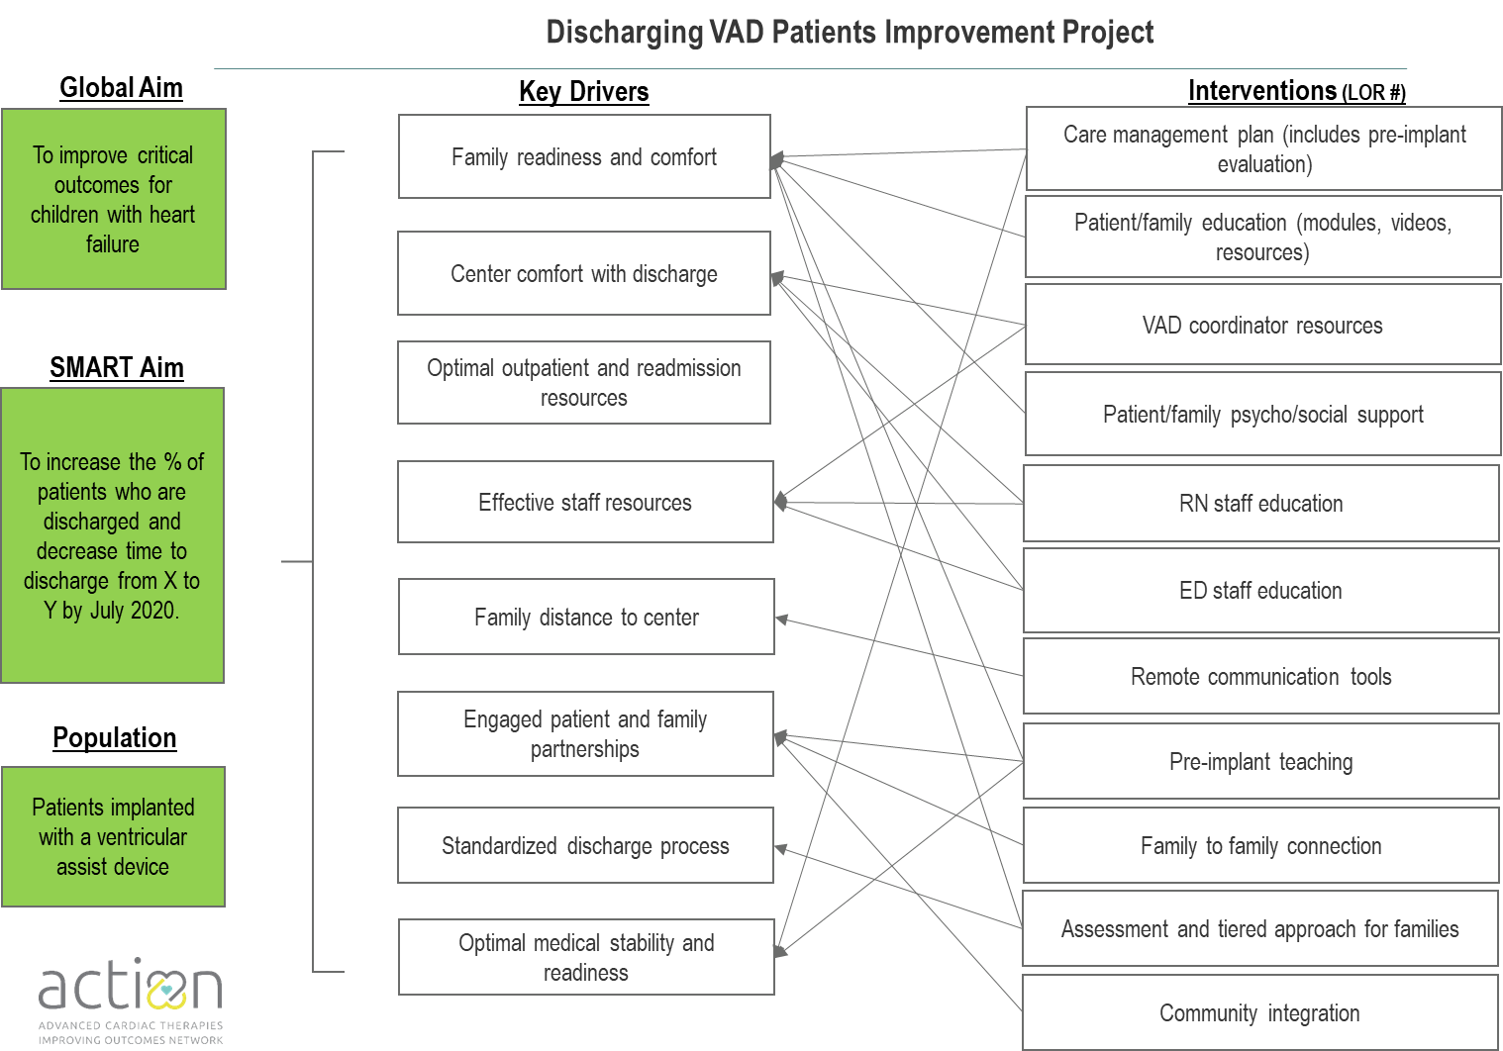

1. IMPROVEMENT APPROACH

**Step 1: Reliably collect and report discharge data in registry**

Each team will develop a process to collect outcomes data

**Step 2: Common Intervention Reliability**

The project will ask teams to focus on being reliable with the common interventions first and be reliable population wide with the common factors.

* Reliability means that an intervention is observed correctly being implemented greater than 80% of the time.
* Population wide means that the factors are implemented to all patients (see Family of Measures description).

As with all of our improvement, we will start small. The interventions are:

* Patient Discharge Journey Map
* ACTION Flight Plan

1. TIMELINE

This timeline is organized for teams that are starting the ACTION Improvement work without reliability to screening interventions. If your team is further along – this is great; you’ll follow the same principle, you’ll just be starting at the common factors. The timeline is our best estimate based on past improvement projects. As we learn with you, we will modify and announce changes to the timeline.

|  |  |
| --- | --- |
| September 2019 | * Invite teams to participate in project at Leadership Meeting * ACTION Newsletter – Invitation Packet Details |
| October 2019 | * Global QI call for questions on application * Teams commit to joining the project * Teams select, resource, and support team members * Teams develop a project plan |
| November 2019 | * Teams adopt operational definition of measures * Teams adopt Key Driver Diagram * Teams assess their current system focused on discharge * Share progress on setting teams, developing plans, and testing to increase reliability to interventions * Teams develop PDSAs to test |
| November 2019 - June 2020 | * Teams test to increase reliability and achieve 80% (if enough patients) * Share progress during Global QI meetings |
| July – December 2020 | * Teams test to increase reliability to future factors and share webinars and in-person meetings |
| January 2021 –  forward | * Sustain reliability and monitor outcomes * Reduction goal achieved * Intervention bundle and change package published * Spread learning to entire network |

1. SPECIAL THANKS

Each of the Discharge committee members below have spent countless hours working as a very effective team to align on this improvement plan and we at ACTION are so grateful for such generous participation. Each of you demonstrate our mission and values of *working together to eliminate serious harm across all children’s Teams*. Our patients and families are so lucky. Thanks!