Continuous Flow Paracorporeal VAD
Circuit Change Guideline

BACKGROUND
There is significant variability in the management of continuous flow paracorporeal ventricular assist devices (VAD) circuits. Typically, management strategies and circuit changes are based on a subjective circuit assessment, limited patient risk vs benefit analysis, and non-standardized procedure.

ACTION REVISED DATE: 08/10/2020

OBJECTIVES
To provide a standardized approach to assessing and managing a paracorporeal continuous flow VAD circuit, to develop a risk vs benefit analysis patient algorithm, and to complete a protocol for a circuit change procedure.

PROTOCOL
The decision to change a VAD circuit in a pediatric patient is generally made by a multi-disciplinary team including CT Surgery, Cardiology (HF/VAD specialist), Cardiac Intensive Care, Perfusionists, & VAD coordinator.

Extracorporeal Centrifugal Continuous Flow Devices
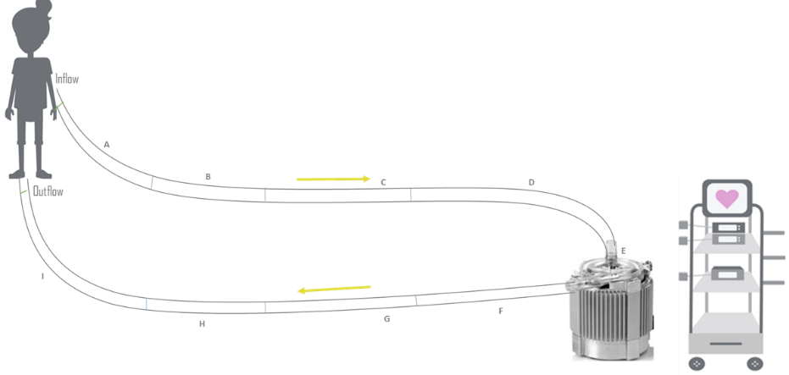
- Circuit Assessment
  - Assess circuit hourly to every four hours starting from venous cannula, pump head, and arterial cannula. Repeat for BIVAD configuration.
Inflow
  - Document clots using standardized language
    - Plaque or thrombin – small white punctate
Outflow
    - Thrombus – large dark area
- Indications for Circuit Exchange (may also consider removing an affected section if circuit change is not indicated)
  - Mobile thrombus or fibrin strand
  - Thrombus accumulation > 5mm
  - Unusual vibration or noise from pump head
  - Increased hemolysis markers
    - LDH > 1.5X baseline
    - Plasma free hgb
    - FDP
    - D-Dimer
    - Platelet decrease
    - Hemaglobinuria

- Pre Circuit Change
  - Continue bivalirudin peri – circuit change
  - Document clot status and VAD settings per protocol
  - PRN baseline labs (within 24 hours of change): CBC with diff, aPTT*, fibrinogen,
    - Optional labs: TEG with PM, CRP, LDH, HIT screen
  - Discuss NPO timing with surgical and CICU team
  - Consider respiratory support management if intubated
  - Discuss whether cardiac anesthesia consult needed
  - Active blood clot with blood available at bedside
  - Consider steroids
  - Ensure adequate line access; create med line
    - Available sedation/analgesia
    - Consider inotropic support in line for labile patients
    - Volume replacement available
    - Sedate patient and remove the chest dressing (optional)
  - Equipment & Circuit Exchange Procedure:
    - Follow circuit’s IFU
- Intra-op or Bedside Management
  - Circuit primed ahead of time
  - TIME OUT #1: verify patient, circuit to be exchanged
  - Skin and circuit prepped appropriately and a sterile field set up as usual
  - TIME OUT #2: sequence for circuit(s) change and plan who is managing circuit settings will be confirmed by surgeon
  - Once circuit paused, surgeon will clamp tubing
      - Can cut tube ties during prep phase to reduce the time off support
- Old circuit will be removed
  - Once connected, surgeon will remove proximal clamp and ask for pump to be restarted
- Early post blood pump change management
  - Continue bivalirudin peri – pump change
  - Labs ( aPTT, PT/INR, fibrinogen, BMP, CBC) within 2 hours of change
  - Correct with blood product replacement as needed, being mindful of risk of dilutional coagulopathy with multiple PRBC transfusions, and correct any surgical bleeding as needed
  - Sterile dressing placed per dressing change guidelines
  - Monitor neurologic status closely
  - Document VAD settings, clot status per protocol
  - Restart feeds

AUTHORS
Beth Hawkins, RN, MSN, FNP-C, Katrina Fields, BSN, James Reagor, MPS, CCP, FPP,
John Lombardi, CCP, & Zach Wilkes, CCP

CONTRIBUTING CENTERS
Boston Children’s Hospital & Cincinnati Children’s Hospital Medical Center

Disclaimer: The ACTION network is focused on quality improvement efforts such as harmonizing best practice protocols, disseminating them among institutions, and helping centers to improve care practices at the local level. This protocol was developed as a consensus tool for pediatric VAD programs. The information in the protocols are based on center practices, individual opinions, experiences, and, where available, published literature. Centers may choose to adapt this protocol to include in their center-specific protocols with reference to ACTION with the understanding that these are meant as guidelines and not standard of care. (Revised: 08/10/2020)

