SynCardia Total Artificial Heart (TAH-t)
Management

BACKGROUND
SynCardia Total Artificial Heart (TAH-t) offers opportunities for mechanical circulatory support in older children and young adults. Due to limited pediatric experience with this device, a structured approach to both patient selection, and patient management is essential followed by careful monitoring and guided therapy.

ACTION REVISED DATE: 10/27/21
Contents
DEVICE DESCRIPTION AND SPECIFICATIONS 2
INDICATIONS FOR IMPLANTATION 3
CONTRAINDICATIONS TO IMPLANTATION 4
PRE-IMPLANTATION EVALUATION AND ASSESSMENT 4
IMAGING 4
LABORATORY ASSESSMENT 5
IMPLANTATION TECHNIQUES 5
SURGICAL TECHNIQUE 5
INTRA-OPERATIVE ECHOCARDIOGAM 7
POST-OPERATIVE PATIENT AND DEVICE MANAGEMENT 7
ANTICOAGULATION 7
LABORATORY MONITORING 7
IMAGING 8
DEVICE MANAGEMENT 8
DEVICE SETTINGS 9
EQUIPMENT 9
PATIENT MANAGEMENT 10
LINES AND TUBES 10
ANTIBIOTICS 10
HEMODYNAMIC MONITORING 10
ANEMIA MANAGEMENT 10
HYPERTENSION 11
OTHER 11
MANAGING COMPLICATIONS AND ADVERSE EVENTS 12
BLEEDING 12
HEMOLYSIS 12
DEVICE CLOT 12
DEVICE FAILURE 13
INFECTION 13
EMERGENCY PROCEDURES 13
Cardiopulmonary Arrest 13
Waveforms 13
Responding to cannula issue 15
APPENDIX 1: NURSING BEDSIDE TEAM ASSESSMENT AND MONITORING 15
ASSESSMENT 15
HYPERTENSION MANAGEMENT 16
SYSTEM CHECKS 16
ACTIVITY 17
FREEDOM DRIVER 17
WHEN TO CALL THE MD 17
APPENDIX 2: FREEDOM DRIVER MANAGEMENT 18

OBJECTIVES
This document will provide an overview of the 50cc and 70cc TAH-t devices, patient selection, implantation techniques and management strategies.

DEVICE DESCRIPTION AND SPECIFICATIONS

The TAH-t is a pulsatile biventricular device that replaces the native ventricles and valves functioning as a total support device for both pulmonary and systemic circulation. There are currently two SynCardia TAH devices available (see figures below) for cardiac transplant-eligible patients. The device is rarely used for destination therapy in young patients due to the complex needs associated with outpatient care.
- 50cc TAH - Approved device for patients with BSA 1.2 m²-1.85 m² (potentially smaller with FIT study)
- 70cc TAH - Approved device for patients with BSA ≥ 1.7 m²
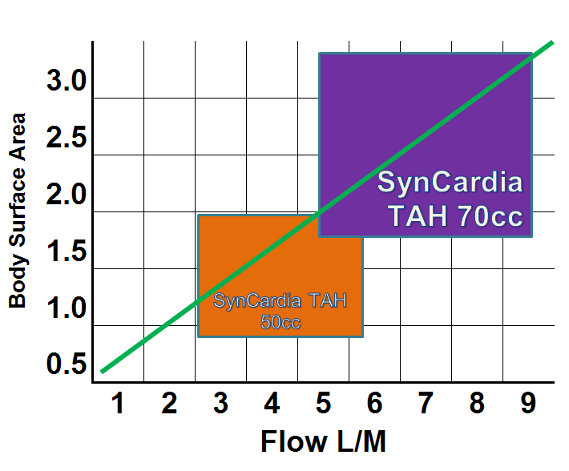

Figure 1: Flow vs body surface area for the 70cc and 50cc TAH.

 | 70cc TAH-t | 50cc TAH-t
Stroke Volume | 70 mL | 50 mL
Displaced Volume | 400 ml | 270 ml
Inflow Valve Diameter | 27 mm | 25 mm
Outflow Valve Diameter | 25 mm | 23 mm
Diaphragms | four (4) flexible polyurethane
Maximum Output | 10.5 LPM | 7.5 LPM

Figure 2: Dimensions of the 70cc and 50cc pump.

INDICATIONS FOR IMPLANTATION

As with many temporary and durable mechanical support devices, the success of support is dependent on careful patient selection. Current experience highlights 4 primary indications for biventricular support:

- Severe Biventricular Failure
  - Restrictive or hypertrophic cardiomyopathy
  - Failed transplant cardiac graft
- Significant ventricular thrombotic burden
  - Clot burden unamendable to thrombectomy
- Incessant Arrhythmias
- Congenital Heart Disease
  - Valvular disease and myocardial dysfunction
  - Fontan circulatory failure

CONTRAINDICATIONS TO IMPLANTATION

The following conditions may not be appropriate for implantation of the TAH-t:

- Irreversible end-organ dysfunction
- Risk of inability to anticoagulated or significant bleeding disorders
- Active systemic infection
- Active malignancy
- Insufficient space to accommodate a TAH including thoracic cage deformities
- Poor transplant candidacy is a relative contraindication

PRE-IMPLANTATION EVALUATION AND ASSESSMENT

IMAGING
Optimal candidacy and device selection will depend on a comprehensive assessment which includes detailed cardiac and vascular imaging.

The following routine measurements should be performed:
- Chest CT – Distance from posterior sternum to anterior spine at T10
  - 70cc
    - Patients with a T10 measurement ≥ 10 cm. Patients supported by the 70cc TAH typically have a body surface area (BSA) ≥ 1.7 m².
  - 50cc
    - Patients with an adequate T10 measurement as determined by 3D imaging assessment or by other standard clinical assessments. The 50cc TAH is intended to support patients with a BSA ≤ 1.85 m².
- Fit study: Segmented chest CT with contrast is performed. Using a reconstructed model of the device and the CT scan results the imaging team can determine fit with virtual reality.

  - Contact for fit studies:
    - Elizabeth Oei
203-807-0965
eoei@syncardia.com
    - Andrea Rogers
262-441-5071
Arogers@syncardia.com

LABORATORY ASSESSMENT

Diagnostics blood tests recommended prior to device deployment
Chemistry and Microbiology
 |  | Comprehensive Metabolic Panel |  | Brain Natriuretic Peptide or NT pro-BNP
 |  | Cystatin C/GFR |  | HLA/ PRA
 |  | CRP |  | +/- MRSA screen (institutional preference)
Hematology
 |  | Type and Screen |  | Heparin Induced Antibody Testing
 |  | CBC w/ Differential |  | LDH
 |  | PT/INR, PTT |  | Anti-Xa if on heparin
 |  | Fibrinogen, D-dimer |  | TEG or ROTEM (if available)
 | - Consider additional thrombophilia or bleeding work up if concerning family history or clinical course (see Action Pre-Implant Protocol for details)
Ancillary Studies*
 |  | Head CT |  | Ultrasound Doppler (arterial & venous) to establish vessel patency, information on access and line placement
 |  | Echocardiogram |  | CT Scan with IV Contrast for T10 measurement and Fit study
 | - Consider if abdominal/renal ultrasound
*Institutional preference

IMPLANTATION TECHNIQUES

ABBREVIATED SURGICAL TECHNIQUE (Courtesy of D. Morales)
Steps
- Median sternotomy
- Dissect out pericardial contents
- Take down Left diaphragm
- Pass the left and right devices about 3 cm below the costal margin
  - Holes should be snug
- Reverse the atrial cuffs and trim the left and right to 3 mm
- Encircle aorta, pulmonary artery, SVC and IVC
- Need to dissect entire heart (prior to CPB or as much as possible)
- Bicaval cannulation and use Carotid cannula
  - May consider using R Jugular as SVC cannula
- Go on with IVC cannula and then remove R IJ and cannulate SVC
- CPB to 32C
- Cross clamp & CP
- Start to excise heart
- Cut across RVOT and identify TV and cut a few (3-4 mm) below annulus until septum
- Cut apex off LV and incise LV towards MV (stopping 5-10 mm from annulus) then cut parallel to annulus towards lateral wall until septum
- Transect MPA and excise RVOT
- Place vent into PV with posterior stitch on ventricle
- Transect aorta and open anterior LVOT
- Cut septum leaving 3 mm on TV side which will leave slightly longer septum on MV side
- Excise TV
- Open RA at this point and over-sew the coronary sinus; unless can clearly see through TV
- Start with left cuff placing in annulus and use MH 3-0 prolene (two needles) laterally thru cuff and get some valve tissue and annulus in stitch (full thickness bites) tie around LVOT
- Do right cuff and start at inferior corner of septum and RV (forehand to a backhand) go clockwise first
  - Septal bites will go thru both cuffs
- Size of SynCardia cuff and tissue cuff depends on sizing and room available.
- Invert both cuff
- Check the cuffs for leaks by inserting the tester (larger one)
  - Hard to place need to use needle holders at 10 and 2 and stretch cuff placing inferior part of tester in first while assistant pulls open the cuff
  - With the LA test will need to place hand behind and occlude the PVs
  - Then place PreviLeak if we have it again or Vista Seal
- Usually cut PA graft to 6 cm and the aortic at 3 cm
- Sew PA graft and then aortic graft
  - Use strips of bovine pericardium
- Check these grafts for leaks with the tester
  - Will need to occlude MPA for PA test
- Sew in Gortex membrane on left pericardium just above PVs and one in diaphragmatic surface (Interrupted to just tack)
- Bring in the LV pump and do atrial connection with needle holder technique (10 and 2 o’clock)
- Connect aortic graft
- Bring RV and use same needle holder technique for atrial connect
- Connect PA graft
- Place active root vent and 18 gauge needle in graft (head down)
- Place right Gortex membrane
- Wean off CPB
  - Need only vasodilators (i.e. nipride, nicardipine) and vasoconstrictors (vasopressin, norepinephrine, etc.)
- LV pressure is 200 mmHg
- RV pressure is 100 mmHg
- Rate at 40 bmp then increase rate and de-air
- Start with vacuum at 0 and slowly uptitrate as needed.
- OFF CPB
- TEE to R/O IVC and PVs okay (leave TEE until chest is closed)
- While achieving Hemostat
  - Repair Right Neck Vessels
  - Close neck
  - Close Pacemaker Pocket site
- After Hemostasis achieved, place Esmark strips around SVC, IVC, MPA and aorta
- Place anterior Gortex membrane (attach all membranes to each other with interrupted sutures

See Surgical Animation: https:/www.youtube.com/watch?v=-P3Z7rr8kzE%20

INTRA-OPERATIVE ECHOCARDIOGAM
- TEE should be used before and after chest closure. Close evaluation for the following should be considered:
  - IVC compression
  - SVC compression
  - Pulmonary vein compression

POST-OPERATIVE PATIENT AND DEVICE MANAGEMENT

ANTICOAGULATION
Anticoagulation is required to prevent clot formation, although considered lower risk due to high CO. Optimal anticoagulation is achieved through a combination of heparin/coumadin and aspirin.

- Anticoagulation to begin as soon as post-operative bleeding has resolved. Given higher risk of bleeding post-op and lower thrombosis risk, anticoagulation may be delayed more so than intracorporeal continuous flow VADs. Often anticoagulation is started 48-72 hours after implant.
  - If choosing heparin, target PTT 40-70 or UFH level 0.2-0.4 have been used. May also follow TEG or ROTEM to aid in optimizing anticoagulation.
  - If choosing bivalirudin, an initial PTT target of 40-50 target with escalation of PTT target 60-80 once there are no concerns for bleeding has been used. Although bivalirudin is not the approved medication for the TAH.
- Aspirin (typically 40.5-81 mg depending on kg) typically started POD 3-5 once post-operative bleeding has been controlled and no concerns for bleeding on heparin or bivalirudin infusion.
- If platelet count increases, consider increasing aspirin.
- In adult patients, a does may be as high as 650 mg.
- When patient is clinically ready, they can be bridged to warfarin per institutional practice. Recommend target INR 2.0-3.0.

Other agents
The decision to use agents other than Heparin should be based on institutional experience with monitoring of the listed agents and careful analysis of risk-benefit ratio based on clinical condition. Information presented in this section is based on institutional experience and adult experience from published case reports.

LABORATORY MONITORING
Post-implantation labs obtained should reflect baseline assessment of patient oxygen delivery, coagulation profile, hemolysis, hemoglobin and end organ function, as well as frequency which allows monitoring of the device and patient response to the device and anticoagulation.

Baseline labs post SynCardia placement: CBC; Chemistry with liver function; Hemolysis labs: plasma Hb, LDH; Coagulation profile: PTT, PT/INR, Fibrinogen, D-dimer, anti-Xa, ACT (POCT), TEG or ROTEM may be used depending on hospital preference; blood gas with lactate and mixed venous oxygen saturation if available.

Recommended laboratory testing following device deployment
Laboratory Markers | 24-48h post implantation | Chronic Monitoring
Hematology and Coagulation
CBC | Q6-12H | Daily
LDH | Q24H | Daily until stable
PT INR | Q24H | Daily until stable
PTT and Anti-10a | Q12H or with every titration | Daily
TEG or ROTEM* | Q24H | Daily until stable
Chemistry and Microbiology
CRP | Q24 | Daily-Weekly
Cystatin C | Once | Weekly
Ancillary Studies
CXR |  | Daily
Echocardiogram (TEE) | PRN
PRA |  | Q 2 weeks*
*These are recommendations only and each center is encouraged to use center-based practice.

Additional Labs to Consider:
- Renal panel to assess end organ function
- Hepatic panel to assess end organ function
- Due to high risk of pancreatitis in patients recovering after cardiogenic shock, a pancreatic enzyme panel should be performed and monitored accordingly.

IMAGING
If there is concern for decreased fills, imaging the liver and U/S of the SVC and IVC may be helpful. If unusual pulmonary edema, a TEE for pulmonary vein compression may be needed. CT scan with contrast may also be helpful. Catheterization and angiogram is NOT possible; wires in the TAH will cause the device to malfunction.

DEVICE MANAGEMENT

The goal is to have partial fill and full eject.
- 50-60 ml for the 70cc TAH-t
- 30-40 ml for the 50cc TAH-t

Pressure waveforms seen below:

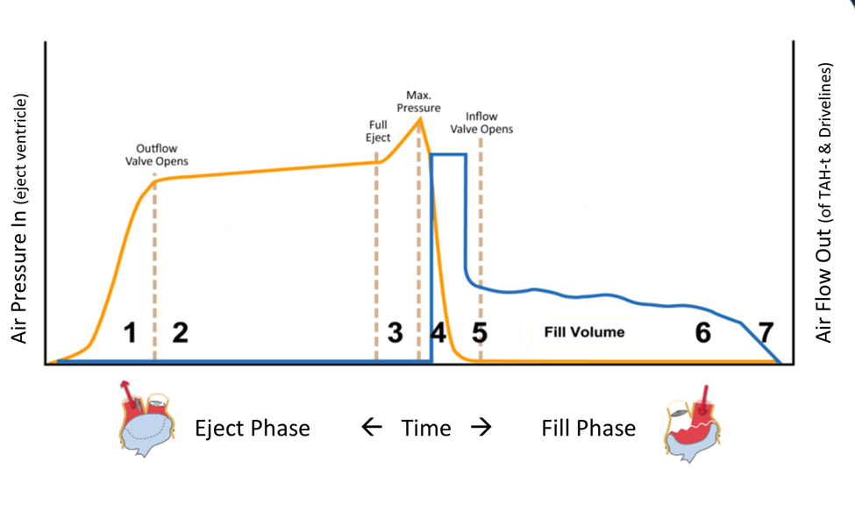
Figure 3: Pressure wave forms as related to cardiac cycle.

DEVICE SETTINGS

 | 70 cc | 50 cc
Left and Right Fill | 50-60 | 30-40
Heart rate | 110-140 | 110-140
Systolic Duration | 45-55% | 45-55%
Left Drive Pressure | 180-210 | 180-210
Right Drive Pressure | 60-100 | 60-100
Vacuum Pressure | 0 to -13 | 0 to -13
Figure 4: Normal ranges for device settings.

EQUIPMENT

Implantable TAH Pump Components | Companion 2 Driver System | Freedom Driver
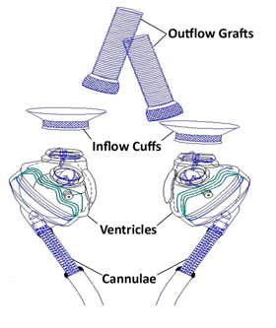 | 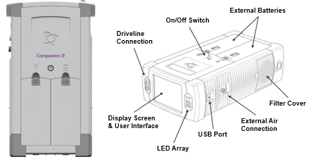  C2 Driver - powers the TAH and pneumatically drives air into the pump. | 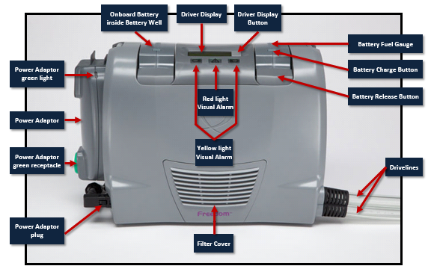  The Freedom Driver
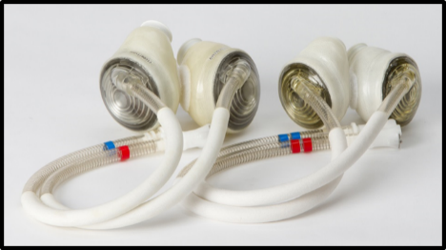  Ventricles/Pumps | 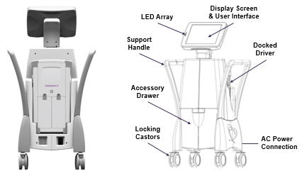Hospital cart

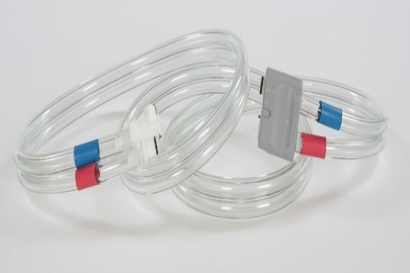  Drivelines | 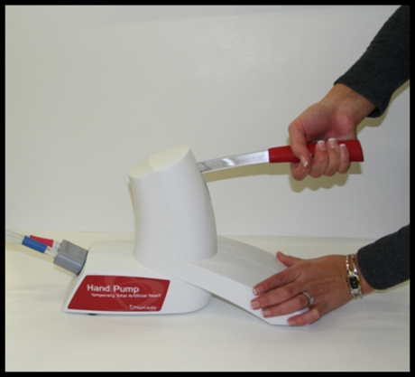  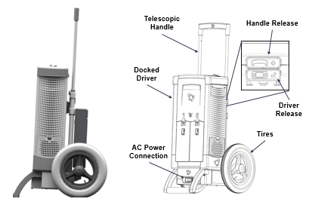  Caddy
Figure 5: See above for equipment components.

PATIENT MANAGEMENT

LINES AND TUBES
- Due to risk of entangling central or midline catheters in the TAH valves, all central line or midline catheters must be placed under fluoroscopy or direct visualization to ensure appropriate placement with their extremity at their side and also with their arm elevated over their head.
- Tip should NOT be near the TAH.
- Sutures and anchoring device placed after insertion. Dislodgement should prompt a stat chest x-ray to confirm line position.

ANTIBIOTICS
- Standard perioperative prophylaxis to be given unless concern pre-implant or development of concerning symptoms.
- If prolonged ICU course preoperatively consider fungal prophylaxis.
- Procalcitonin and/or CRP to be followed routinely and PRN if concerned.

HEMODYNAMIC MONITORING
- CVP is usually between 10-20 mmHg
- Running patient dry is preferable
- Use device settings (especially vacuums) to augment cardiac output

ANEMIA MANAGEMENT
- Patients on SynCardia will run a lower hematocrit.
- PRBC transfusions ordered by the VAD team if Hct <20, if hemodynamically indicated, or patient has clinical signs of hypovolemia with the anemia.
- LDH and plasma free hemoglobin to be monitored for red cell lysis (expect high LDH)

HYPERTENSION
- Target normotensive blood pressures
- In the immediate post-operative period, nipride/nicardipine and appropriate sedation may be used to optimize blood pressure control. Short term agent like hydralazine may be considered as adjunct.
- If chronic hypertension, can consider transitioning to enteral agents such as ACE inhibitor, calcium channel blocker or use of a clonidine patch.

Hypertensive Crisis Management

Note: When increased systemic vascular resistance (afterload) occurs, the TAH (especially the Freedom driver) is unable to deliver appropriate cardiac output and will begin alarming. It is imperative to lower blood pressure and set a specific goal for each patient.

Example Outpatient Hypertensive Urgency Plan for a 50 kg patient with goal BP >140 mmHg

Use | Medication | Directions
Elevated systolic blood pressure  greater than 140 mmhg | Nifedipine (Procardia)  [10 mg cap] | Take 1 cap (10 mg) as directed for blood pressure greater than 140 for two consecutive measurements
Elevated systolic blood pressure  greater than 160 mmhg | Nitroglycerin (Nitrostat)  [0.4 mg sublingual tablet]  *store in original container | Dissolve 1 tab (0.4 mg) under the tongue as directed for systolic blood pressure greater than 160  Dissolve under the tongue. Do not chew, crush or swallow
Elevated systolic blood pressure  greater than 140 mmhg (and no response to other drugs) | Hydralazine  [10 mg tab] | Take 1 tab (10 mg) as directed

OTHER
Diuresis
- Recommend IV diuresis immediately post-op to target a CVP ~10-15 see the chart to estimate the CVP in the appendix. (CVP is not always as low as you may expect).
- Use vacuums to improve fill when possible. Minimize fluid boluses.
- Transition to oral furosemide once hemodynamics stabilized.
  - If inadequate, additional agents may be added or ultra-filtration may be initiated.
- Dialysis possible with modification of settings during treatment.

GI Prophylaxis
- Recommend proton pump inhibitor (PPI) for post-operative GI prophylaxis and especially after initiation of ASA.
- Patients transition to oral PPI once on oral anticoagulation.

Nutrition
- Nutritional rehabilitation should be optimized. Recommend consulting dietician.
- Consider assessing for nutritional deficiencies and vitamin supplementation to optimize wound-healing.

Pain Management
- Initially IV medications used post-operatively and then transitioned to oral once extubated and taking nutrition.
- Usually oral pain control needed long term.
- Consider noise cancelling headphones for sleep.
- NSAIDs such as Ibuprofen or Toradol should NOT be used; they inhibit the effect of aspirin.

MANAGING COMPLICATIONS AND ADVERSE EVENTS

Potential adverse events include, but are not limited to: bleeding, fluid overload/device overfill, cerebral vascular accident/stroke, hemolysis, infection, device malfunction and death.

BLEEDING
  - Must watch closely for mediastinal bleeding leading to tamponade.
  - Assess the patient and evaluate the cause of bleeding (over anticoagulation, coagulopathy vs surgical site bleeding).
    - Send labs evaluating for coagulopathy (CBC, PT, PTT, Fibrinogen, Rotem, Anti-Xa) and assess the need for blood transfusions during prolonged periods of bleeding and correct any deficiencies.
  - Anticoagulation goals may need to be adjusted if there is ongoing bleeding or oozing and the pump itself is otherwise functioning well.
  - If bleeding continues, consider need for surgical exploration.
  - Surgical intervention for bleeding should be considered if bleeding is difficult to control or there is evidence of tamponade.
  - Tamponade is usually caused by compression of IVC, SVC, PVs or obstruction of atrial flow. This compression may be due to clot compressing a vital structure.
  - The waveform below is an example of cardiac tamponade with slow decrease in flows.
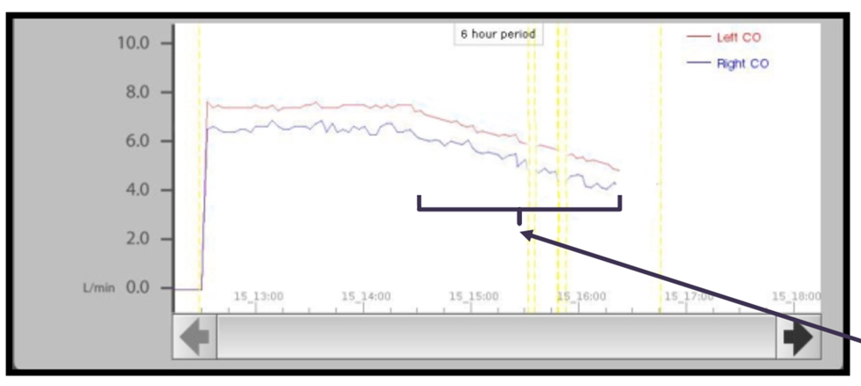

HEMOLYSIS
  - Some degree of hemolysis will occur. LDH usually runs 2-3 x normal.
  - Although rare, significant hemolysis can induce AKI, abdominal/GI issues and feeding difficulties, continue to monitor renal function.

DEVICE CLOT
  - Although rare, in the setting of subtherapeutic anticoagulation or periods of profound inflammation, thrombus formation could occur, resulting in device failure.

DEVICE FAILURE
  - This is not a common occurrence with the SynCardia device, however, if you are concerned a change in the driver should occur. A C2 backup should be available at all times.

INFECTION
- As with any foreign indwelling device, there is a risk of infection. Prophylactic antibiotics are not generally recommended for the duration of the device. However, for surgical prophylaxis, cefazolin or other antibiotic covering skin flora may be administered for 24 hours postoperatively.
- If the patient has been in the ICU for a prolonged time prior to implantation consider anti-fungal prophylaxis.

EMERGENCY PROCEDURES

Cardiopulmonary Arrest
If your patient arrests and loses blood pressure and perfusion pressure, CPR should not be performed. Defibrillation should not be performed. Code dose epinephrine will not help the patient. Consider hanging a sign on the bed about the patient’s status and alerting your code team that the patient is not a standard resuscitation. Also consider a medical alert bracelet.
Emergency Switch out of SynCardia Freedom Driver:
  - Disconnect BLUE, Disconnect RED
  - Reconnect RED, Reconnect BLUE
  - You don’t want BLUE on without RED because of risk for development of pulmonary edema

Responding to cannula issue
- Apply silicone tape to seal the hole.
- Call VAD team for further instructions.

ECMO
- Patients can go on V-V ecmo for respiratory failures if needed. Contact SynCardia for further information about experience in the field.

Waveforms

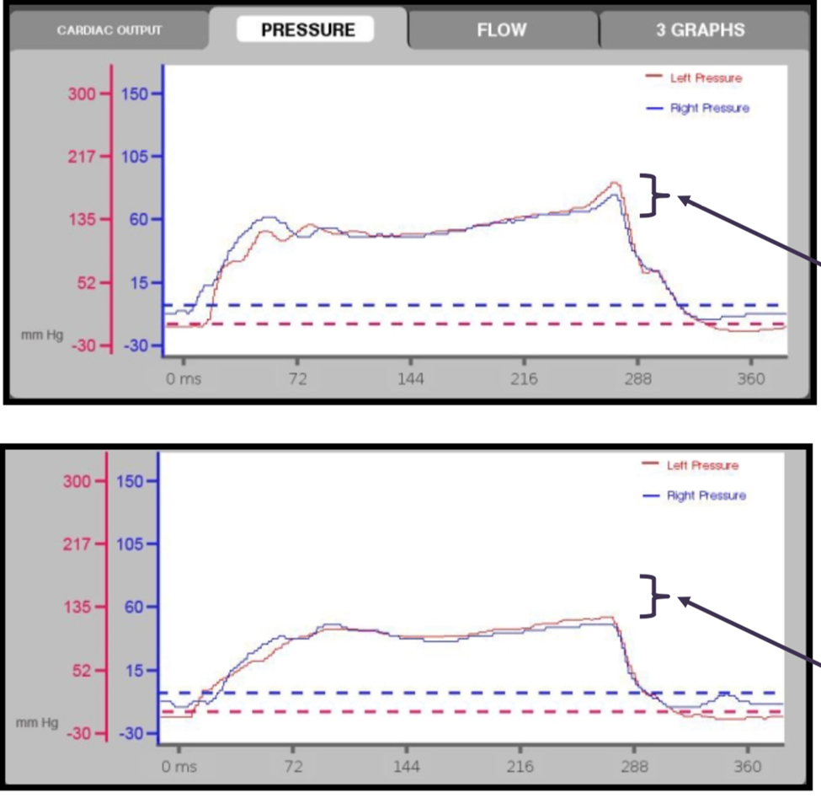

Figure 6: Top image shows full ejection with sharp eject flag or waveform. Bottom image shows a blunted flag or waveform of both right and left.

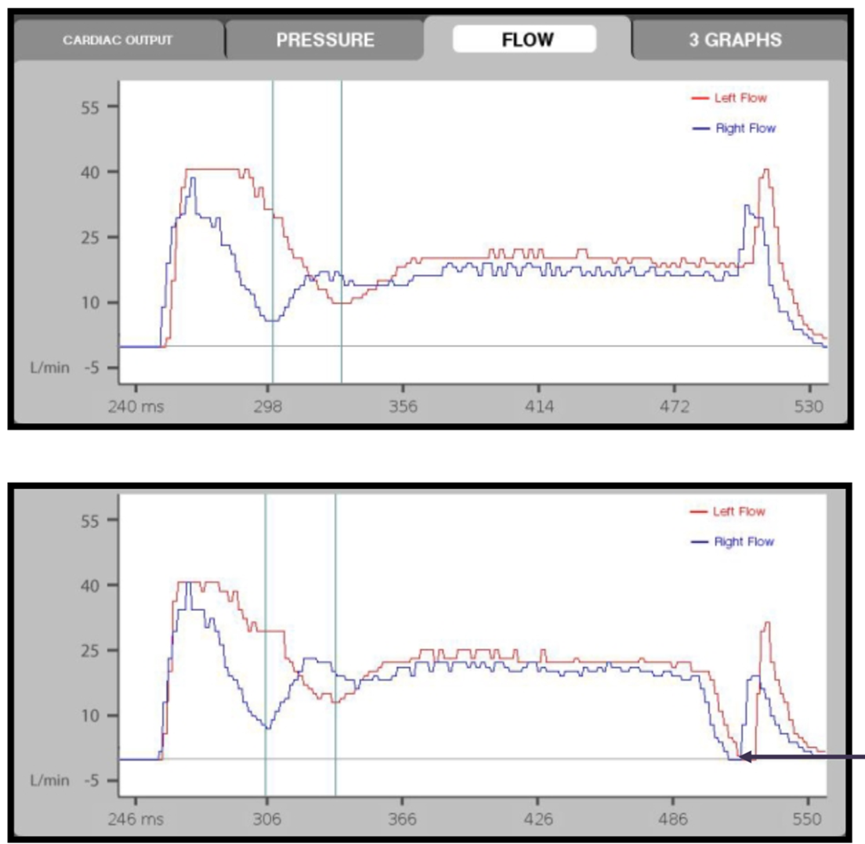

Figure 7: Top image shows partial fill and the bottom image shows full fill of both devices.

APPENDIX 1: NURSING BEDSIDE TEAM ASSESSMENT AND MONITORING

ASSESSMENT
The SynCardia TAH-t “acts” like a native heart in that it is:
- Fluid sensitive – With low circulating volume, there will be low cardiac output
- Partial fill, full eject – The ventricles will partially fill and fully eject to prevent hemostasis

Assessment focuses on assessing cardiac output:
- ADEQUATE Cardiac Output:
- Extremities are warm
- Cap refill is < 3 seconds
- No mottling or duskiness is present
- Partial Fills and Full Eject
- No evidence of tamponade on waveforms

HYPERTENSION MANAGEMENT
- Target normal blood pressure
  - If hypertensive, pump will begin to struggle (a fault alarm will intermittently sound) or fail (continuous fault alarm will sound). Treat patient with prn rescue meds as ordered for elevated SBP and call Heart Failure/VAD or ICU team.
- Emergency meds should be kept with the patient at all times and there should be standing prn orders for when and how to treat hypertension
Battery Life
- For C2 Driver, battery life is 1 hour
- For Freedom Driver, battery life is approximately 2 hours

SYSTEM CHECKS
Frequency determined by institutional policy
- Document the following system parameters. Note that Freedom Driver will only monitor HR (beats/min), left fill volume, left cardiac output)
Example C2 Driver Parameters for 70 cc pump:
  - Left and Right Fill Volume
    - Goal is “partial fill”: 50-55 mls
  - Heart Rate
    - Typical range: 110-140 bpm
  - Systolic duration
    - Typical range: 45%-55%
  - Left and Right Drive Pressure
    - Left typical range: 180-210 mmHg
    - Right typical range: 60-100 mmHg
  - Left and Right Vacuum Pressure
    - Left typical range: 0 to -13 mmHg
    - Right typical range: 0 to -10 mmHg
  - Blood Pressure
  - Left and Right Cardiac Output
    - Typical range: 6-9 L/min
  - Drivelines OK (no kinks, etc.)
  - Air Leaks (Y/N)
  - AC Power Lamps on (x3)
  - Any Visible or Audible alarms (Y/N)

- C2 Driver: Monitor waveforms per institutional policy. Can consider every 1 hour in the ICU and every 4 hours when on the floor:
  - Partial fill
    - If flow waveform drops to “zero” – this indicates full fill and needs to be investigated and resolved.
  - Full eject flag (waveform)
    - If “flag” missing on waveform – this indicates partial eject and needs to be investigated and resolved.

- Document the following Q shift:
  - Back-up Driver set/ready (Y/N)
  - Driveline Connectors Available (Y/N)
  - Battery Checks OK
    - If not on medical air, batteries will last for 1 ½ hrs.
    - Internal battery will last for 10 min.
  - Driver Key Location
  - Emergency equipment at bedside:
    - If on C2 Driver Only: Back-up C2 Driver, plugged in and emergency tool kit
    - If on Freedom: back-up Freedom Driver, batteries, power cord, emergency tool kit and C2 Driver

ACTIVITY
- After approved by care team:
  - Up ambulating at least TID, Up in Chair at least TID
  - Use of Incentive Spirometry/Cough Deep Breathing Exercises
  - OT/PT Consults
- Travel outside of the room should be approved by the care team at rounds. Patient must always have emergency back-up equipment with them.
- Patient should be accompanied by appropriately trained staff per institutional policy and have appropriate back up equipment.
- If leaving the unit or floor for a procedure, ensure appropriately trained staff are available to accompany the patient and monitor the driver.

FREEDOM DRIVER
- Review HR setting as per order (only parameters viewed: HR, FV and CO)
- Reminder…Battery Life for Freedom Driver=Fully Charged provides 1.5 hours of battery life
- Documentation/assessment every per institutional policy
- Patient may only leave the floor with a SynCardia trained individual, accessary bag with backup batteries, power-cord, SynCardia Freedom Driver and unit phone number.
- Three types of alarms
  - Battery – beeping tone with blinking yellow light
    - One or both batteries with <35% remaining charge - change one at a time
    - Alarm will continue until both batteries are charged above 35%
  - Temperature (“hot flash”) – beeping tone with blinking red light
    - Ensure filter and/or fan is not blocked
    - Move Freedom Driver to a different area
  - Fault – constant tone with solid red light
    - **Patient not getting the CO they need**
      - Check for disconnection, hypertension
      - Assess fluid status (elevate LEs, increase fluid intake)
      - One or both batteries with <30% remaining charge - change one at a time
  - Call the Heart Failure/VAD Team on Call to notify of fault alarms and patient assessment.

WHEN TO CALL THE MD
- All issues/concerns: Call Heart Failure/VAD/ICU Team
- If patient is in distress-call Rapid Response/Code (based on clinical picture). If Rapid Response/Code called, the Heart Failure/VAD Team should be notified immediately.
- No Compressions/Defibrillation/ACLS & PALS Drugs
- Heart Failure/VAD Team should be called for:
  - Fever/Signs of Infection
  - Concern for bleeding
  - Any changes in Anticoagulation Management
  - Changes in Neuro status
  - Concerning Hemodynamic changes
  - Hypertension
  - Any evidence of poor perfusion
  - Device alarms

APPENDIX 2: FREEDOM DRIVER MANAGEMENT

The Freedom Driver is a portable pneumatic device that provides additional mobility for stable TAH patients. Transition to the Freedom Driver is initiated at the discretion of the VAD team at the following criteria:
- Closed Chest
- Prior stable mobility using C2 Driver
- Hemodynamic/Hypertension Stability (at least 5 days without rate change on C2)

Procedure for switching between C2 Driver to Freedom Driver: (Please notify all care teams prior to switching drivers)
- Ensure patient is in a seated/rested position and all necessary materials available
  - Have back up freedom drive and hand pump available
    - Will need 2 VAD trained personnel at bedside to complete switch
- Insert two fully charged batteries to primary Freedom Driver
- Connect the primary Freedom Driver into a red wall power outlet
- Verify that the Freedom Driver starts (you should hear the motor and feel air pumping from the drivelines)
- Prepare patient for switch. Coordinate switch with additional personnel. Perform steps 6 and 7 simultaneously.
- Disconnect BLUE cannula from BLUE C2 driveline
  - Press and hold metal release clip.
  - Pull BLUE cannula from BLUE C2 driveline
  - Immediately insert BLUE cannula to BLUE Freedom driveline until click is heard
  - Lightly tug on connection to make sure it is secure
- Disconnect RED cannula from RED C2 driveline
  - Press and hold metal release clip.
  - Pull RED cannula from RED C2 driveline
  - Immediately insert RED cannula to RED Freedom driveline until click is heard
  - Lightly tug on connection to make sure it is secure
- NOTE: Disconnect BLUE, Disconnect RED
  - Reconnect RED, Reconnect BLUE
    - You don’t want BLUE on without RED because of risk for development of pulmonary edema

Note: Freedom Driver support can vary from C2 driver. If patient becomes unstable, immediately switch back to C2 and manage patient’s condition.

Emergency Department Hypertensive Urgency Management

- Obtain IV access and call the VAD/ICU Team
  - While obtaining access, give Nitroglycerin 0.4 mg tablet by sublingual route
- IV therapy available in ED STS Pyxis:
  - Hydralazine
    - Initial Dose: 10-20 mg/dose, may increase to 40 mg/dose. Do not dilute. Use 20 mg/mL concentration.
    - Administration: IV over 1-2 minutes; Do not exceed 0.2 mg/kg/min
    - Frequency: May repeat in 2 hours
  - Labetalol
    - Initial Dose: 20 mg; may administer 40-80 mg, up to 300 mg total cumulative dose. Do not dilute. Use 5 mg/mL concentration.
    - Administration: IV over 2-3 minutes; do not exceed 2 mg/minute
    - Frequency: May need to administer every 10 minutes

- Order Nipride continuous infusion to bedside to start at 1mcg/kg/min (if needed, consult with VAD Attending)

- Change from Freedom Driver to C2 Driver.

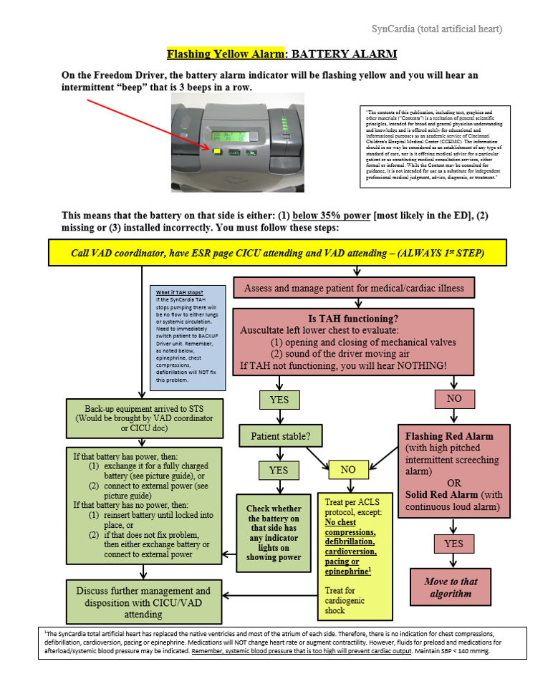

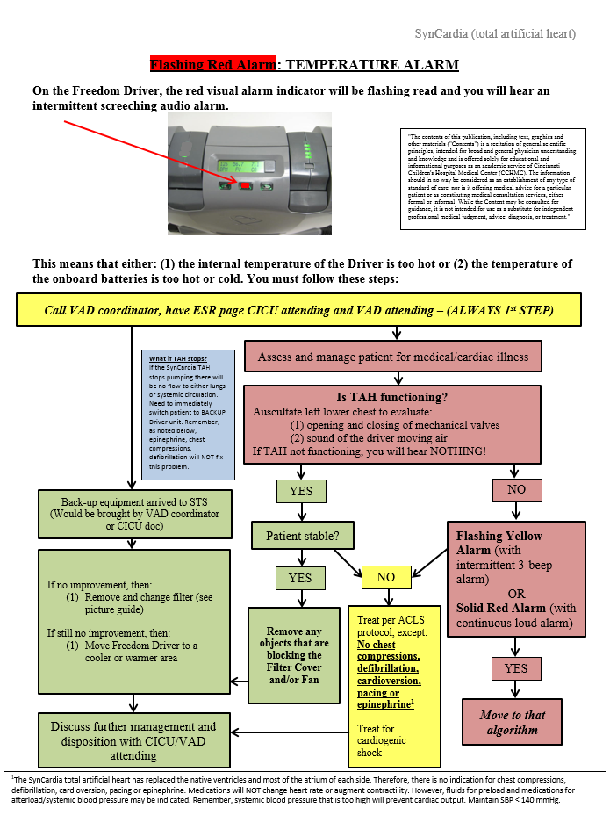

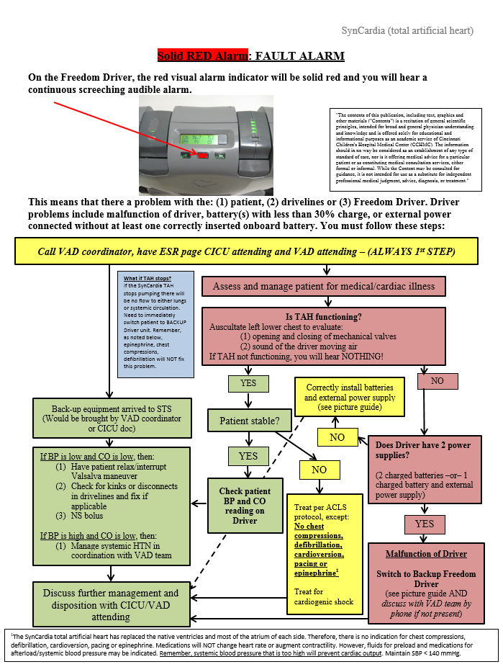

AUTHORS
Angela Lorts MD, David Morales MD, Tanya Perry MD, Katrina Fields RN, Aamir Jeewa MD, Elizabeth Oei RN, Bethany Wisotzkey MD, Molly Brickler, & Michelle Ploutz MD

CONTRIBUTING CENTERS
Cincinnati Children’s Hospital Medical Center, Phoenix Children’s Hospital, Hospital for Sick Children, Stollery Children’s Hospital, & Children’s Hospital of Wisconsin

Disclaimer: The ACTION network is focused on quality improvement efforts such as harmonizing best practice protocols, disseminating them among institutions, and helping centers to improve care practices at the local level. This protocol was developed as a consensus tool for pediatric VAD programs. The information in the protocols are based on center practices, individual opinions, experiences, and, where available, published literature. Centers may choose to adapt this protocol to include in their center-specific protocols with reference to ACTION with the understanding that these are meant as guidelines and not standard of care. (Revised: 10/27/21)

