VAD Nutrition
Energy Intake, Fluids, and Micronutrients

BACKGROUND
For children with end-stage heart failure, VAD support aims to improve cardiac output, allowing for stabilization of end organ function and optimization of nutritional and functional status. Children with a VAD may experience early satiety, anorexia and nausea which potentially compromise their nutrition and recovery. Therefore, appropriate nutritional assessment and therapy may decrease risk for morbidity and mortality.

ACTION REVISED DATE: 01/24/22

OBJECTIVES
  - Establish a standardized nutritional approach to minimize nutritional deficits in patients with VAD.
  - Identify micronutrients requiring evaluation, supplementation, and management in patients with VAD.

PROTOCOL

Process:
  - New Implants
    - Nutritional assessment as part of the inpatient or outpatient VAD evaluation in advance of surgery by RD
    - RD to reassess each VAD patient following VAD placement and during the remainder of hospital stay
    - RD may follow VAD patients after discharge on a consult basis and/or request from VAD team
    - If emergent implantation RD to conduct nutritional assessment post-operatively
  - VAD Readmissions
    - Nutrition screening and care evaluation per each institution’s nutrition policy
    - Assessment per institutional policy or at the request of the VAD team for patients determined to be at high nutrition risk, with reassessment and follow-up

- Nutrition Assessment:
  - Growth history including current height and weight as well as nutrition-focused physical exam
  - Diet history including appetite, food habits, special diet adherence, food allergies, cultural, religious, and ethnic food preferences, intake history, eating problems, and social issues affecting food intake
  - Use of herbs and supplements, medication use, and identification of potential nutrient-drug interactions
  - Physical activity, physical limitations
  - Obtain baseline labs, if possible. NOTE: levels are impacted by critical illness
    - Complete metabolic panel including serum albumin, magnesium, BUN and creatinine
    - Pre-albumin
    - Complete blood count with differential
    - C-reactive protein
    - Reticulocyte count
    - Zinc
    - Vitamin A
    - Vitamin C
    - Vitamin D 25-OH, if levels very low consider checking parathyroid hormone
    - Selenium
    - Iron studies (iron level, total iron binding capacity, ferritin, transferrin, transferrin saturation (if not included in other studies) )
    - Vitamin B levels if malnutrition is suspected and/or malabsorption under investigation
  - History of nutrition-related medical conditions (e.g., diabetes, hypertension, disorders of lipid metabolism)
  - Education needs for the acute care and outpatient (pre-admit and post- discharge) settings are identified. Educational needs address existing medical conditions, cultural and religious beliefs, physical and/or cognitive limitations, and barriers to communication.
  - Nutrition problems are identified (nutrition diagnoses) based on presenting signs and symptoms, according to the International Dietetics and Nutrition Terminology (IDNT) and causes or potential causes of these problems are determined.
  - The nutrition assessment is used to formulate a nutrition care plan, which is documented in the patient's medical record. The nutrition care plan includes:
    - Prioritized short- and long-term goals
    - Nutrition prescription to include recommended diet order, enteral or parenteral nutrition order, and vitamin and mineral supplementation. It may be adjusted for concurrent medical issues. It will also include any needs for nutrition education or counseling, as well as incorporation of additional interdisciplinary team members such as OT, ST, and PT.
  - The RD contacts physicians and other healthcare team members to discuss the nutritional prescription. The RD attends rounds per institutional policy.

- Nutritional reassessment
  - Indicators defined in the nutrition prescription to determine response to nutrition
    - Intervention (i.e., weight gain, linear growth, etc.)
    - High risk inpatients are reassessed frequently at the discretion of the RD or RD or per the nutrition policy of each institution.
    - Reassessment includes:
      - Updating of the subjective and objective data gathered during the prior nutrition assessment and identification of any changes
      - Assessment of implemented interventions and recommendations
      - Assessment of progress towards goals
      - Revision of nutrition diagnoses, as needed
      - Revision of goals and nutrition prescription as needed
      - Timeframe for nutritional reassessment
  - The RD contacts physicians and other healthcare team members to discuss the nutritional prescription. The RD attends rounds per institutional policy.

VAD Patient Population Nutrition Recommendations:
  - Protein
    - Infants < 1 year old:
      - Pre-term: 3.5-4 g/kg/day
      - Term: 3 g/kg/day
    - Children ≥ 1 year old and Adolescents: 2 g/kg/day
    - Compromised renal function may affect protein prescription per RD
  - Energy
    - Indirect calorimetry is the gold standard for determining energy requirements. It is a clinical tool that measures resting energy expenditure by analyzing the concentration of O2 and CO2 in respiratory gases. Resting energy expenditure can be used to determine total energy expenditure if physical activity levels are known. When this is unavailable or contraindicated, predictive equations can be used. If using predictive equations, note that VAD patients may have Total Energy Expenditure (TEE) that is 10-30% higher than healthy controls.
    - The RD should adjust nutrition prescription for individuals needs based on growth velocity and physical assessment throughout their entire VAD course.
    - In normal weight children and adolescents this is generally calculated via the patient's basal metabolic rate and multiplying this number by an activity and/or stress factor.
      - In critically ill VAD patients, those in catabolic state, may need an activity or stress factor as high as 2.
      - The clinical expertise of the RD can assist with determining individual energy requirements in pediatric patients.
    - If the patient is overweight or underweight, or malnutrition is suspected an alternative predictive equation may be used.
      - The Pediatric Nutrition Care Manual provides calculators for appropriate equations, including the WHO Equations for REE’s
    - Early nutrition intervention is critical to support a positive nitrogen balance. Measuring Nitrogen balance while possible is labor intensive requiring 24-hour urine urea nitrogen (UUN) collection and not possible at times.
      - Protein intake/6.25 - (UUN + 4*) = Nitrogen balance
*To account for average loss via sweat and feces.
    - All goals may of course be impacted by patient status, infection, intubation, etc.

  - Fluid
    - Fluid Intake: Patient specific fluid requirements determined upon review of serum sodium levels, underlying medical condition (i.e., heart failure, obesity) and a physical examination of fluid status by the provider
      - In some cases, fluid restriction is needed, close collaboration with RD is recommended in these cases to ensure both nutrition and hydration needs are met.
    - Body weight < 10 kg: 100 ml/kg/day for maintenance
      - Infants will often receive 140-150 ml/kg/day to support sufficient calories.
    - Body weight 11-20 kg: 1000 mL + 50 mL/kg >10 kg
    - Body weight >20 kg: 1500 mL + 20 mL/kg >20 kg
  - Enteral Nutrition (EN)
    - Early EN delivery is recommended if oral diet cannot be initiated within 24-48 hours of admission to the ICU in the critically ill pre-or post-operative VAD patient.
    - Current intake is compared to calculated requirements and limits. Nutrition-related deficits and excesses (protein, calories/energy, vitamins, minerals, fluid, etc.) are identified.
      - For patients who are attempting to consume all their calories orally, a 3-day calorie count should be initiated with input from RD regarding best strategy to meet daily intake goals (can include oral supplements if needed).

- Micronutrient Requirements:
  - Micronutrients such as trace elements, vitamins, and electrolytes are essential, and deficiencies may result in poor wound healing and/or clinical deterioration.
  - All VAD patients would benefit from baseline levels as defined in Section II.
  - See table below for goal levels, dosing recommendations and laboratory evaluation follow-up for patients receiving supplementation or replacement.
    - For patients in the lower end of the reference range consideration should be given to empiric supplementation at ½ the deficiency dose if enteral nutrition will be delayed and parental nutrition is not undertaken in the interim. The ½ deficiency dose is a strategy utilized at some institutions and reflected the table below to ensure adequate micronutrients for wound healing.
  - VAD patients without any micronutrient deficiencies should receive the following:
    - Daily multivitamin with iron.
      - Small, young and pre-term infants may need adjustments in consultation with RD and pharmacy based on their ability to metabolize specific nutrients.
      - Fish oil (omega-3 fatty acid) supplementation to reduce inflammatory response and platelet aggregation. Suggested dosing is to meet adequate intake (AI) for age. Dosing beyond this amount should be managed with physician guidance.
        - Allergy to fish is an absolute contraindication.

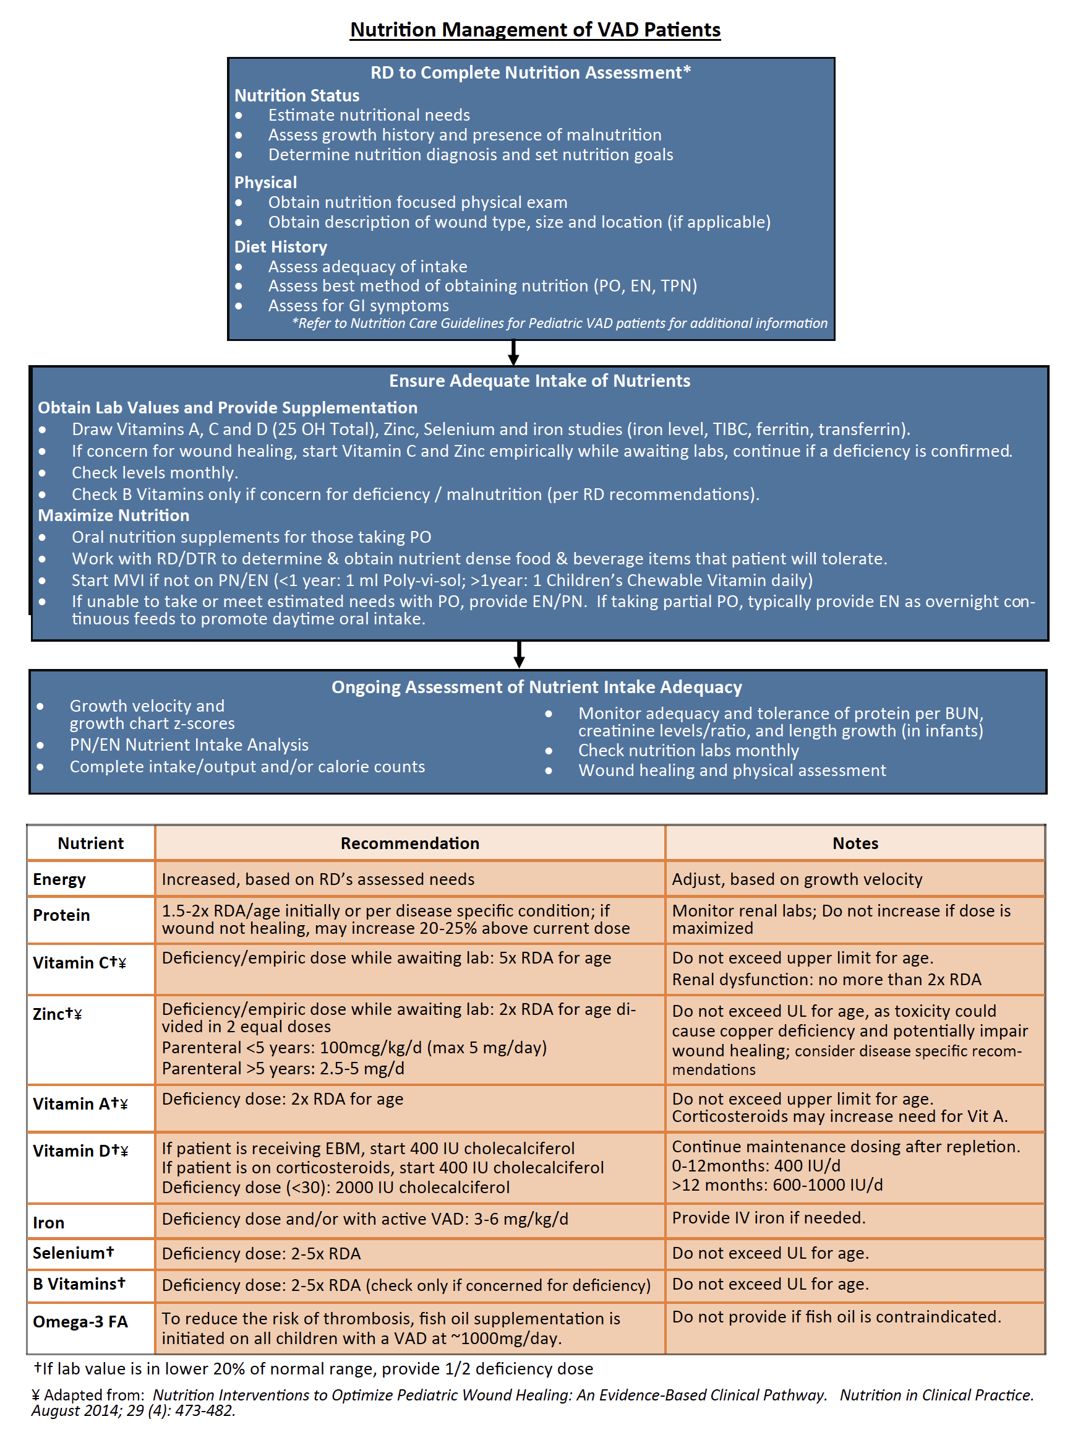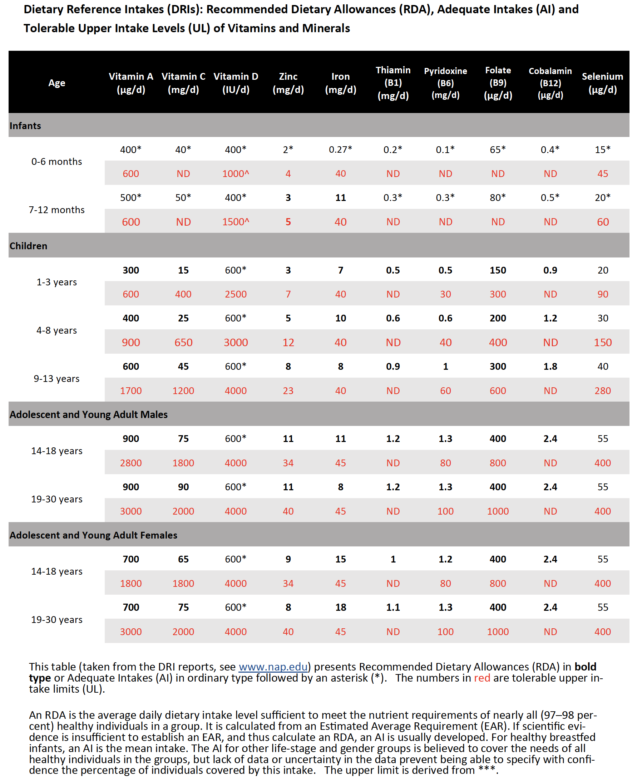

References
Baharestani, M.M., Ratliff, C. R, Pressure ulcers in neonates and children: an NPUAP white paper. Adv Skin Wound Care, 2007; 20(4):208- 220.
Bailer J, Kaufman B, Nutrition implications of heart failure and heart transplantation in children with dilated cardiomyopathy: A case series. ICAN 2010; 2:377-84.
Benstoem, C, Goetzenich, A., Kraemer, S, Borosch, S, Manzanares, W. Hardy, G. Stoppe, C. Selenium and its supplementation in cardiovascular disease – What do we know? Nutrients, 2015, 7: 3094-3118
Bergqvist, A., Chee, C., Lutchka, L, Rychik, J. Stallings, V Selenium deficiency associated with cardiomyopathy: A complication of a ketogenic diet 2003; 44(4) 618-620
Bomer, N. Beverborg, N. Hoes, M. Streng, H, Vermeer, M. Dokter, M. et al. Selenium and outcome in heart failure. Eur Journal of Heart Failure, 2020; 22: 1415-1433
Barnes K. Complications in patients with ventricular assist devices. DCCN 2008; 27(6):233-41
Brown, K.L., and Phillips, T.J. Nutrition and wound healing. Clinics in Dermatology, 2010; 28, 432-439.
Cereda, Emanuele et al. A Nutritional Formula Enriched with Arginine, Zinc, and Antioxidants for the Healing of Pressure Ulcers. A Randomized Trial. Ann Intern Med, 2015; 162: 167-174.
El-Amir N, Gardocki M, Levin HR, Markowitz DD, Greenspan R, Catanese KA, et al. Gastrointestinal consequences of left ventricular assist device placement. Am Soc Art Int Org 1996; 42:150-3
Fleith M, Clandinin MT. Dietary PUFA for preterm and term infants: review of clinical studies. Crit Rev Food Sci 2005;45(3):205-29
Hovasi J. Congenital heart disease. Nutrition Manual for At-Risk Infants and Toddlers. 1st ed. Chicago: Precept Press; 1997.141-8
Kavanaugh-McHugh, A, Ruff, A., Perlman, E., Hutton, N, Modlin, J Rowe, S. Selenium deficiency and cardiomyopathy in acquired immunodeficiency syndrome. Journal of Parenteral and Enteral Nutrition; 1991: 15(3) 347-349
Kris-Etherton PM, Harris WS, Appel LJ. Fish consumption, fish oil, omega-3 fatty acids and cardiovascular disease. Circulation 2002; 106:2747-57
Mehta NM, Compher C, ASPEN Board of Directors. ASPEN Clinical Guidelines: Nutrition support of the critically ill child. JPEN- J Parenter Enter Nutr 2009; 33:260-75.
Miller TL, Neri RD, Extein J, Somarriba G, Strickman-Stein N. Nutrition in pediatric cardiomyopathy. Prog Pediatr Cardiol 2007 November;24(1):59-71.
Nydegger A, Bines JE. Energy metabolism in infants with congenital heart disease. Nutrition 2006; 22:697-704.
Nydegger A, Walsh A, Penny DJ, Henning R, Bines JE. Changes in resting energy expenditure in children with congenital heart disease. Eur J Clin Nutr 2009; 63:392-7
Riediger ND, Othman RA, Suh M, Moghadasian MH. A systematic review of the roles of n-3 fatty acids in health and disease. J Am Diet Assoc 2009; 109:668-79.
Staveski SL, Avery S, Rosenthal DN, Roth SJ, Wright GE. Implementation of a comprehensive interdisciplinary care coordination of infants and young children on Berlin heart ventricular assist devices. J Cardiovas Nurs 2011; 26(3): 231-8
Stiller B, Lemmer J, Schubert S, Ewert P, Schulze-Neick I, Hubler M, et al. Management of pediatric patients after implantation of the Berlin heart EXCOR ventricular assist device. Am Soc Art Int Org 2006; 497-500
Thompson, KL, Leu, MG, Drummond, KL, Popalisky, J, Spencer, SM, Lenssen, PM. Nutrition interventions to optimize pediatric wound healing: An evidence based clinical pathway. Nutrition in Clinical Practice. 2014; 29(4): 473-482.
Valentova M, von Haeling S, Doehner W, Murin J, Anker S, Sandek A. Liver dysfunction and its nutritional implications in Heart Failure. Nutrition 2013;29(2):370-8
Van der Kuip M, Hoos MB, Forget PP, Westerterp KR, Gemke RJBJ, de Meer K. Energy expenditure in infants with congenital heart disease, including a meta-analysis. Acta Pediatr 2003; 92:921-7
Wilson SR, Givertz MM, Stewart GC, Mudge GH. Ventricular assist devices: the challenges of outpatient management. J Am Coll Cardiol 2009; 54(18):1647-59

AUTHORS
David W. Bearl, MD, MA, Nancy A. Jaworski APRN, DNP, Jane Douglas, MS, RD, LDN, CNSC, Ryan Rafacz, RD, LDN, CNSC, Julie Pingel, Pharm D, Stephanie Babwik RD, Kylie Lewis RD, & Jennifer Conway, MD

CONTRIBUTING CENTERS
Monroe Carell Jr. Children’s Hospital at Vanderbilt, Nashville, Stollery Children’s Hospital, C.S. Mott Children’s Hospital, Lurie Children’s Hospital of Chicago, Children’s Hospital of Colorado, Primary Children’s Hospital, UCSF Benioff Children's Hospital, Children’s Hospital of Philadelphia, The Hospital for Sick Children, Johns Hopkins Health System, & Cleveland Clinic Children's Hospital

Disclaimer: The ACTION network is focused on quality improvement efforts such as harmonizing best practice protocols, disseminating them among institutions, and helping centers to improve care practices at the local level. This protocol was developed as a consensus tool for pediatric VAD programs. The information in the protocols are based on center practices, individual opinions, experiences, and, where available, published literature. Centers may choose to adapt this protocol to include in their center-specific protocols with reference to ACTION with the understanding that these are meant as guidelines and not standard of care. (Revised: 01/24/22)

