Driveline and Cannula Site Infection Management for Pediatric VAD Patients

BACKGROUND
Infection is one of the most common adverse events following VAD implantation. Infections remain one of the major contributors to morbidity, mortality, and hospital readmissions in VAD patients, especially driveline and cannula site infections.

ACTION REVISED DATE: 7/26/2022

OBJECTIVES
To review the management of driveline and cannula site infections for pediatric VAD patients.

PROTOCOL
Close surveillance and monitoring of clinical symptoms and driveline/cannula site appearance. Considerations for treatment of driveline and cannula site infections include:

Prevention:
- Perioperative Antibiotics (See ACTION Antibiotic Prophylaxis Protocol)
- Sterile Dressing Changes (See ACTION Care of Driveline and Cannula Site Protocols)
- Hand hygiene:
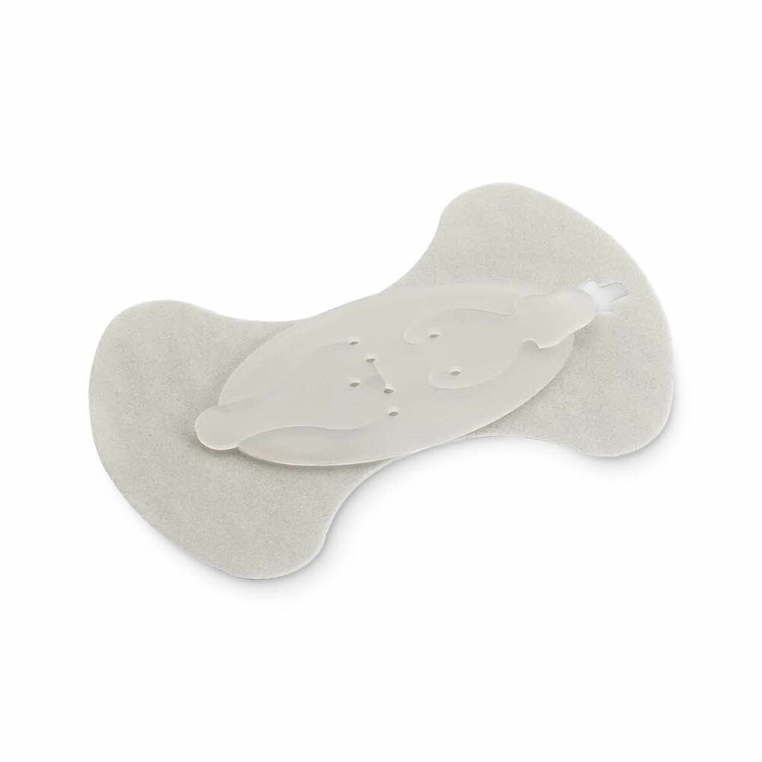
  - Strict hand hygiene by healthcare workers.
  - Patients and caregivers should receive continuing education on proper hand hygiene and dressing change routines.
- Immobilization of drivelines and cannulas:
  - Consider Foley anchor to prevent drivelines from pulling and tugging.
Foley Anchor
  - Anchoring at the time of implant is beneficial.
  - Certain centers have found benefit in using retention sutures (for ~6-8 weeks), especially in obese patients.
- Barriers to prevent contamination of driveline/cannula site with bodily fluid:
  - If patient has a G-tube, consider placement of ostomy bag around G-tube to prevent gastric contents from leaking into the driveline/cannula site.
  - For incontinent or diapered patients, consider the use of Steri-Drape 3M barriers to prevent urine and feces from coming in contact with the driveline/cannula site.
- Showering:
  - Once showering is approved, consider taking showers on days driveline dressing is scheduled to be changed and change dressing immediately following the shower
  - Avoid contact of shower water (consider using Aquaguard as a border around site)
  - Keep driveline site as dry as possible during the shower
- Maintain good nutrition
Monitoring:
- Frequent monitoring of driveline or cannula sites
  - Recommendations for Dressing Frequency
    - Weeks 0-1: Every Day
    - Weeks 1-2: Every Other Day
    - Above 2 weeks: Consider twice weekly or at the discretion of the care team
- Any acute event related to driveline integrity such as trauma, tugging or pulling, should be assessed closely for breakdown around site.
  - Signs of driveline site disruption after a tugging/pulling event include bleeding, new discharge, and/or visualization of disruption of the driveline-skin barrier.
- Exposure of velour on driveline sites is a major risk factor for infections and should be monitored.

Evaluation:
- Appearance of driveline or cannula site
  - Assess color, tenderness, swelling, drainage amount and consistency, foul odor, undermining (erosion at base) at the site, or tunneling (see Figure and pictures below)
- Consider Imaging
  - Sterile US of driveline site/cannula site to evaluate for pocket infections
    - Consider timing of dressing change to follow the US
  - CT scan or PET if concerns for deep driveline/cannula site infections
  - ECHO (Consider TEE if strong suspicion for endocarditis)
- Consider evaluation of systemic involvement (fever, nausea, vomiting, diarrhea, fatigue, or hemodynamic changes)
  - Inflammatory and infectious markers (CBC, CRP, ESR, pro-calcitonin)
  - Blood cultures (if suspicion of systemic infection)

Stage 1 - Mild breakdown | Stage 2 - Moderate breakdown | Stage 3 – Severe breakdown
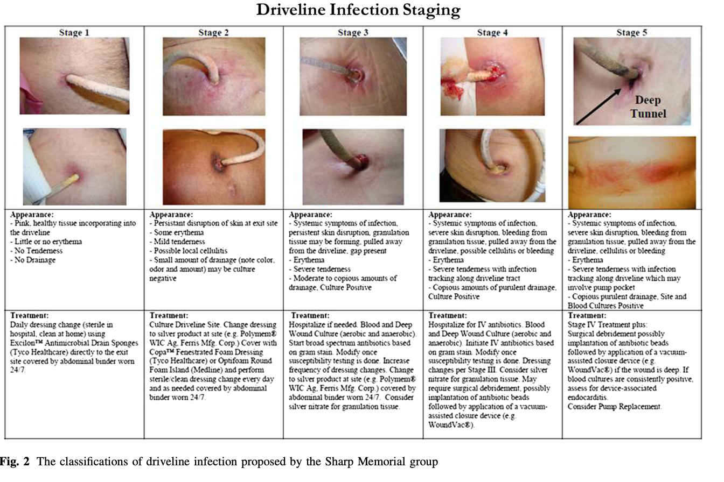
Appearance:  - Pink, healthy tissue incorporating into the driveline  - Little or no erythema  - No tenderness  - No drainage | Appearance:  - Persistent disruption of skin at exit site  - Some erythema  - Mild tenderness  - Possible local cellulitis  - Small amount of drainage (note color, odor, amount) may be culture negative | Appearance:  - Severe skin disruption (bleeding from granulation tissue, pulled away from the driveline, cellulitis, bleeding)  - Erythema  - Severe tenderness with infection tracking along driveline tract  - Moderate to copious purulent drainage.
Figure 1: The classifications of driveline infection proposed by the Sharp Memorial group
Treatment:
- Review dressing change protocols to ensure compliance and close monitoring (See ACTION Care of Driveline and Cannula Site Protocols)
- Treatment should be based on the staging of the driveline/cannula site
- Consider increasing dressing change frequency
- Consider Wound Team Consult
- Degree of Breakdown/Infection
  - Stage 1 – Mild Breakdown
    - Increase frequency of dressing changes and close monitoring
      - Consider changing dressing type to one with anti-microbial and absorbency properties such as Mepilex AG
      - Consider adding antimicrobial disc such as a Biopatch (also consider that the Biopatch could be the cause of this irritation and should be discontinued)
      - Consider adding products with silver (healing and microbial properties) such as Aquacel rope to site if erythema
      - Consider changing to less concentrated chlorhexidine such as dilute Hibiclens from CHG swab if site is erythematous
    - If a tugging or pulling event occurs, the driveline skin barrier may be disrupted, and additional prevention efforts should be started.
      - Increase frequency of dressing changes
      - There is no evidence to support the use of oral antibiotics when there is disruption of the driveline without any other signs of infection
      - Reverting to the management strategy at the time of VAD implant is a reasonable approach to prevent infection after disruption and avoid side effects of antibiotics such as antibiotic resistance, diarrhea, or GI discomfort
  - Stage 2- Moderate Breakdown
    - Daily dressing changes and close monitoring
      - Consider using product with silver (healing and microbial properties)
      - Silver wound vac sponge
      - Silverlon instead of CHG Biopatch if site is erythematous
    - Consider CV Surgery evaluation for local debridement
    - Consult consultation with an infectious diseases specialist
    - Consider sterile culture from driveline/cannula site (bacterial and fungal) when there is evidence of purulent drainage
    - With superficial DLI without concerns for systemic illness, consider oral antibiotic therapy
      - For first line empiric antibiotic treatment, consider anti-staphylococcal coverage
        - patient may warrant broader coverage based on epidemiologic or patient factors
        - Local epidemiologic antibiograms and alternatives for antibiotics allergies should prompt modification of antimicrobials
  - Stage 3 – Severe Breakdown
    - Daily Dressing Changes and Close Monitoring
    - Monitor for signs of systemic Infection (fever, or leukocytosis)
    - Consider Admission for IV Antibiotics
      - For first line empiric antibiotic treatment, patient may warrant broader coverage based systematic involvement
        - Local epidemiologic antibiograms and alternatives for antibiotics allergies should prompt modification of antimicrobials
      - Consider sterile culture from driveline/cannula site (bacterial and fungal) when there is evidence of purulent drainage
        - Culture and susceptibility can guide more targeted therapy if available
      - Duration of therapy should be based on clinical response and resolution of infectious signs/symptoms. Antimicrobial coverage may be required for duration of VAD support and decisions should be made with an infectious diseases specialist.
    - Consider CV Surgery evaluation and possible admission to OR for debridement/explant needs for invasive infections
      - Consideration of wound vac
      - Consideration of pump replacement
    - Anticoagulation Considerations due to systemic inflammatory response:
      - Consider close monitoring of inflammation and fibrin in pump
      - Consider frequent surveillance of PTT/DTT for patients on bivalirudin.
      - Antibiotic therapies can potentiate effects on INR. Additional surveillance of anticoagulation assays should be considered.
- Other Considerations
  - Re-occurring infections:
    - Chronic suppressive oral antibiotics may be considered
    - Consider re-tunneling of driveline/cannulas or replacement of pump
  - Avoid medihoney to driveline site as it has been associated with biofilm formation ²
- Transplant Considerations
  - Early listing for transplant after infection related device complications to remove source of infection as long as patient is stable and effective antibiotics are available to treat the infection. Please consider that if there is a systemic infection, transplant and immunosuppression may pose more risk. Consider modification of induction therapy in a patient who is bacteremic.
  - Consult Transplant Infectious Diseases for guidance on timing for transplantation.
  - Active local infection is not an absolute contraindication to transplantation

AUTHORS
Allison Reichhold, MSN, CPNP, Lara Danziger-Isakov, MD, Ami B. Patel, MD, Neha Bansal, MD, Alexa Harris PA-C

CONTRIBUTING CENTERS
Lurie Children’s Hospital of Chicago, Cincinnati Children’s Hospital Medical Center, Children’s Hospital at Montefiore, Lucile Packard Children’s Hospital, Monroe Carell Jr. Children's Hospital, C.S. Mott Children’s Hospital, Texas Children's Hospital, The Hospital for Sick Children, Children’s Hospital Colorado,

Disclaimer: The ACTION network is focused on quality improvement efforts such as harmonizing best practice protocols, disseminating them among institutions, and helping centers to improve care practices at the local level. This protocol was developed as a consensus tool for pediatric VAD programs. The information in the protocols are based on center practices, individual opinions, experiences, and, where available, published literature. Centers may choose to adapt this protocol to include in their center-specific protocols with reference to ACTION with the understanding that these are meant as guidelines and not standard of care. (Revised 7/26/22)
References:
- Hernandez GA, Breton JDN, & Chaparro SV. Driveline infection in ventricular assist devices and its implication in the present era of destination therapy. Open J Cardiovasc Surg 2017; 9:1179065217714216.
- J Heart Lung Transplant 2016; 35:108–14. Continuous-flow left ventricular assist devices and usefulness of a standardized strategy to reduce drive-line infections. .Cagliostro B, Levin AP, Fried J, et al.
- J Heart Lung Transplant 2016; 35:108–14. April 2016 Volume 35, Issue 4, Supplement, Page S350 Site Management Strategies in Pediatric Ventricular Assist Device (VAD) Patients. M.V. Horn et al.
- Qu, Y. et al. In vitro evaluation of medihoney antibacterial wound gel as an anti-biofilm agent against ventricular assist device driveline infections. Front. Microbiol. 2020, 11, 2927
- Morales DLS, Adachi I, Peng M, et al. Fourth Annual Pediatric Interagency Registry for Mechanical Circulatory Support (Pedimacs) Report. STS Pedimacs Annual Report 2020; 110.6:1819-1831
- Trachtenberg BH, Reyes AC, Elias B, et al. A review of infection in patients with left ventricular assist devices: prevention, diagnosis and management. Methodist Debakey Cardiovasc J. 2015; 11(1): 28-32.

Appendix
VAD Dressing Change Kits

Children’s Hospital Colorado
We recently changed to the Medline EBSI Sensitive Skin VAD Kit with contents previously described. We have heard good feedback from families regarding ease of use and have had positive short-term experience with the Silverlon antimicrobial dressing.
https://www.medline.com/product/ERASE-BSI-Dressing-Change-Systems/Z05-PF153134
Medline, product number EBSI-1502

Morgan Stanley Children’s Hospital of New York Presbyterian
For our driveline sites, we have kits that Centurion makes. Included is a sterile field, antiseptic applicator (Chloraprep), Silvercel dressing, 10-2x2 gauze, Hydrofilm dressing, face masks, clean and sterile gloves, and an anchor (we have 2 different kits--one with a smaller anchor and one with a larger anchor). Instructions regarding how to perform the dressing are also included. We do not have specific kits for our cannula dressings.

Texas Children's Hospital
We utilize Centurion Chronic driveline kit. You can customize.

Norton Children’s Hospital
We use Wound Care Resources or Acelis. Our DLES kit has the silverlon disc, sterile gloves, mask, sterile water wipe, preventix stick, alcohol swab and clear dressing. We prefer to use the cath grip holder, not the Foley anchor and sometimes have to find other dressings, if the child is sensitive.

C.S. Mott Children’s Hospital
We use centurion Kit. We have two one for daily dressing's and one for weekly dressings. Both include clean & sterile gloves, gown, mask's,hat and sterile field, 3-steril saline wipes, 2-chlorprep applicator's, 2-skin protectant (cavalon) sticks, Silverlon disk, sorbaview dressing and anchor. The weekly kits contains a sorbaview with clear window and 2 anchor's. The daily kit dressing sorbaview dressing does not have window, and has only 1 anchor. Both include step by step directions for dressing change.

Children's Healthcare of Atlanta
Right now, we gather the supplies individually and create our own on a sterile field, but I am working with a Medline rep to get a kit. They provide a standard kit for HM3 called EBSI sensitive skin VAD kit, which includes gloves, hand sanitizer, 2 hair bouffants, 2 masks, adhesive remover, sterile gloves, 4x4 split gauze, 1 chloraprep, 1 silverlon dressing, 1 saline wipe, sorbaview dressing, and anchor. They also offer custom kits, I am waiting on pricing. We are working on possibly creating a custom kit for the Berlin and PediMag, but Medline would want to be able to provide to other centers as well in order to make it cost-effective. I am happy to give you the contact info of the rep I have been working with if you reach out to me: margaret.ciarletta@choa.org.

Levine Children's Hospital
For our drivelines we have recently changed to using a custom kit from Centurion as well that the adult VAD team created. There are 4 different kits depending on patient needs or sensitivities. Two with chloraprep and two with Hibiclens. In the groups of two there are 1 with Silverlon dressing and one without for the patients that are further out postoperatively. Each kit has an anchor, 4x4 gauze, split 2x2 gauze, saline wipe(only in silverlon kits) Cavalon sticks, 4 pairs sterile gloves (2L and 2XL), 2 masks, sorbaview dressing, and tweezers (more for adult population if needed). The staff and patient families like the custom kits much better. For our cannula dressings we just gather all the supplies. Happy to give any information I can on the kit pricing and order numbers! Contact info: Stephanie.Rought@atriumhealth.org.

Children's Memorial Hermann Hospital
We use a custom kit through Medline for inpatient and also provided via DME for our outpatients. EBSI LVAD Multi- Day Mgmt Kit. Inside it has pockets for each step holding the supplies needed, and includes a picture and written step-by-step instructions. Outside of the kit contains gloves, masks x2 and freederm adhesive removal. Inside contains 2 chlorapreps, saline wipe and silverlon patch, Cavilon no-sting barrier, sorbaview, medium cathgrip anchor, and a sterile 2x2 gauze.

Children's Hospital of Pittsburgh
We also recently changed from a custom kit from Centurion to a new kit supplied by Medline which now includes the Silverlon dressing. This kit includes pictorial instructions, along with the following contents: gloves (2), hand sanitizer, mask (2), adhesive remover, 4x4 gauze sponge, saline wipes (2), Prevantics preps (2), Sureprep skin protectant, Silverlon dressing, foam dressing, SecureView dressing with closure piece, Cathgrip double anchor securement device, and drape. The weekly driveline tray kit code is EBI1526.

