<Month ##, 20##>

To Whom it may Concern,
Contact
Information
PATIENT DETAILS
<Patient Name>
<Patient Address>

VAD TEAM CONTACT AT <Hospital Name>
<VAD Contact Name>
<Site Address>
<000.000.0000>
<email>
This letter is to inform you that one of your passengers, whose identifying information appears to the left, has special healthcare needs.
The passenger has a Heartmate 3TM Left Ventricular Assist Device (LVAD) Device (VAD) or “blood pump”. The device takes over the pumping function of the patient’s sick or weakened heart so that the patient’s lungs, organs, and tissues get the oxygen-rich blood they need. A VAD is a life-sustaining device.
I am requesting your help in assisting the passenger through the security check-in and boarding process. In addition, the patient will need to carry on and stop HeartMate 3TM related accessories on the plane since the equipment must always remain with them for safety reasons. This equipment includes their power supply (either the Power Module or Mobile Power Unit (with associated Patient Cable and power cable), the HeartMate Battery Charger (with power cable) and sufficient back up 14V batteries, battery clips (4), and system controllers (2) for travel duration including delays.
For security clearance purposes, please ONLY utilize metal detector wand or perform manual pat down on patient. Patient CANNOT go through full body scanner or metal detector.
Be advised that the HeartMate 3TM system using 14V lithium-ion batteries has been tested and approved for air transport, including commercial aircraft (passenger cabin only). The VAD system is compliant with all related FAA safety requirements and will not interfere with aviation electronics, per Section 21, Category M of the RTCA document number RTCA/DO-160, as specified in “Use of Portable Electronic Device Aboard Aircraft” AC number 91-21.1B, Section 8A.
The VAD power capacity complies with the on-board IATA regulations-Aircraft Travel.
Thank you in advance for your assistance. If you have questions about the device, feel free to contact me directly at the telephone number listed to the right.
Sincerely,
Ventricular Assist Device (VAD) Team at <Hospital Name>

Power Supply
Power Module (with power cord) and Patient Cable
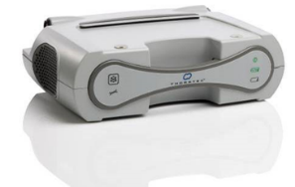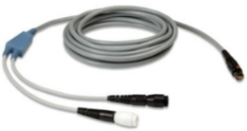
OR

Mobile Power Unit (with power cord) and Patient Cable
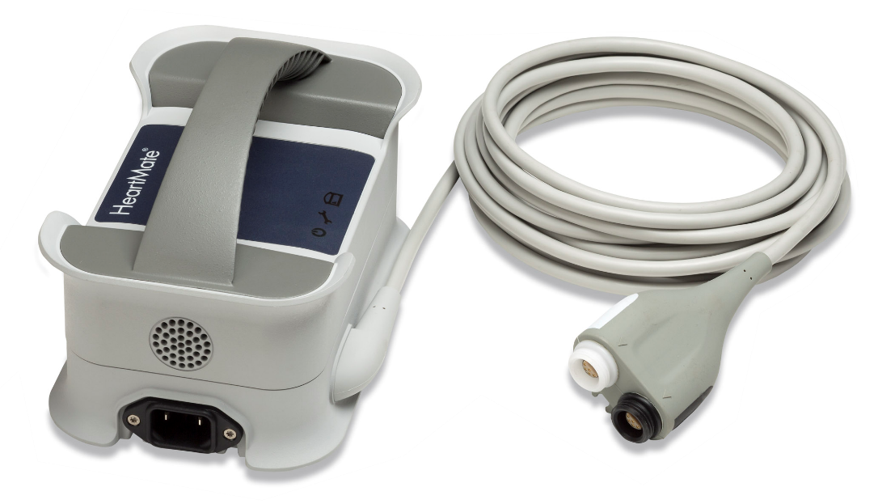
Batteries & Clips
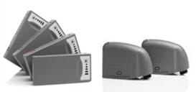

Universal Battery Charger (Includes power cable)
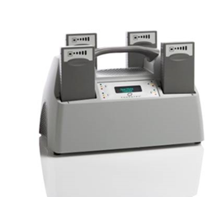
Contact
Information
PATIENT DETAILS
<Patient Name>
<Patient Address>

VAD TEAM CONTACT AT <Hospital Name>
<VAD Contact Name>
<Site Address>
<000.000.0000>
<email>
