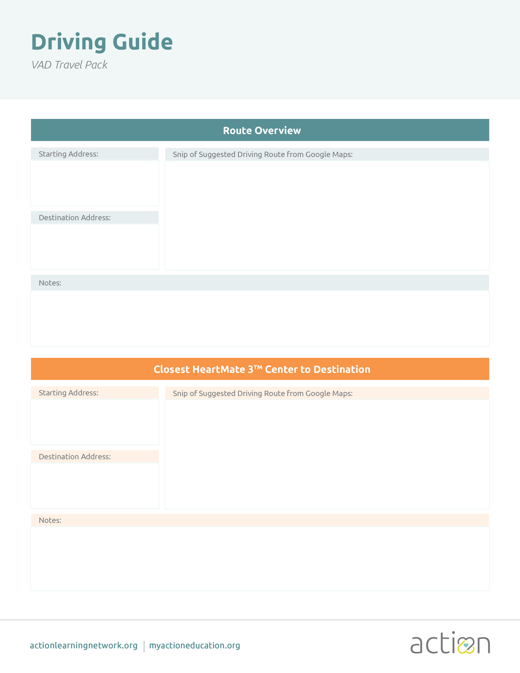

< ADD YOUR HOSPITAL LOGO HERE OR DELETE >   
(Align to right margin)

Delete & Insert Picture

Name of Site

Address Line 1  
Address Line 2  
City, State, 00000

Insert Notes

Address Line 1  
Address Line 2  
City, State, 00000

Name of Site

Insert Notes

Delete & Insert Picture

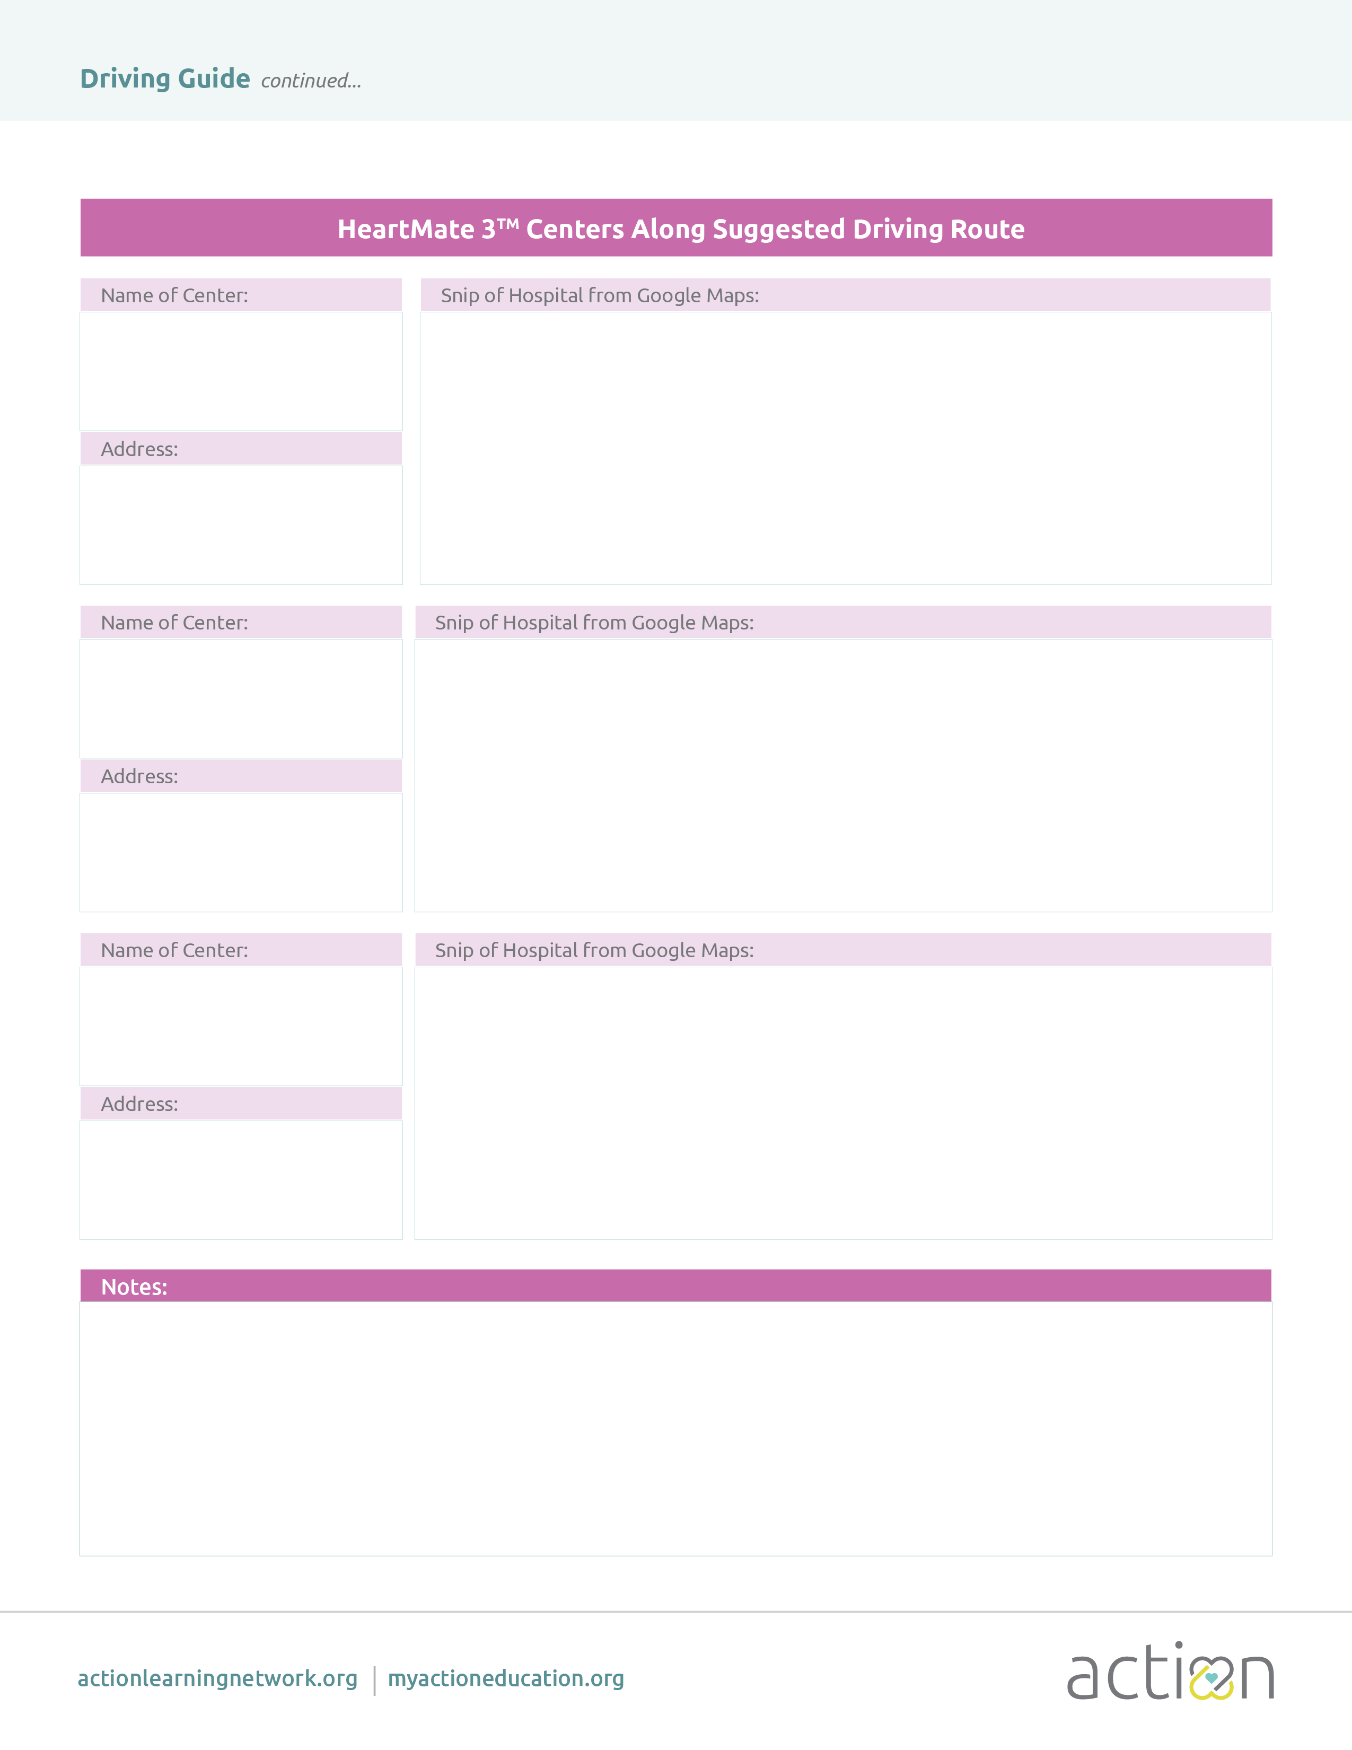

Insert Notes

Name of Site

Address Line 1  
Address Line 2  
City, State, 00000

Address Line 1  
Address Line 2  
City, State, 00000

Name of Site

Address Line 1  
Address Line 2  
City, State, 00000

Name of Site

Delete & Insert Picture

Delete & Insert Picture

Delete & Insert Picture