Compassionate Deactivation of
BERLIN HEART in Children

ACTION REVISED DATE: 10/07/2024

STEPS FOR POWERING OFF IKUS UNIT

1.In the monitor program, select the option Drive OFF (see Fig.1)
and press <Enter> to confirm.

2. Respond to the prompt in the dialog window by pressing the <X> key or the
<1> key. The system stops operation immediately and writes an operating log.

3. Wait until the log has been completed. When the message Switch drive off with main switch! appears, press <F10> to shut down the monitor program.
Confirm by pressing the <X> key or the <1> key.

4. Select 3. End (<3>, see Fig. 2) in the start menu and switch off
the laptop.

5. Switch the Ikus off by turning the key switch to [0] position.

Fig.1

Fig.2

STEPS FOR POWERING OFF ACTIVE DRIVER

1.In the PC panel, log in as Expert.
2. At the top of the Menu, push the PUMP icon.
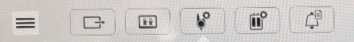
3. In the Pump screen, push the PLAY/PAUSE button.
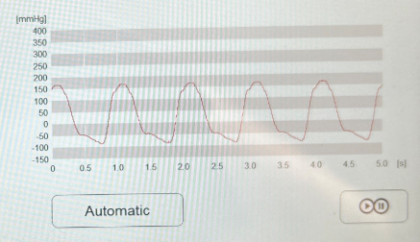
4. Acknowledge that you want to STOP the pump.
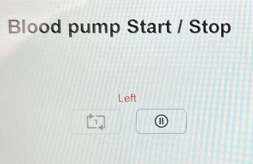
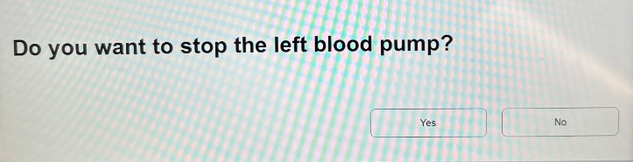
5. Once the pump is stopped, disconnect the driveline and flow probe from the driver and remove the driver from the room. The driver can be shut down once outside of the room.

Disclaimer: The ACTION network is focused on quality improvement efforts such as harmonizing best practice protocols, disseminating them among institutions, and helping centers to improve care practices at the local level. This protocol was developed as a consensus tool for pediatric VAD programs. The information in the protocols are based on center practices, individual opinions, experiences, and, where available, published literature. Centers may choose to adapt this protocol to include in their center-specific protocols with reference to ACTION with the understanding that these are meant as guidelines and not standard of care. (Revised 6/21/19)

