Compassionate Deactivation of
HeartWare HVAD in Children

ACTION REVISED DATE: 10/07/2024

STEPS FOR POWERING OFF HEARTWARE HVAD

Action: Before proceeding, ensure deactivation of pacemaker or ICD (defibrillation and pacing functions) if applicable (item 1.3 of Checklist)

Step 1: Place data/monitor cable to the primary controller

Step 2: Login to the monitor using the pump icon on home screen-password 68773 (Nurse), <enter>
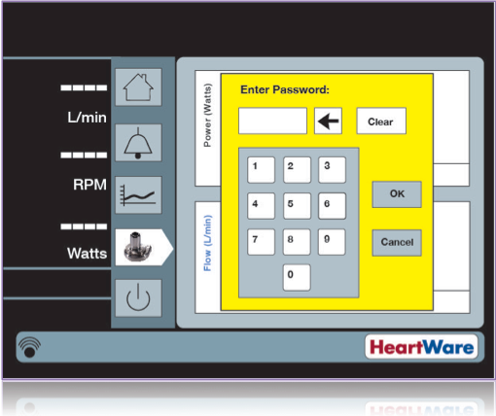

Step 3: Go to Speed/Control tab
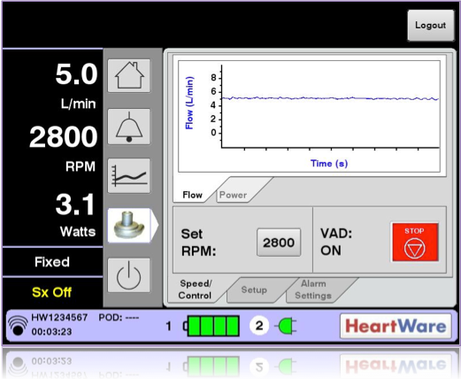
Step 4: Press Red VAD Stop button

Step 5: Press <Yes>, to confirm you want to stop the VAD
Step 6: Remove data cable, place red alarm adapter to data port
Step 7: Remove both power sources to power down the controller, then remove driveline.

Alternative Steps without monitor:

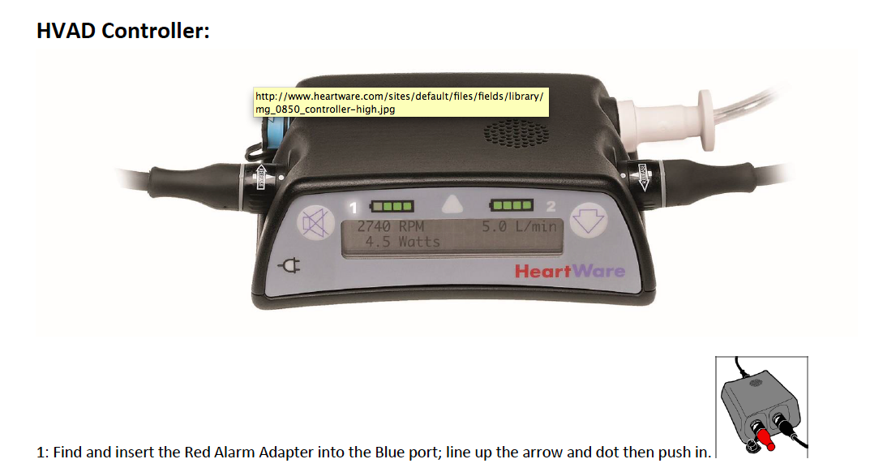
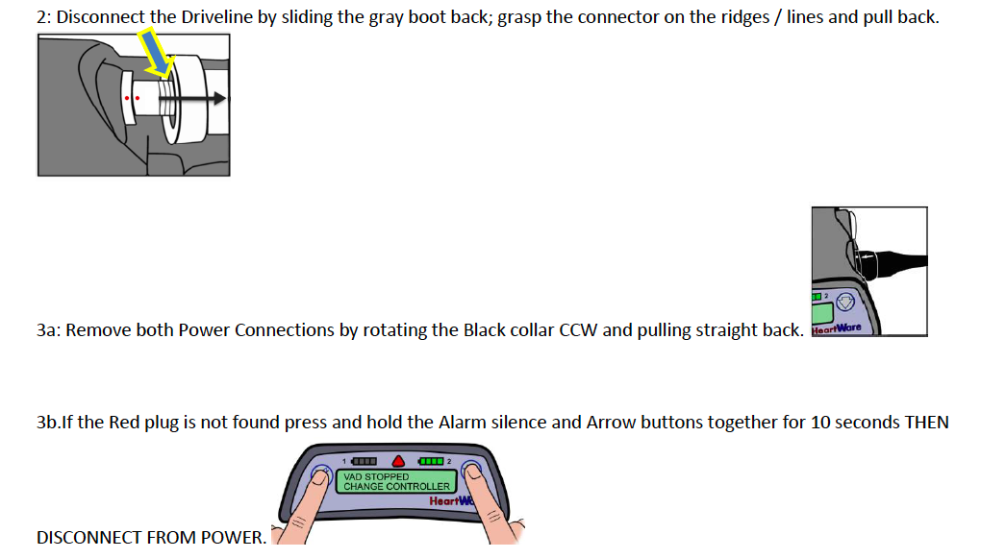

Disclaimer: The ACTION network is focused on quality improvement efforts such as harmonizing best practice protocols, disseminating them among institutions, and helping centers to improve care practices at the local level. This protocol was developed as a consensus tool for pediatric VAD programs. The information in the protocols are based on center practices, individual opinions, experiences, and, where available, published literature. Centers may choose to adapt this protocol to include in their center-specific protocols with reference to ACTION with the understanding that these are meant as guidelines and not standard of care. (Revised 6/21/19)

