Compassionate Deactivation of
PEDIMAG & CENTRIMAG in Children

ACTION REVISED DATE: 10/07/2024

STEPS FOR POWERING OFF PEDIMAG & CENTRIMAG

- Turn minimal flow limit alarm down to zero
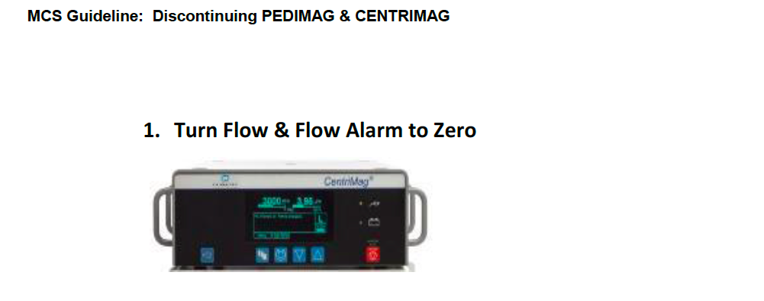

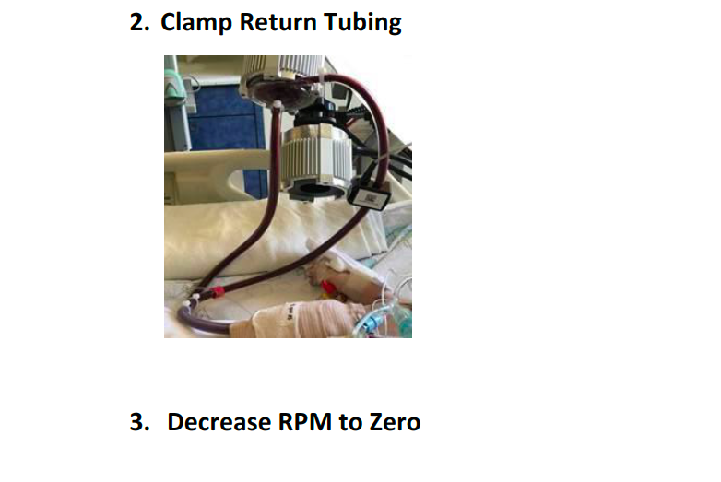

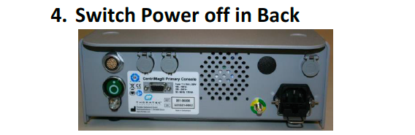

Move the clear door over the green power button and hold for 5 seconds to power off.

Disclaimer: The ACTION network is focused on quality improvement efforts such as harmonizing best practice protocols, disseminating them among institutions, and helping centers to improve care practices at the local level. This protocol was developed as a consensus tool for pediatric VAD programs. The information in the protocols are based on center practices, individual opinions, experiences, and, where available, published literature. Centers may choose to adapt this protocol to include in their center-specific protocols with reference to ACTION with the understanding that these are meant as guidelines and not standard of care. (Revised 6/21/19)

