Evaluation and Management of Protein Losing Enteropathy in Fontan Patients

BACKGROUND
The common endpoint of staged surgical palliation for patients with single ventricle physiology is the Fontan procedure. Approximately 5-12% of Fontan patients will develop protein-losing enteropathy (PLE), characterized by the abnormal intestinal loss of serum proteins. It is a potentially devastating disease with 5-year mortality reported as high as 50% after diagnosis. Although the exact cause of PLE is incompletely understood, abnormal mesenteric resistance, chronic systemic and enteral inflammation, derangement of the lymphatic circulation, and abnormal enterocyte basal membranes all likely play a role in PLE’s development and progression. The role of abnormal lymphatic anatomy and function is increasingly appreciated. Regardless of underlying pathophysiology, PLE leads to significant morbidity in Fontan patients. Treatment strategies have evolved over time and have variable reported efficacy, contributing to the challenges in management of these complex patients.
ACTION REVISED DATE: 12/12/2024

OBJECTIVES
To offer standardized guidance for evaluation and management of Fontan patients during initial and recurrent episodes of PLE.

PROTOCOL
- Clinical definition of PLE in Fontan patients
Concurrent with the enteric loss of protein, patients with PLE present with a history of edema, abdominal distension (ascites), diarrhea, and/or effusions. Patients may also have reduced linear growth velocity with reduced bone density in chronic cases due to disruption in calcium regulation as well as consequence of steroid therapy. PLE patients may have increased susceptibility to infection due to stool immunoglobulin loss and lymphopenia. Laboratory derangements include hypoalbuminemia and hypoproteinemia. Coagulation abnormalities may also be present due to dysregulation of clotting factors which places patients at additional risk of thromboembolic events. PLE is often a chronic disease with a relapsing and remitting clinical course over time.
Hallmarks of PLE Presentation:
low serum albumin
–
positive stool alpha-1-antitrypsin
–
edema, effusions, ascites, GI symptoms, diarrhea

- Initial evaluation of PLE
Laboratory evaluation |  |  | Diagnostics |  | Invasive imaging and intervention considerations (patient specific)
Blood |  |  | Echocardiogram | Holter monitor | Cardiac catheterization
Albumin | CBC w/diff | LFT | Electrocardiogram | Cardiac MRI | Lymphangiogram
Total protein | BMP w/Mg | +/- ATIII | CXR (AP & Lat) | +/-Venous US | MRI  Interventional radiology
IgG level | INR, PTT | Vitamin D | Abdominal US |  | MRI  Interventional radiology
Urinalysis | Stool alpha-1-antitrypsin |  |  |  | MRI  Interventional radiology
*PLE specific lab work and diagnostic testing should be performed with new diagnosis PLE and then as indicated with recurrence of PLE. Invasive imaging and intervention should be performed on a patient-by-patient basis after initial evaluation.

- Physical Exam
    - height, weight, BMI
    - peripheral edema and/or ascites
    - muscle wasting
    - abdominal distension, hepatomegaly
    - pulmonary exam changes consistent with pleural effusion
  - Laboratory Evaluation
    - Serum albumin
    - Serum total protein
    - Stool alpha-1 antitrypsin level
      - Ideally collected via 24-hour stool collection (gold standard) but consider spot level in patients in whom 24 collection not possible.
    - Complete metabolic profile (CMP) (including serum electrolytes, BUN, creatinine, calcium and magnesium) with inclusion of liver function tests
    - Complete blood count with cell differential (CBC w/diff)
    - Assess for anemia and lymphopenia.
    - Coagulation studies, including INR and partial thromboplastin time (PTT)
    - Serum immunoglobulin G level
    - Serum vitamin D level
    - Pre-albumin level
    - Consider urinalysis, including protein, and urine creatinine
    - Consider anti-thrombin III level with history of thrombosis
  - Diagnostic studies
    - Echocardiogram to assess current function and structures with particular attention to fenestration status, Fontan flow characteristics, pulmonary vein patency, atrial septum restriction, atrio-ventricular valve regurgitation, ventricular function, and ventricular outflow obstruction.
    - Electrocardiogram (ECG) to assess baseline rhythm and serial changes
    - Chest X-ray (CXR) with AP and lateral views to assess for pleural effusion and/or pulmonary edema
    - Abdominal ultrasound (US) with Doppler to assess for ascites, liver size/architecture/vessel flow, spleen, and evidence of portal hypertension
    - Holter monitor to assess baseline rhythm, sinus node dysfunction, occult arrhythmia
    - Consider cardiac magnetic resonance imaging (MRI) to further assess function, Fontan circuit, valve function, potential anatomical obstruction, and collateral burden
    - Consider venous US of upper and lower extremity veins to assess for patency and presence of new narrowing or obstruction
  - Invasive imaging and interventions
    - Cardiac catheterization
      - Measure Fontan pressures, cardiac output, ventricular end-diastolic pressure, and pulmonary vascular resistance, which will help to guide the medical management.
      - Evaluate and possibly treat any anatomic abnormalities that increase pressure in the Fontan pathway, such as baffle obstruction, pulmonary artery stenosis, and aortopulmonary collaterals
    - Consider lymphangiogram
      - MRI lymphangiogram
      - Interventional radiology
  - Lymphatic Intervention
Patients with PLE recalcitrant to medical interventions may be considered for targeted lymphatic system interventions.
The Fontan circulation, with its obligate increase in central venous pressure, is accompanied by increased hepatic lymphatic fluid production. This increased lymphatic volume drains via lymphatic channels that connect to the intestinal lumen, usually the duodenum. In addition, increased hepatic lymphatic fluid production may be accompanied by ascites. Both of these mechanisms may be partly responsible for the development of PLE. Hepato-duodenal lymphatic connections can be visualized by intra-hepatic or intra-mesenteric dynamic contrast MR lymphangiography using gadolinium. The presence of such connections can also be proven by intrahepatic lymphatic injection of iosulfan blue, with confirmation of iosulfan blue entering the duodenal lumen via concurrent endoscopy. These connections can then be embolized using glue injected via a transabdominal approach into the hepatic lymphatic channels; improvement or resolution of PLE has been reported in some patients undergoing this procedure.
“Rerouting” of the innominate vein (which receives thoracic duct effluent) to a lower-pressure cardiac chamber has also been performed in some patients with severe PLE. In such interventions, the innominate vein drainage is diverted to the left atrium, either via direct surgical anastomosis or by transcatheter means using a covered stent. This approach appears to be most effective for patients with high transpulmonary gradients. In practice, this approach is not commonly utilized.
There are no absolute contraindications to lymphatic intervention. These procedures are not widely available at all centers but can play an important role for some patients who have failed all other therapies and may not be ideal candidates for heart transplantation. The following are relative contraindications or patients in whom lymphatic intervention may be less effective:
- Presence of a permanent pacemaker, which may preclude the ability to perform MR lymphangiography. Direct intranodal lymphangiography using iodinated contrast can be performed as an alternative, but is cumbersome
- Inability to hold anticoagulation for several days post-procedure due to severe thrombotic disease (due to requirement for transabdominal puncture for glue administration)
- Pre-existing pancreatic or biliary disease (also due to requirement for transabdominal puncture)
- Patients who have undergone previous thoracic duct embolization or ligation

Lymphatic procedures are not without reported risks. Reported potential complications include transient abdominal pain, hemoperitoneum, transaminase elevation, bile duct spasm/obstruction, radiation-induced skin burns, pulmonary emboli of embolic material (potentially leading to edema or infarct), leg edema, pneumoperitoneum, stroke from embolic material, and uncommonly pancreatitis and/or biliary peritonitis.
  - Expert consultation
    - Dietician to help with initiation of high-protein diet and supplements
    - Hepatology/Gastroenterology with expertise in Fontan population and PLE
    - Electrophysiology (EP) for patient with concern for contributing sinus node dysfunction, arrhythmia and/or significant atrioventricular desynchrony
    - Consider Heart failure/transplant team referral as per ACTION document “Considerations for Advanced Heart Failure Consultation in Fontan Patients”

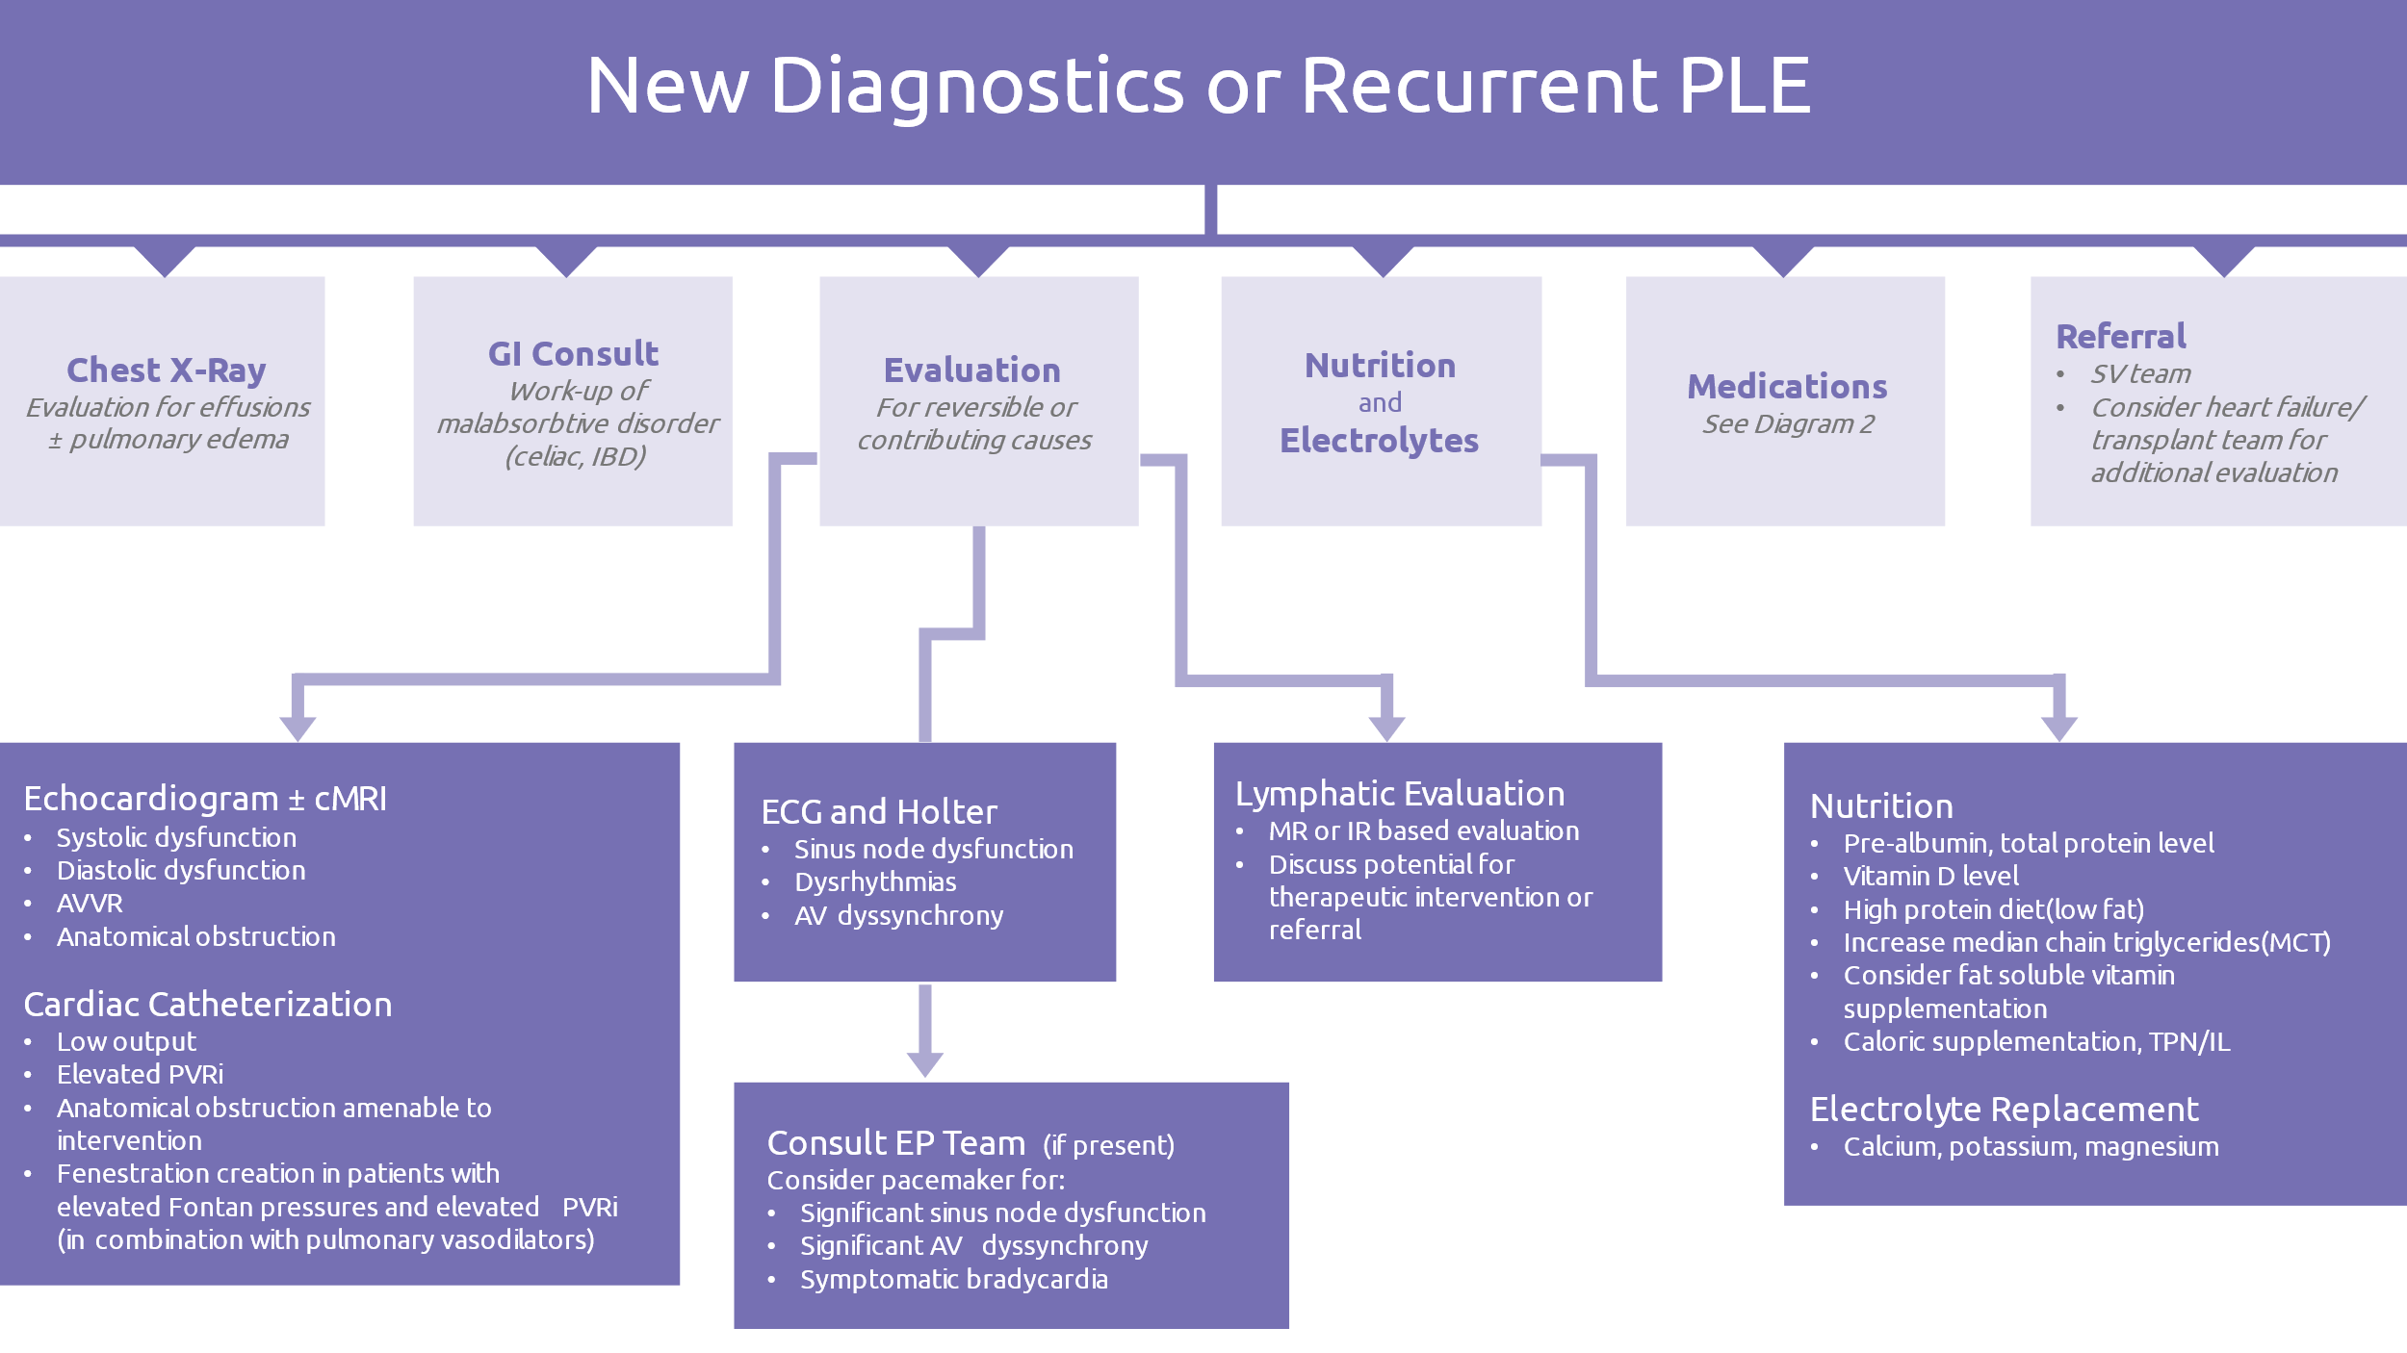

- Management of PLE
Management of PLE includes evaluation for cardiac issues that may be amendable to intervention to optimize Fontan physiology and titration of medical therapy to treat related symptoms. Patients should be evaluated for anatomical lesions that can be treated via cardiac catheterization, dilation/stent of obstruction or embolization of significant collaterals. Patients should also be evaluated for potential venothrombosis given increased risk, particularly in patients with prior history or low ATIII levels. Some patients with identified lymphatic abnormalities may be candidates for lymphatic based interventions. Any rhythm disturbances, such as tachyarrhythmias or bradycardia, should prompt discussion with EP regarding possible anti-arrhythmic or pacing therapy. Medical management focuses on reducing volume overload, improving nutrition, and reduce recurrence. Risk and benefits of potential diagnostic evaluations and treatments presented in this guideline should be discussed in a multi-disciplinary fashion with involvement of the patient and family.
Depending on severity of symptoms and PLE at presentation, patients may require hospital admission for medical therapy, particularly in patients requiring intravenous therapy.

  - Dietary interventions (in consultation with experience dietician)
    - High-protein diet appropriate for age
    - Consider low long chain triglyceride (LCT) diet supplemented with medium chain triglycerides (MCT) may be beneficial if lymphatic abnormalities are contributing to PLE pathophysiology. Decreasing LCT intake theoretically decreases lymphatic flow and pressure which is thought to contribute to decreased losses via gastrointestinal tract. When this therapy is followed, it is crucial to provide adequate LCT, 2-4% of total calories, to prevent essential fatty acid deficiency. A serum triene-to-tetraene ratio can be obtained to assess for essential fatty acid deficiency.
    - Consider supplementation of fat-soluble vitamins in water-soluble forms to account for increased losses via the gastrointestinal tract.
    - In severe refractory cases, may require period of bowel rest and concurrent total parental nutrition (TPN) support
    - Discuss with team (including cardiac catheterization and interventional radiologist) referral for lymphatic intervention
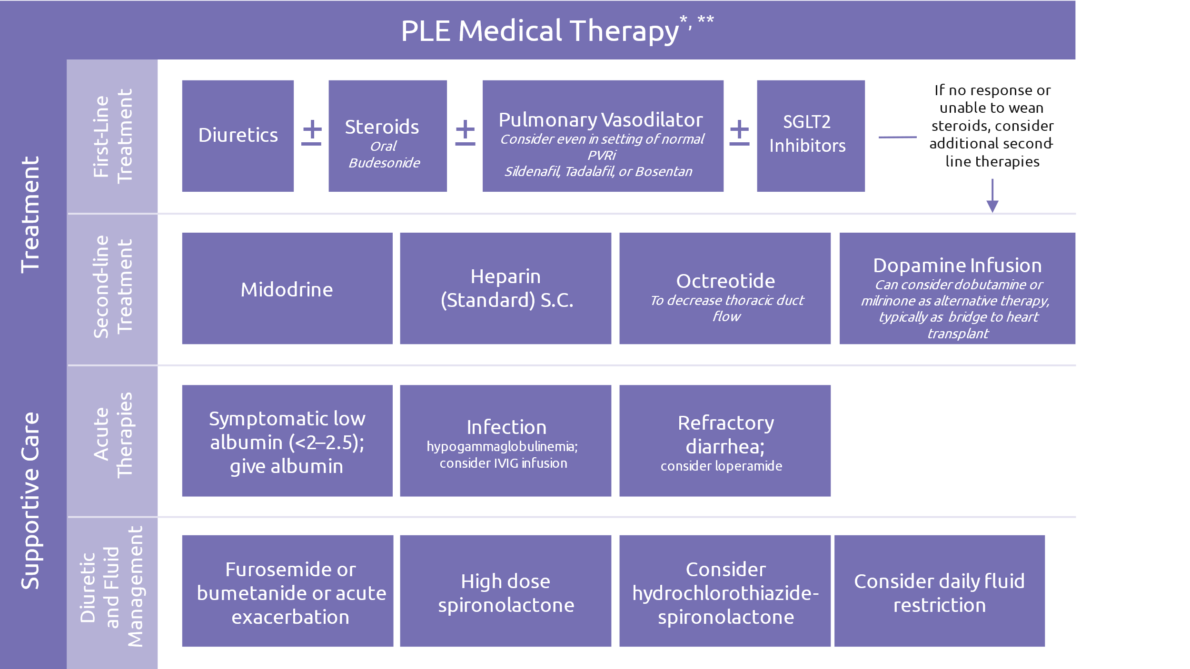
  - Medications

*See suggested dosing in table below. If patient does not respond to first line therapy, discuss second-line therapy treatment strategy with advanced heart function support team.
**Anticoagulation note: Warfarin levels may be affected by albumin infusions given changes in protein bound drug amounts. Caution should be applied in adjusting warfarin dosing in patients on warfarin receiving intermittent albumin infusions.

Medication | Dosing Recommendations | Implications of therapy/clinical pearls
Albumin¹ | - 1-4g/kg/d divided every 4-6 hours with a goal of increasing serum albumin to ≥3 g/dL. | - Use 25% product  - Follow albumin infusion with administration of diuretic such as loop diuretic  - Central access not required
Aspirin | Daily 81mg po dosing | - Due to increased thrombosis risk  - If thrombosis, consider change to SQ LMWH or warfarin
Budesonide | Oral delayed release capsule:  - Children less than 7 years: starting dose 6 mg once daily^{2,3}  - Children greater than or equal to 7 years: starting dose 9 mg once daily or 3 mg Q8H^{4,5} | - Consider “pulse” steroid course of 3-5 days with first or mild PLE episode (some patients may require longer term therapy with taper)  - If prolonged therapy: after clinical improvement and albumin greater than 3 g/dL for at least 1-3 months, then consider wean over several weeks to 3 mg once daily or every other day with goal albumin greater than 2.5 g/dL. Consider completely tapering off in patients after augmenting other therapies and/or with significant side effects.  - Prolonged therapy increases risk of acquired adrenal insufficiency.
Dapagliflozin (or Empagliflozin) | <50kg:  Dapa 0.1mg/kg/dose daily  ≥50Kg:  Dapa 5-10mg (max 10mg) daily  Empa 5-10mg (max 10mg) daily | - Mixed report of efficacy for PLE but widely used as first line clinically  - Possible side effects of UTI and/or peritoneal infections  - SGLT2i must be held at least 24-72 hours prior to planned NPO to avoid risk of ketoacidosis
Dopamine⁶ | IV: 3-5 mcg/kg/min starting dose | - May provide benefit outside of improving cardiac function, chronotropy and/or mesenteric blood flow
Dobutamine | IV: 0.5-1 mcg/kg/min starting dose | - Often used as bridge to heart transplant
Furosemide | - IV: 0.5-2mg/kg/dose children, 20-40mg adolescents starting dose  - PO: 0.2-2mg/kg/dose children, 20-40mg adolescents  - Q6-24 hour dosing  - 2 mg/kg/day reported in PLE (route unspecified)⁷ | - Titrate dose and frequency to effect. Gradually decrease frequency and dose to minimal effect dose.
Heparin (UFH)^{8,9,10} | SQ: 5000 units/m2/day divided BID | - Long term administration (greater than 6 months) can cause bone loss/softening due to a reduction in bone mineral density  - Discontinue therapy if no response after trial of 2-3 months  - If titrating higher than recommended dosing, consider obtaining UFH level 6 hours after dose given  - LMWH does not appear to have the same efficacy/benefit that UFH does for these patients  - Contraindicated in patients with recent significant bleeding
IVIG¹¹ | IV: 1g/kg/dose every 4 weeks  *consider higher doses and/or more frequent administration in patients with very low IgG levels | - Consider dose adjustment for obesity (Ideal or adjusted body weight)  - Some patients experience infusion site discomfort with peripheral infusion
Loperamide | - Use in children less than2 years generally not recommended  - Use age and weight specific dosing | - One case report of use in an adult patient¹²  - Use lowest effective dose for shortest duration  - Use for PLE beyond 1 month has not been described
Midodrine | Children: starting dose ~0.2 mg/kg/day PO divided TID¹³  Adolescent/adult: starting dose 2.5 mg PO two to three times daily¹³  Maximum dose: 10 mg PO TID | - CHCO non-formulary medication  - Monitor for supine hypertension and bradycardia
Milrinone | IV: 0.25-0.5 mcg/kg/min starting dose | - Caution/adjust dose for renal impairment  - Often used as bridge to heart transplant
Octreotide | - continuous IV: 1-2 mcg/kg/hour  - IM LAR depot: 10-20 mg monthly reported¹⁴  - IM immediate release: 50 mcg TID reported¹⁴ | - After continuous IV initiation, may convert to subcutaneous injections  - May cause hyperglycemia, hypoglycemia, hypothyroidism, cholelithiasis  - Cardiac side effects: bradycardia, QT prolongation  - Caution/dose adjustment in patients with hepatic impairment
Sildenafil | Infants and children:  - Starting dose: 0.5 mg/kg/dose PO every 6 hours reported¹⁵  - Maximum dose: 1.5 mg/kg/dose PO every 6 hours reported¹⁵  - Maximum total daily dose: 60 mg PO  Adolescents and adults greater than 45 kg:  - Starting dose: 10 mg PO every 8 hours | - Titrate to goal dose over several days  - If no improvement within 3+ months, wean off
Spironolactone^{16,17,18} | PO/NG/G-tube: 4-6 mg/kg/day divided BID | - Consider transition to eplerenone if gynecomastia develops  - Periodic serum potassium checks necessary
Tadalafil | 0.5-1 mg/kg/dose once daily. Maximum dose is 40 mg (if tolerated) | - Consider as alternative for sildenafil with once daily dosing in older patients

- Chronic PLE management
PLE in Fontan patients is often punctuated by exacerbation episodes with or without chronic symptoms. These patients require close monitoring for early intervention and medical optimization. PLE also places Fontan patients at increased risk for non-cardiac sequela which treating providers must be aware of. In some patients, severity and frequency of symptoms prompts referral for heart transplantation. In general, early referral to the heart transplant team is preferred.
  - Clinic visits
    - Every 6 months for patients with quiescent PLE
    - More frequently for patients with active PLE with consideration of escalation of treatment at each visit
  - Laboratory evaluation
    - Every 3-6 months early after diagnosis and then at least annually: BMP, Magnesium, LFTs, CBC, albumin, total protein
  - Diagnostic testing (in addition to routine cardiac testing for Fontan population
    - Consider DEXA-bone scan bi-annually in patients at high risk for or with prior h/o osteopenia

REFERENCES
- Rychik J, Atz AM, Celermajer DS, et al. Evaluation and management of the Child and adult with Fontan circulation: a scientific statement from the American Heart Association. Circulation. 2019;140:e234-e284.
- Turner Z, Lanford L, Webber S. Oral budesonide as a therapy for protein-losing enteropathy in patients having undergone Fontan palliation. Congenit Heart Dis. 2012 Jan-Feb;7(1):24-30.
- Thacker D, Patel A, Dodds K, et al. Use of Oral Budesonide in the Management of Protein-Losing Enteropathy After the Fontan Operation. Ann Thorac Surg. 2010 Mar;89(3):837-842.
- Schumacher KR, Cools M, Goldstein BH, et al. Oral Budesonide Treatment for Protein-Losing Enteropathy in Fontan-Palliated Patients. Pediatr Cardiol. 2011 Oct;32(7):966-971.
- John AS, Driscoll DJ, Warnes CA, et al. The use of oral budesonide in adolescents and adults with protein-losing enteropathy after the Fontan operation. Ann Thorac Surg. 2011 Oct;92(4):1451-6.
- Friedland-Little JM, Gajarski RJ, Schumacher KR. Dopamine as a potential rescue therapy for refractory protein-losing enteropathy in Fontan-palliated patients. Pediatr Transplant. 2017 Jun;21(4). doi: 10.1111/petr.12925. Epub 2017 Mar 30. PMID: 28370952.
- Mizuochi T, Suda K, Seki Y, et al. Successful diuretics treatment of protein-losing enteropathy in Noonan syndrome. Pediatr Int. 2015 Apr;57(2):e39-41.
- Donnelly JP, Rosenthal A, Castle VP, et al. Reversal of protein-losing enteropathy with heparin therapy in three patients with univentricular hearts and Fontan palliation. J Pediatr. 1997 Mar;130(3):474-8. doi: 10.1016/s0022-3476(97)70214-2. PMID: 9063428.
- Ryerson L, Goldberg C, Rosenthal A, et al. Usefulness of heparin therapy in protein-losing enteropathy associated with single ventricle palliation. Am J Cardiol. 2008 Jan 15;101(2):248-51. doi: 10.1016/j.amjcard.2007.08.029. PMID: 18178416.
- Bendayán I, Casaldaliga J, Castelló F, et al. Heparin therapy and reversal of protein-losing enteropathy in a case with congenital heart disease. Pediatr Cardiol. 2000 May-Jun;21(3):267-8. doi: 10.1007/s002460010055. PMID: 10818189.
- Zaupper LB, Nielsen BW, Herlin T. Protein-losing enteropathy after the total cavopulmonary connection: impact of intravenous immunoglobulin. Congenit Heart Dis. 2011 Nov-Dec;6(6):624-9. doi: 10.1111/j.1747-0803.2011.00568.x. Epub 2011 Oct 20. PMID: 22010984.
- Windram JD, Clift PF, Speakman J, et al. An unusual treatment for protein losing enteropathy. Congenit Heart Dis. 2011 May-Jun;6(3):253-6.
- Weingarten AJ, Menachem JN, Smith CA, et al. Usefulness of midodrine in protein-losing enteropathy. J Heart Lung Transplant. 2019 Jul;38(7):784-787.
- John AS, Phillips SD, Driscoll DJ, et al. The use of octreotide to successfully treat protein-losing enteropathy following the Fontan operation. Congenit Heart Dis. 2011 Nov-Dec;6(6):653-6. doi: 10.1111/j.1747-0803.2011.00518.x. Epub 2011 May 5. PMID: 21545466.
- Uzun O, Wong JK, Bhole V, Stumper O. Resolution of protein-losing enteropathy and normalization of mesenteric Doppler flow with sildenafil after Fontan. Ann Thorac Surg. 2006;82:e39–e40.
- Ringel RE, Peddy SB. Effect of high-dose spironolactone on protein-losing enteropathy in patients with Fontan palliation of complex congenital heart disease. Am J Cardiol. 2003 Apr 15;91(8):1031-2, A9. doi: 10.1016/s0002-9149(03)00135-8. PMID: 12686359.
- Okano S, Sugimoto M, Takase M, et al. Effectiveness of High-dose Spironolactone Therapy in a Patient with Recurrent Protein-losing Enteropathy after the Fontan Procedure. Intern Med. 2016;55(12):1611-4. doi: 10.2169/internalmedicine.55.6303. Epub 2016 Jun 15. PMID: 27301514.
- Grattan MJ, McCrindle BW. Recurrent exacerbations of protein-losing enteropathy after initiation of growth hormone therapy in a Fontan patient controlled with spironolactone. Congenit Heart Dis. 2010 Mar-Apr;5(2):165-7. doi: 10.1111/j.1747-0803.2009.00320.x. PMID: 20412490.

AUTHORS
Kathleen Simpson, MD & Matthew O’Connor, MD

CONTRIBUTING CENTERS
Children’s Hospital Colorado, Children’s Hospital of Philadelphia, Monroe Carell Jr. Children's Hospital, Boston Children’s Hospital, Stollery Children’s Hospital, Phoenix Children's Hospital, Cincinnati Children’s Hospital, Johns Hopkins Health System, C.S. Mott Children’s Hospital, Children’s Hospital of Wisconsin, & The Hospital for Sick Children

Disclaimer: The ACTION network is focused on quality improvement efforts such as harmonizing best practice protocols, disseminating them among institutions, and helping centers to improve care practices at the local level. This protocol was developed as a consensus tool for pediatric VAD programs. The information in the protocols are based on center practices, individual opinions, experiences, and, where available, published literature. Centers may choose to adapt this protocol to include in their center-specific protocols with reference to ACTION with the understanding that these are meant as guidelines and not standard of care. (Revised: 04/12/2022)

