Fitness Assessment and Promotion in
Pediatric Heart Failure: Stable Post-VAD
and Heart Failure

BACKGROUND
Due to disease severity in children and young adults with heart failure, patients are at risk for deconditioning and associated morbidity and mortality. Assessing the severity of deconditioning or frailty in children and young adults can be difficult due to lack of standardized assessment tools or guidelines. How to safely encourage and manage rehabilitation and exercise in these patients with heart failure, including VAD, is also challenging.

ACTION REVISED DATE: 03/06/2024

OBJECTIVES
Standardize physical fitness assessment and promotion in children and young adults with heart failure and stable ventricular assist device (VAD) support to maintain or improve functional fitness.

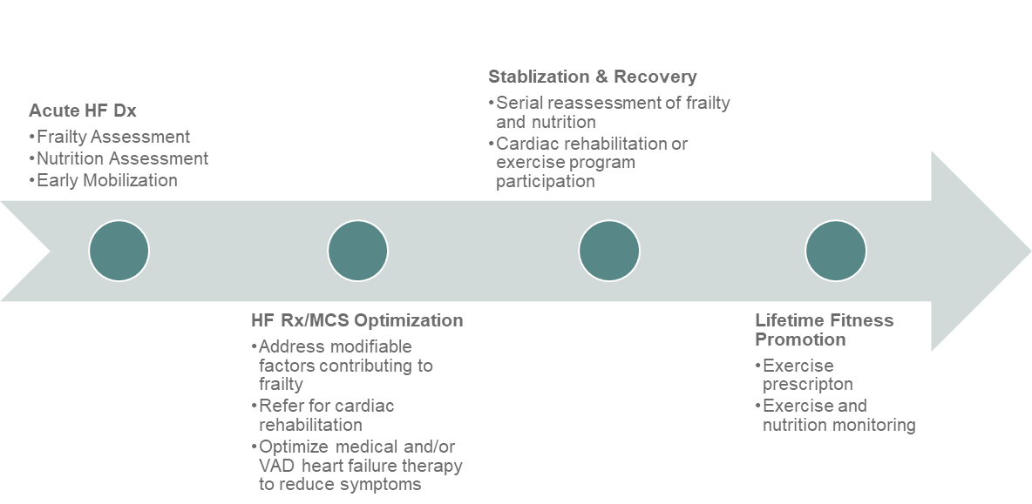
PROTOCOL

Section 1: Frailty Assessment

Frailty refers to the multisystem physiologic reserve and vulnerability to stressors and poor health outcomes. Frailty and poor fitness may compromise the success of advanced heart failure therapies.¹ Frailty consists of multiple components, and we present the following suggested framework (including suggested metrics that each have normative values in the pediatric population) recognizing the need for further validation in pediatric heart failure patients*:

1. Muscle Mass Assessment
a. Mid-upper arm circumference (cm)
b. Lean body mass (kg) per dual X-ray absorptiometry (DXA) or bioelectric impedance analysis (BIA)

2. Strength Assessment
a. Hand grip strength (kg) per hand grip dynamometer
-Recommended for ages ≥ 6 years old using published reference values (see table)

3. Speed and Sub-maximal Aerobic Capacity Assessment
a. Six-minute walk test distance (m)
b. Two-minute walk test distance (m) (if cannot complete 6MWT)
-Can be performed as 3 years old with published reference values (see table)
c. Aerobic capacity assessment (CPET)
-For older patients (typically ≥7) with ability to perform more strenuous exercise assessment (described in Section 2)

4. Fatigue
a. Patient and parent reported per questionnaires
-PedsQL Fatigue Scale (includes pediatric and adult versions)
-Parent report available as young as 2 years old
-Patient report available as young as 5 years old

5. Functional Status
a. Patient-reported per questionnaire: Pediatric Physical Activity Questionnaire (PAQ)
i. PAQ-A Scale (age 14-20 years old)
ii. PAQ-C Scale (age 8-14 years old)
b. Device based assessments per accelerometry (either validated, research-grade accelerometer or commercially available devices such as Apple Watch or FitBit)
c. Provider-assigned
i. 5-15 years: Lansky Play-Performance Scale
ii. >15 years: Karnofsky Performance Scale (KPS)
d. Early mobility assessment tool (Boston AmPAC) – gauges independence with basic mobility skills in the early stages of a VAD and identify when a patient is now ‘functional’ to return to more vigorous exercise.

*Assessment of each Frailty component as being normal or abnormal should include use of normative z-score values when appropriate (with abnormal being outside ± 2 z-scores) or published normative cut-offs for questionnaires and scales.

Specific Frailty Metric Instructions

Mid-upper arm circumference (MUAC) can easily be measured and normalized using z-score tape One such tape is manufactured by Abbott with instructions shown below.

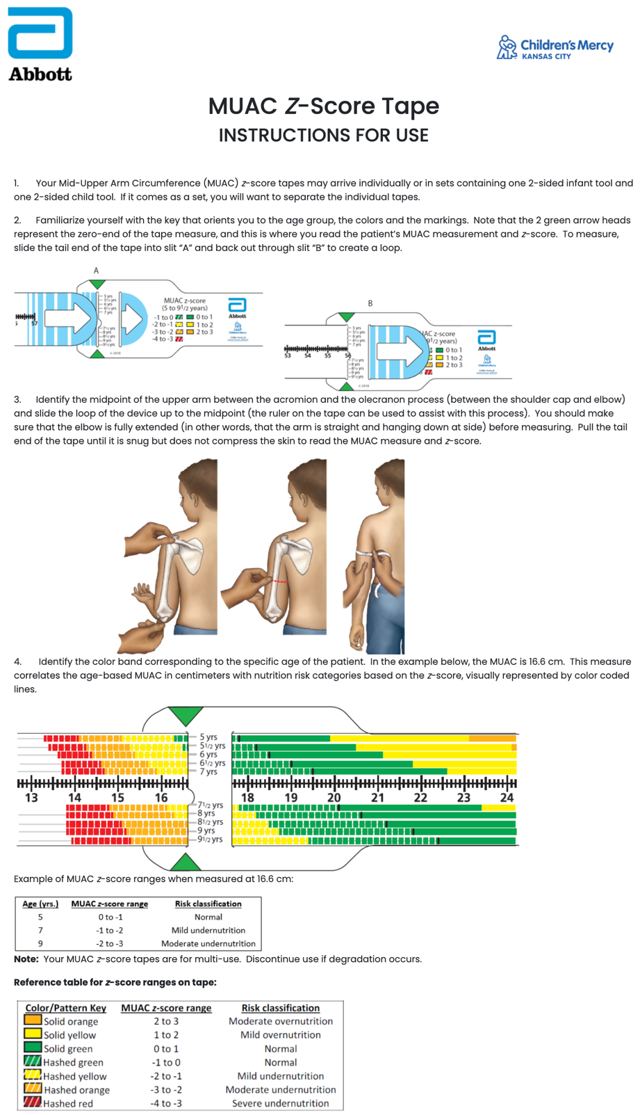
There are tapes for age ranges 2-23 months, 24-59 months, 5-9 years, and 10 to 18 years.

Link to instructional video by Abbott Nutrition Health Institute:
https://anhi.org/resources/podcasts-and-videos/muac

Website to auto-calculate MUAC z-score: https://peditools.org/cdcmuac/

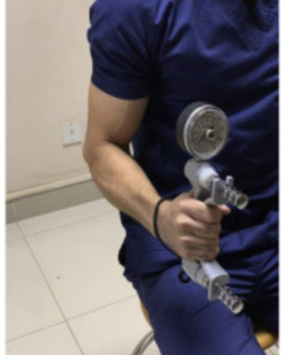
Hand grip strength can be easily measured with use of a handgrip dynamometer. A medical grade digital or hydraulic dynamometer (e.g., Jamar) set at the second position is used. The dominant hand is ascertained (i.e., right-handed vs. left-handed). As initially recommended by the American Society of Hand Therapy and later described in the NIH Toolbox, the patient is instructed to sit in an upright position with shoulders adducted, elbow flexed at 90° and forearms in neutral position^{2,3} as illustrated below.

The patient is encouraged to give their best effort in isometric grip strength, with one repetition for each hand. The test is then repeated for 2 successive trials, alternating between each hand (3 total trials per hand). The average value of the dominant hand is compared to published normative values for children (6-19 years)⁴ and adults.⁵ Because weak and frail patients can fatigue easily on this test, it is reasonable to use the maximum value of the dominant hand. Ideally, a center should be consistent in whether the average value or maximum value of the dominant hand is used.

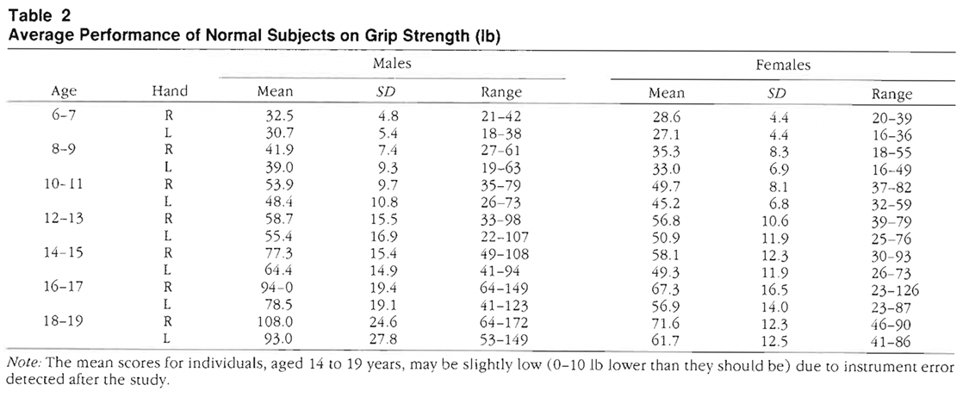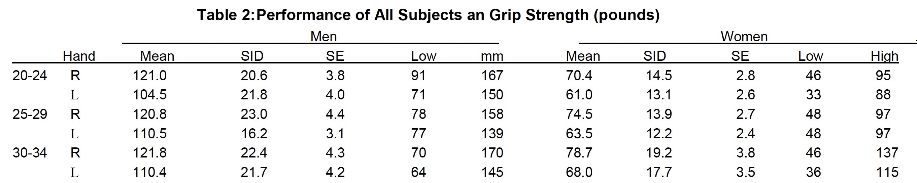
The six-minute walk test (6MWT) is a feasible and standardized measure of gait speed and endurance that has been classically part of the Frailty assessment in adults and can be performed in most children. The distance covered in meters is compared to published normative values (Klepper et al).

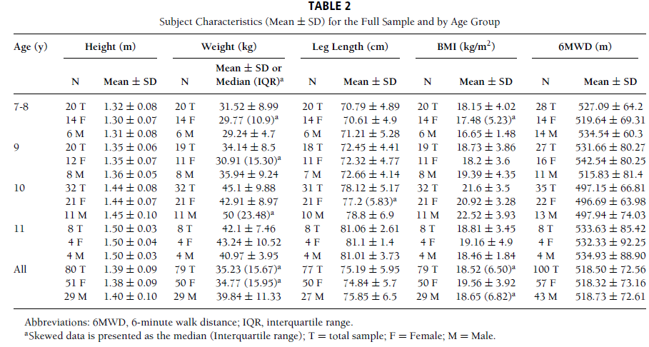

The two-minute walk test (2MWT) is a feasible and standardized measure of gait speed and endurance. For younger patients, the 2MWT distance is highly correlated to the classic six-minute walk test and has the advantage of a higher completion rate. For these reasons, the 2MWT is preferred by the NIH as the standard motor function tool for gait and may an option for younger patients (3-8 years old) or patients who cannot perform the 6MWT. Instructions for standardized 2MWT execution are included in the NIH Toolbox⁶ (https://www.youtube.com/watch?v=8ysD6YdhNjY). The distance covered in meters is compared to published normative values for children⁷ and adults (>17 years).⁸

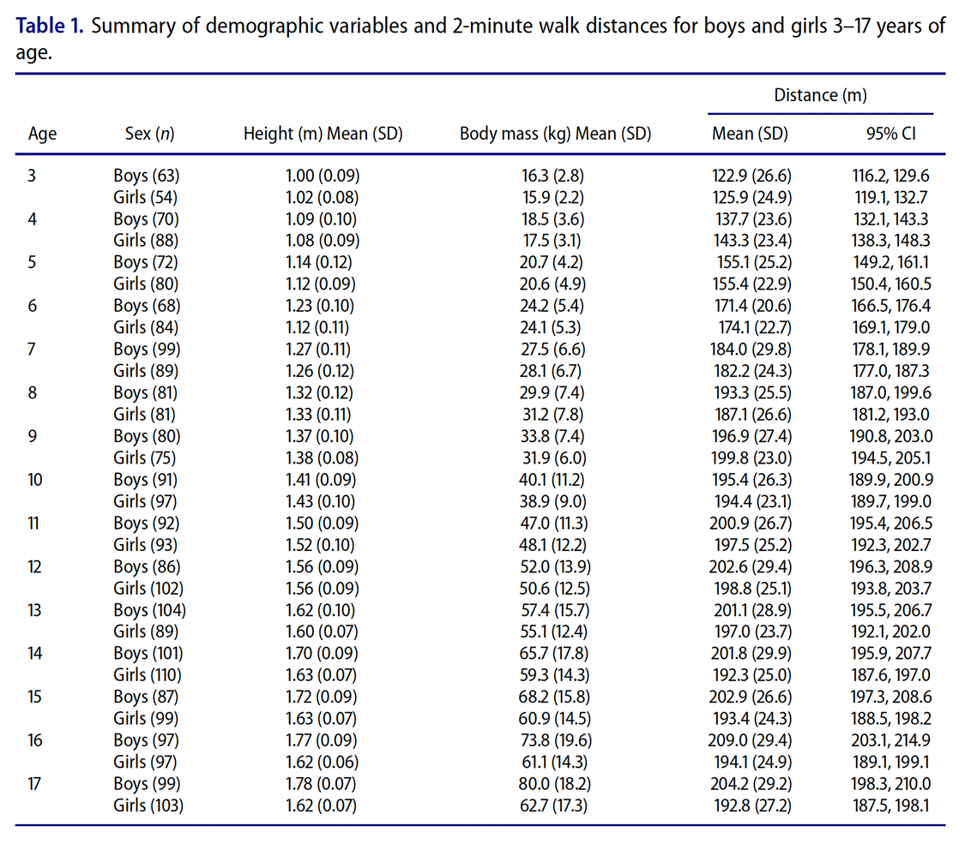
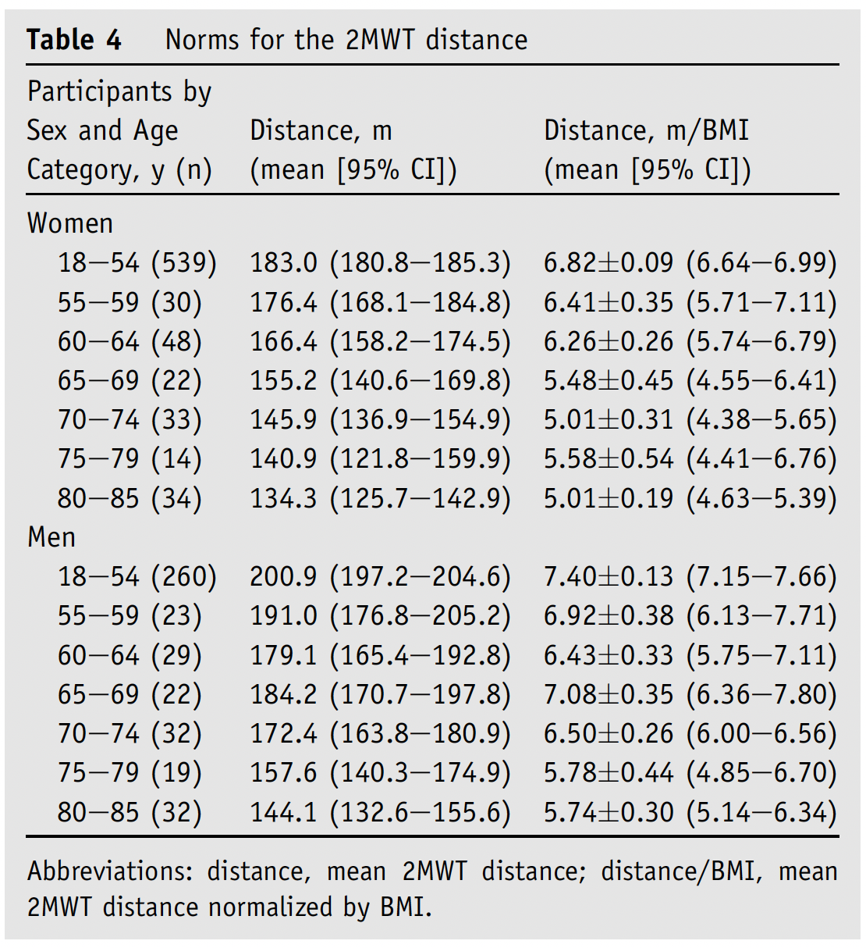
Distance SD = 32.8 m for Men, and 30.1 m for Women

Functional status can be measured with a validated scale commonly used in pediatric chronic disease. The Lansky Play Performance Scale (LPPS)⁹ and the analogous Karnofsky Performance Scale (KPS)¹⁰ for older adolescents and adults have been used for decades in various studies and registries including the UNOS database. The scale is summarized in the table below.

For fitness scoring in this domain, a suggested system is to assign 0 points if the value is 80-100 (not significantly limited), 1 if 50-70 (mild to moderate restriction), or 2 points if 10-40 (moderate to severe restriction).

Section 2: Exercise Training
VAD Exercise Training Tips to Avoid Adverse Events
- Individualized exercise assessment and prescription
- Pre-screening with risk stratification
- Prolonged graduated warm-up and cool-down
- Low-to-moderate intensity exercise training
- Avoid breath hold and Valsalva maneuver
- Avoid trauma
- Adapt for co-morbidities
- Monitor training by exercise physiologist or physical therapist familiar with VAD
- Keep the feet moving during active recovery
- Monitor patients for 15 minutes post-exercise initially
- Make sure VAD driveline is secured
- Follow sternal precautions
Individualized Exercise Training²
- Exercise rehabilitation should occur 2-3x/week at minimum with goal ≥3x/week
- Can occur either inpatient, outpatient, remotely (telemedicine or independent home training)
- Can be performed by exercise physiologist or physical therapist
- Can train with intracorporeal or paracorporeal VADs
- CPET can provide guidance for identifying target heart rate (based on heart rate at anaerobic threshold) or perceived exertion

Assessment Components | Assessment Tools
Aerobic capacity | Cardiopulmonary Exercise Test (CPET)¹  Six Minute Walk Test
Musculoskeletal strength | Maximal voluntary contraction  30 second chair rise  Hand grip dynamometry
Composite | BOT Short Form  Frailty score (future project)
Functional assessment occurs at regular intervals every 4-8 weeks
Refer to “Exercise Training for Early Post-VAD Pediatric Patients” Document:
- Early mobilization post-VAD
- Readiness Checklist for Exercise Training after VAD implant in children
- Approach to Individualized Exercise Training in Early Pediatric VAD Recipients
- VAD Exercise Training Tips to Avoid Adverse Events

Cardiopulmonary Exercise Testing
To determine functional capacity for individualized exercise training prescriptions, maximal cardiopulmonary exercise testing (CPET) should be considered. If feasible, cycle ergometry should used instead of treadmill due to safety and stability of a stationary bicycle, quantification of external work, and minimization of motion artifact, although treadmill can be considered with close supervision for fall risk. Patients may wear an abdominal binder and must have their driveline secured per center protocol to prevent driveline motion and irritation. Initial CPETs are performed after VAD implant based on clinical readiness as determined by the primary care team (protocol minimum 14 days post-implant). A follow-up CPET is performed following completion of the dedicated exercise training and rehabilitation program (individualized exercise training protocols developed based on baseline CPET as described below).
The CPET includes continuous heart rate and rhythm monitoring. VAD parameters are also continuously monitored throughout exercise and recovery. Metabolic and ventilatory data are assessed on a breath-by-breath basis using a metabolic cart. Parameters collected (Table) are measured at maximal exercise and at the ventilatory anaerobic threshold (VAT), including minute oxygen consumption (VO2), minute carbon dioxide production (VCO2), minute ventilation (VE), work rate (Watts) and the respiratory exchange ratio (RER). Methods for calculating the VAT are based on the V-slope and the ventilatory equivalents methods. Maximal tests are defined based on RER > 1.10, among other measures including heart rate response and subjective assessment of exertion (rate of perceived exertion, RPE) by the patient via a Borg scale. Normative values for the primary outcome variables have been published.¹¹ Doppler blood pressure and VAD monitor can be monitored at rest and peak exercise.

Table. Primary outcome variables during symptom-limited CPET for VAD recipients

 | Rest | Anaerobic Threshold | Maximal  Exercise
Heart Rate (bpm) | X | X | X
VAD Flow (L/min) | X | X | X
Work Rate (watt) |  | X | X
Indexed VO2 (mL/kg/min) Unindexed VO2 (L/min) |  | X | X
Pulsatility Index | X | X | X
Oxygen Saturation* | X | X | X
Doppler MAP | X |  | Optional
*oxygen saturation via pulse oximeter may have inconsistent measurement on continuous-flow devices

Target Heart Rate (HR)

The target HR range during exercise depends on the individual patient’s physiology, including health of the conduction system and prescribed chronotropic medications, which is summarized as the heart rate reserve (HRR), as well as the desired training intensity. The HRR is calculated by subtracting the resting HR from the maximal HR during the baseline CPET. The target HR ranges can then be calculated as such:

Target HR Range for Light Intensity Aerobic Exercise = (Maximal HR – Resting HR) x 0.5 to 0.6 + Resting HR

Target HR Range for Moderate Intensity Aerobic Exercise = (Maximal HR – Resting HR) x 0.6 to 0.75 + Resting HR

Target HR Range for High Intensity Aerobic Exercise = (Maximal HR – Resting HR) x 0.75 to 0.9 + Resting HR

For example, a patient with a resting HR of 60 and maximal of HR 160 bpm would have a moderate intensity target HR range of 120 to 135 bpm based on this calculation:
(160-60) x 0.6 + 60 = 120 bpm
(160-60) x 0.75 + 60 = 135 bpm

Rate of Perceived Exertion (RPE)

The Borg scale is an example of an RPE scale. Such scales are useful when the target HR ranges are not known. Then can also be used to empower the patient to better assess their own exercise performance. In the example below, green indicates low intensity, yellow indicates moderate, and orange indicates high intensity exertion.
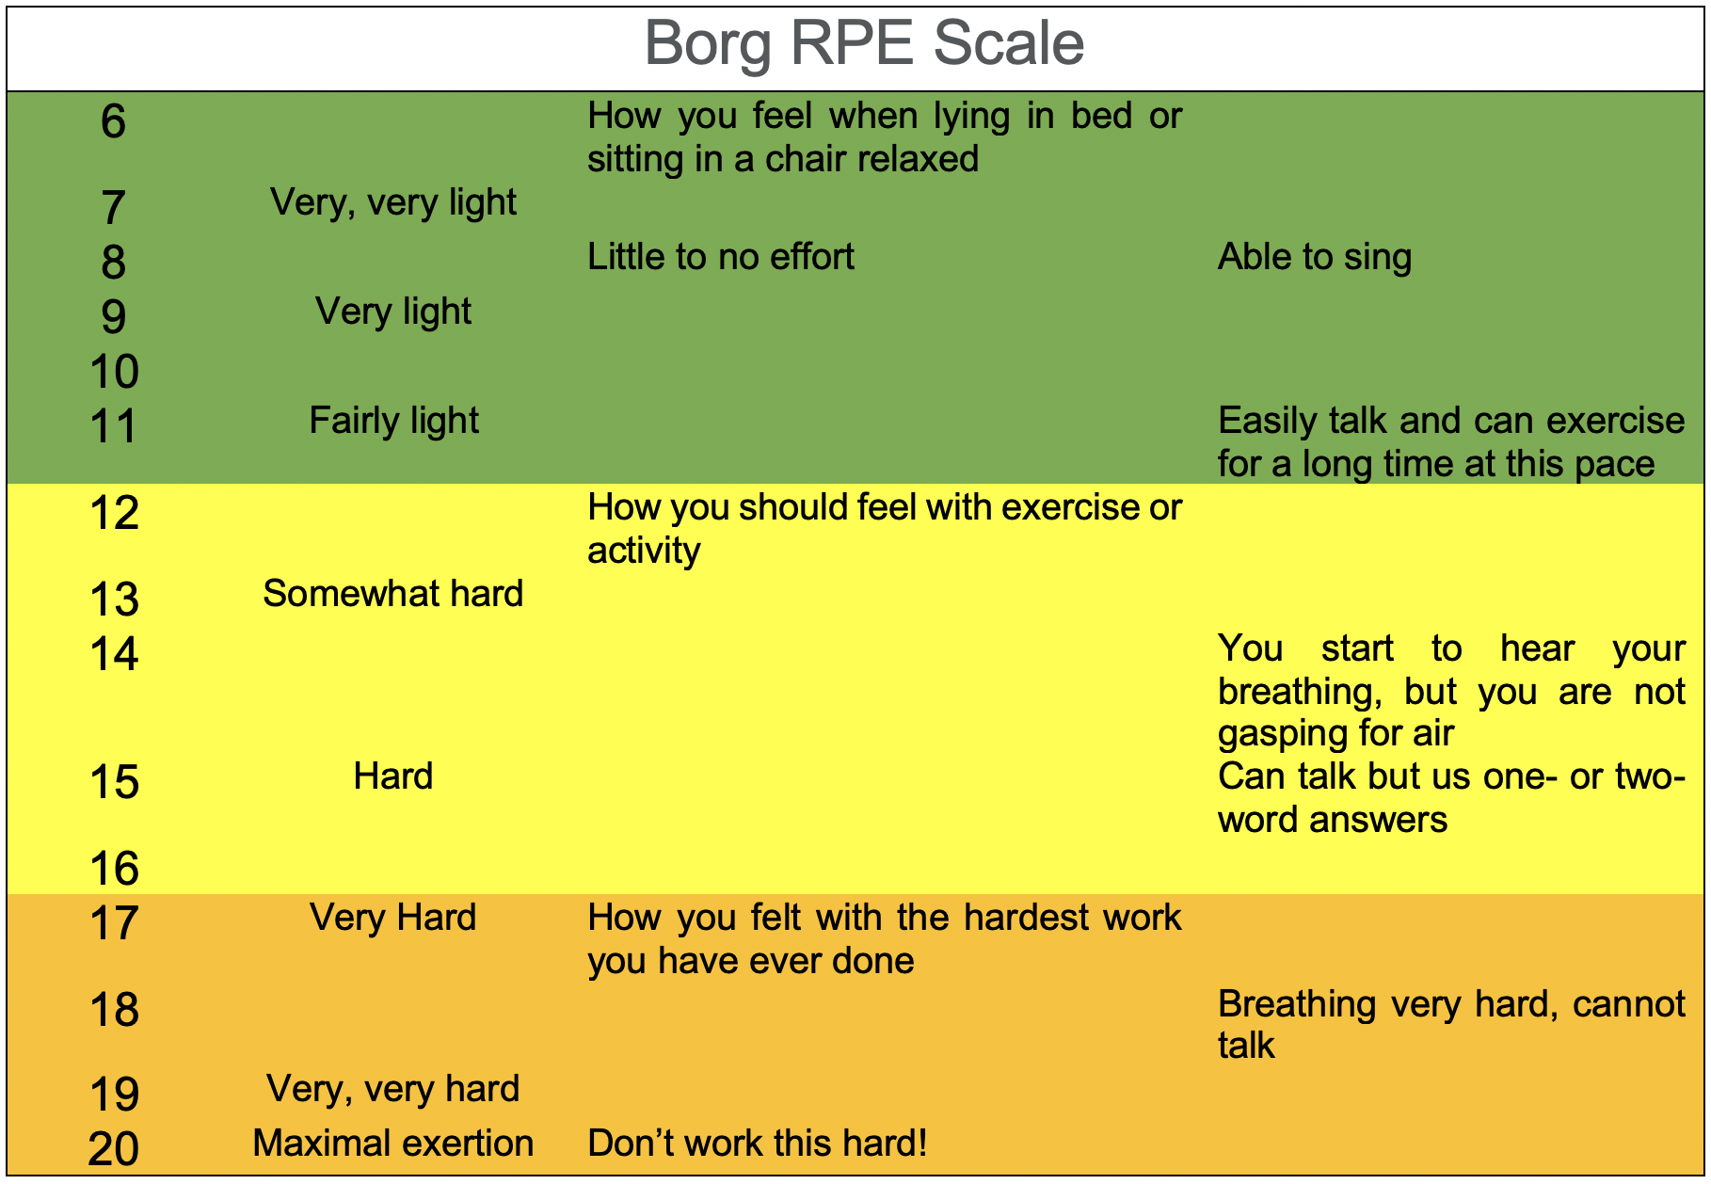

The OMNI scale is another useful RPE scale. An example is shown below.

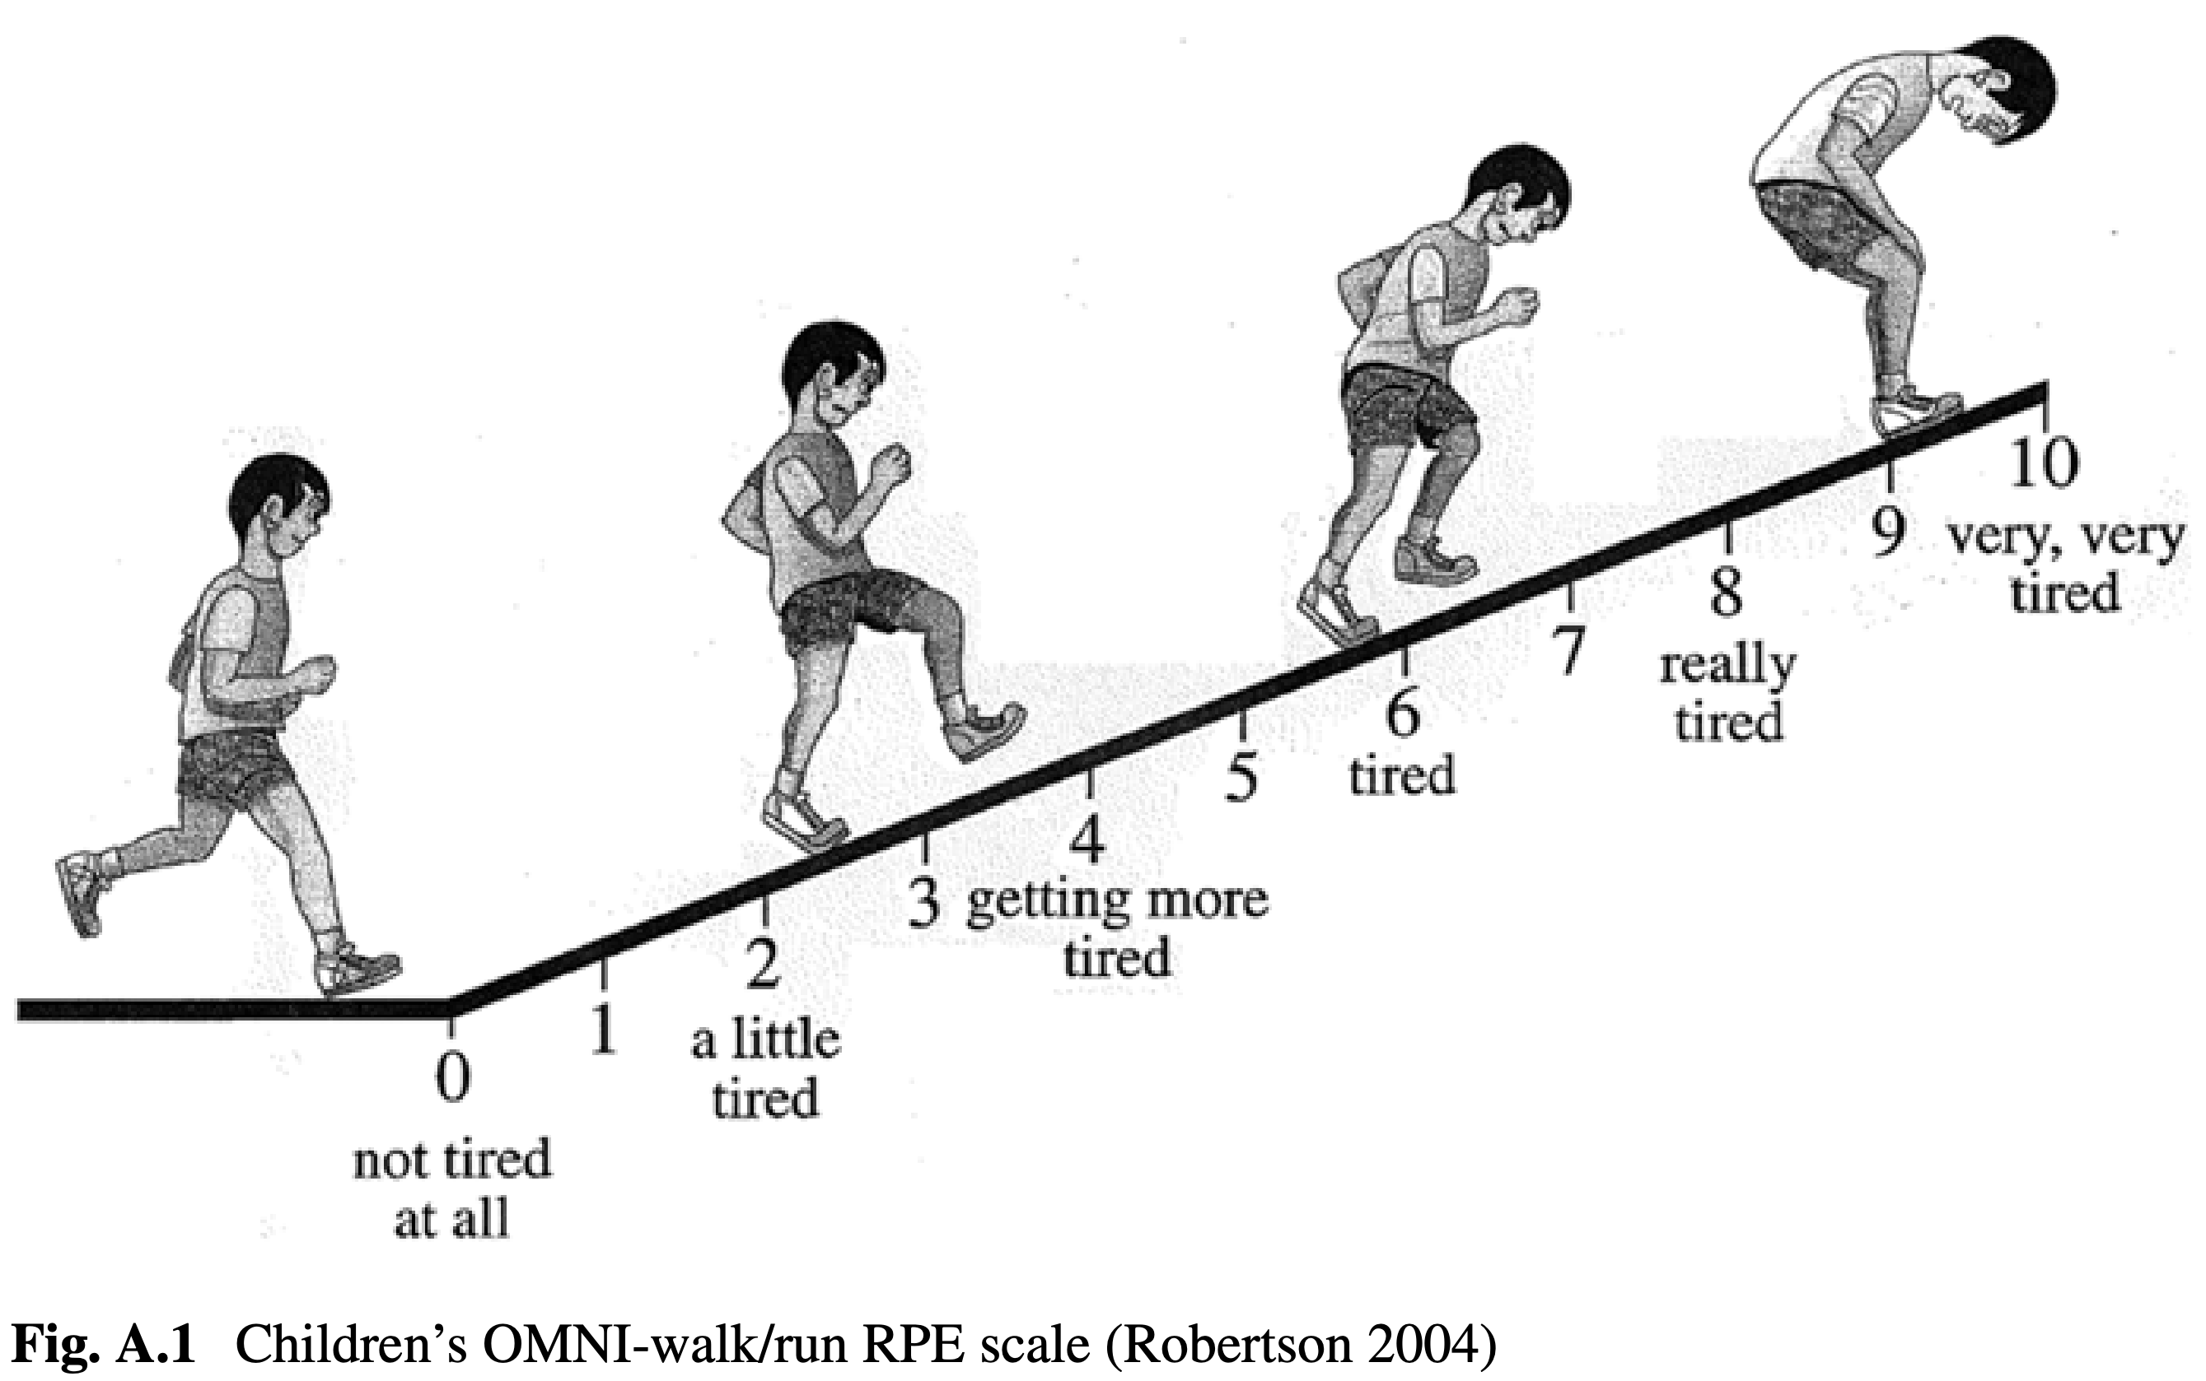
Individualized Exercise Training Late after VAD Implant or Stable Heart Failure

Prescribed exercise therapy can be supervised by a PT or exercise physiologist depending on center resource availability and setting. When developing individualized exercise training (ET) recommendations for children with VADs, the baseline CPET provides valuable guidance by assessing for evidence of exercise-induced symptoms, arrhythmia, ischemia, or abnormal hemodynamic response, and to establish a baseline level of fitness. Furthermore, target heart rate during ET is based on submaximal and maximal CPET parameters. Specifically, the target heart rate range for moderate intensity exercise is calculated from the heart rate at the VAT or the desired perceived exertion.
ET can occur during inpatient, outpatient or home-based sessions (after initial stabilization and demonstration of adequate knowledge on how to safely perform exercises). ET should aim to incorporate developmentally appropriate play-based activities as much as possible to maintain patient engagement. ET consists of two to three sessions per week, lasting from 30-60 minutes. Sessions include aerobic and musculoskeletal conditioning and are performed under the guidance of a pediatric cardiac exercise physiologist. Each session begins with a 10- to 15-minute warm-up period using either cycle ergometry or treadmill walking. Level of exertion is maintained at the heart rate at VAT determined during baseline CPET.
After the warm-up, patients perform musculoskeletal conditioning consisting of play-based therapy or circuit training of resistance exercises depending on the developmental level of the patient for a period of 15 minutes. Resistance exercises concentrate on either upper extremity and torso strengthening (biceps, triceps, shoulder, back and abdominal muscles) or lower extremities (quadriceps, hamstring, and calf muscles). For older children, musculoskeletal training intensity is maintained at 60% of pre-training one repetition maximal voluntary contraction. Patients are instructed to perform one repetition every 3 to 4 seconds, with a goal of 15 repetitions performed in one minute. Patients are instructed regarding the correct lifting and breathing technique to avoid the Valsalva maneuver. Sessions end with a 10- to 15-minute cool-down period, again using either cycle ergometry or treadmill walking while maintaining heart rate at VAT.

Example exercise videos can be accesses via: Hep2go.com
-Users can set up free account and search exercises for video examples

Exercise Rehabilitation Example (Inpatient or Outpatient)
Weekly Schedule:
 | Monday | Tuesday | Wednesday | Thursday | Friday
Aerobic Training | Treadmill or Cycle |  | Treadmill or Cycle |  | Treadmill or Cycle
Musculoskeletal Training | Upper body |  | Lower body |  | Both

TREADMILL WORKOUT:
5 minutes @ 2.5-3.0 mph followed by 10 minutes @ 3.5 mph
- Do not let your heart rate go over you target heart rate based on your baseline functional assessment.
- Use the RPE scale to judge your intensity (example Borg scale target: 13 out of 20)
- Take a break if you need to but finish the 15 minutes
- Drink water, stay hydrated!

STRENGTH:
- What you need: Light weights, towel, water
- Try to move through each exercise without taking a break, but if you need a minute for a quick water break that would be fine.
- Do as many as you can using correct form, comfortable weights (no more than 15 lbs.) and BREATHE!!......blow out of your mouth when you move the weight.
- If you struggle with any given weight, put it down, pick up lighter weights and finish the set.
- Stretch arms out again

UPPER BODY
Warm-up
Neck rolls (3 each side holding for 5 seconds each)
Shoulder rolls (10 forward, 10 backward)
Cross hands over in front, put palms together and roll shoulders forward – Hold for 10 sec
Hands clasped together behind back, push hands down to stretch chest
Cross hands over in front, put palms together and roll shoulders forward – Hold for 10 sec
Hands clasped together behind back, push hands down to stretch chest
Small arm circles with palms out, fingers up (15 each direction)
Small arm circles with palms in, fingers down (15 each direction)
Shake arms out

Pick 6 exercises of those listed below (may need modification based on sternal precautions)
Alternate shoulder press: 12-15 reps
Start with weight at shoulder height. Raise weight straight up over head alternating hands.

Standard arm curls: 12-15 reps
Start with arms fully extended down at waist. Raise both weights up to shoulder level keeping elbows in next to chest.

Triceps kick back: 12-15 reps
Start with one foot in front of the other. Bend over at the waist with head up and back flat. Raise weights to side of the chest at the shoulder. Extend weights backward above the level of the back. Pause at the extension and try not to swing the weights.

Two arm shoulder press: 12-15 reps
Same as alternating shoulder press but raising both arms at the same time.

Cross over curls: 12-15 reps
Alternate arms curls but lift weight to opposite shoulder crossing over the chest.

Triceps press: 12-15 reps
Use one arm at a time. Raise weight straight up over head. Then bend at elbow and lower the weight behind your head. Raise weight back up to overhead position keeping elbow pointing straight up.

Upright rows: 12-15 reps
Hold weights down near your waist with straight arms. Raise weights together upward to just below chin. Make sure your elbows are above your hands as you raise the weights to your chin.

Static arm curls: 12-15 reps
Alternate weights in each hand. Perform 4 regular arm curls with one hand while the other hand is holding its weight halfway up. At the 4th rep switch hands with the same technique.

Chair Dips: 12-15 reps
Use a chair with no arms, a bench, or a step. With hands facing forward next to your side, raise yourself up (if using the chair) or dip yourself off the step, then raise yourself upward.

Front and lateral arm raises: 12-15 reps
With a straight arm raise weight up to shoulder level. Lower weight then raise weight directly to each side.

Curls: 24 reps
8 curls halfway up, 8 curls halfway down, 8 full curls

Lawnmower:12 reps each arm
One foot forward and bent at the knee, the other foot back and fairly straight. Using one weight in one hand and the opposite forearm resting on your front bent thigh. Start with the weight on the floor and raise it upward toward your armpit keeping your elbow in along the side of your body. The switch hands and legs... this looks like you are starting a lawnmower.

Elbow Out Lawnmower: 12 each arm
Same thing as the regular lawnmower but turn weight in the starting position so your knuckles are facing forward. When you raise the weight you elbow should go outward.

Reverse Grip Bent Over Row: 12 reps
One foot in front of the other with knees slightly bent, head up, and flat back. Hold a dumbbell in each hand with palms facing forward. Raise the weights from close to the floor upward to the side of your chest keeping your elbows in.

Seated Bent Over Fly: 12 reps
Sit at edge of bench, bend over, raise weights pulling back and pinching your scapula bones together.

LOWER BODY: Perform all 6 exercises listed below

Regular squat: 10 reps
Feet shoulder width apart. Bend at knees to almost a knee angle of 90 degree while keeping head up and back flat. Do not bend at waist…. bend at the knees to lower yourself.

Runner stance squat: 10 reps
Start with right foot in front and left back on the ball of your foot (heel up). Bend using front knee the same as a regular squat. After 30 seconds, switch legs and repeat.

3-Part Squat: 10 each position
These are squats in 3 positions: first with feet together, then with feet shoulder width apart, then a little wider but with toes pointed at 45 degree angle (make sure your knees bend outward over your toes).

Squat reach: 10 reps
Regular squat but when you stand back up raise arms to reach up toward the ceiling and go up on your toes (Balls of your feet like calf raises)

Calf raises (3 types, 20 each)
Stand with feet pointed out like a duck. Raise yourself up using the balls of your feet and pause at the top for 2 seconds. Perform 10 slow, then 10 fast calf raises. Repeat this using feet pointed straight, then pointed inward slightly like a pigeon. (60 total reps)

Tip-Toe Squats: 10 reps
Perform these on the balls of your feet (like a calf raise) without touching your heel to the ground.

Home-Based Rehabilitation Adaptation

Exercise interventions and rehabilitation programs can either be facility/hospital-based, home-based, or a hybrid of both. Facility-based programs can often be impractical or inaccessible for patients and their families, with significant associated time and financial costs. This is particularly true for pediatric cardiac centers providing regionalized care to geographically disperse regions. Home-based programs may present a more practical and attractive alternative in many circumstances, promote improved involvement and adherence, and lead to more equitable care. Traditional home-based programs, however, sacrifice the ability for real-time supervision of safety, technique, and compliance. Telemedicine-equipped programs with remote physiologic monitoring allow for live supervision, providing many of the advantages of a facility-based program while still allowing for the convenience and accessibility permitted by home-based programs. It is recommended that patients be able to demonstrate appropriate and safe exercise participation under supervision of a trained exercise therapist before transitioning to a home-based exercise-training program.

Home-based protocol
If a fully home-based protocol is intended, the following exercise regimen should be completed three times per week:

The protocol described above can be modified at the discretion of the clinical team and the pediatric cardiac exercise physiologist. If the necessary equipment is available, aerobic exercise can include the “Treadmill Workout” described above or walking/stairs or cycling if a stationary ergometer is available for the designated period, ensuring to not exceed a moderate intensity (“able to speak in full sentences”).

Following the aerobic warm-up a resistance training program can be designed to include upper and lower body exercises, with a total of 6 exercises listed above. The exercises can vary from day-to-day to introduce variability.

Requirements
In order for a home-based program to be effectively and safely administered, the following requirements should be in place:
- Clearance from the clinical team/cardiologist primarily caring for the patient
- Baseline maximal cardiopulmonary exercise test (CPET)
- Prior enrolment (at least 4 weeks) in an inpatient or outpatient hospital-based supervised rehabilitation program at equal or greater intensity without significant adverse events directly attributable to the program
- Parent/guardian available to be on site and supervising as needed
- Adequate knowledge on how to safely execute the exercises
- Access to a phone for reasonable urgent communication as needed

The following items would enhance the program but are not mandatory
- Supervision by pediatric cardiac exercise physiologist or clinician via telemedicine
- Remote physiologic monitoring, including but not limited to oximetry, ECG, and heart rate monitoring
- Objective assessment of outcome measures, including physical activity, weight, lean muscle mass, etc.

How to get exercise testing and cardiac rehabilitation services reimbursed

Medicare and most private insurers have historically covered cardiac rehabilitation services for conditions that are modeled after adult-acquired heart disease such as myocardial infarction or coronary bypass surgery. Pediatric cardiac rehabilitation reimbursement by payors has steadily gained traction, especially in HF, cardiomyopathy, and complex cyanotic CHD. There are two primary CPT codes: 93797 (cardiac rehabilitation without telemetry) and 93798 (cardiac rehabilitation with telemetry). Below is additional information on billing codes.

- Standard Exercise Test Codes
  - CPT 94618 - 6 Minute Walk Testing
  - CPT 94621 - Cardiopulmonary Exercise Test
  - CPT 93017 - Cardiovascular Exercise Test

- Standard Cardiac Rehabilitation CPT Codes (93797, 93798)
  - Established coverage for inpatients and outpatients meeting below criteria
    - CMS Coverage Criteria (January 1, 2010, Medicare Part B)
      - Heart attack within last 12 months
      - Coronary artery bypass surgery
      - Current stable angina
      - Heart valve repair or replacement
      - Coronary angioplasty or coronary stenting
      - Heart or lung transplant
      - Stable chronic heart failure defined as an EF of 35% or less and NYHA class II to IV symptoms despite optimal heart failure therapies for a minimum of 6 weeks
      - Other conditions as specified through a national coverage determination

- Standard Pulmonary Rehabilitation CPT Codes (G0237, G0239, G0424)
  - Does not include specifications for diagnosis coverage criteria or PFT guidelines (G0237, G0239)
    - Typically covers patients with chronic lung disease who have persistent symptoms despite medical therapy, functional limitations related to disease symptoms and impaired quality of life
  - CMS coverage criteria for outpatient services (January 1, 2010 Medicare Part B)
    - Moderate to very severe COPD (G0424) with GOLD classification
      - Stage 2 - Moderate COPD, FEV1 between 50-80% of predicted
      - Stage 3 - Severe, FEV1 30-50% of predicted
      - Stage 4 - Very severe to end stage COPD, FEV1 29% or lower or low blood oxygen levels and stage 3 FEV1

- Exercise Consultation Services Codes – Defined as, “education and training for patient self-management by a qualified, non-physician health care professional using a standardized curriculum, each 30 minutes”
  - CPT 98960 - Individual session
  - CPT 98961 - Group session
- Telehealth-based Exercise Therapy Sessions
  - CPT 98960 (95 modifier) - Individual session
  - CPT 98961 (95 modifier) - Group session

- Insurance Coverage
  - Coverage is not guaranteed but is more likely if linked diagnoses include heart failure (e.g., “Heart failure due to congenital heart disease” = ICD-10 codes 150.9, Q24.9), heart or lung transplant, or heart valve repair or replacement
  - Work with your center’s financial team to standardize a prior authorization process
  - Be prepared and willing to send supportive documentation and make a phone call

REFERENCES

1. Macdonald P. Frailty of the Heart Recipient. Transplantation. 2021.
2. Leong DP, Teo KK, Rangarajan S, Lopez-Jaramillo P, Avezum Jr A, Orlandini A, Seron P, Ahmed SH, Rosengren A and Kelishadi R. Prognostic value of grip strength: findings from the Prospective Urban Rural Epidemiology (PURE) study. The Lancet. 2015;386:266-273.
3. Dowhan L, DeChicco R, Welsh R, Wehner R, Habib M, Hipskind P and Cresci G.
Comparison between handgrip dynamometry and manual muscle testing performed by registered dietitians in measuring muscle strength and function of hospitalized patients. Journal of Parenteral and Enteral Nutrition. 2016;40:951-958.
4. Mathiowetz V, Wiemer DM and Federman SM. Grip and pinch strength: norms for 6-to 19-year-olds. American Journal of Occupational Therapy. 1986;40:705-711.
5. Mathiowetz V, Kashman N, Volland G, Weber K, Dowe M and Rogers S. Grip and pinch strength: normative data for adults. Arch Phys Med Rehabil. 1985;66:69-74.
6. Reuben DB, Magasi S, McCreath HE, Bohannon RW, Wang Y-C, Bubela DJ, Rymer WZ, Beaumont J, Rine RM and Lai J-S. Motor assessment using the NIH Toolbox. Neurology. 2013;80:S65-S75.
7. Bohannon RW, Wang Y-C, Bubela D and Gershon RC. Normative two-minute walk test distances for boys and girls 3 to 17 Years of age. Physical & occupational therapy in pediatrics. 2018;38:39-45.
8. Bohannon RW, Wang Y-C and Gershon RC. Two-minute walk test performance by adults 18 to 85 years: normative values, reliability, and responsiveness. Archives of physical medicine and rehabilitation. 2015;96:472-477.
9. Lansky SB, List MA, Lansky LL, Ritter‐Sterr C and Miller DR. The measurement of
performance in childhood cancer patients. Cancer. 1987;60:1651-1656.
10. Mor V, Laliberte L, Morris JN and Wiemann M. The Karnofsky performance status scale: an examination of its reliability and validity in a research setting. Cancer. 1984;53:2002-2007.
11. Burstein D, McBride M, Min J, Paridon A, Perelman S, Huffman E, O’Malley S, Del Grasso J, Groepenhoff G, Paridon S, Brothers J. Normative values for cardiopulmonary exercise stress testing using ramp cycle ergometry in children and adolescents. J Peds. 2021;229:61-69.

AUTHORS
Kathleen Simpson, MD, Michael Khoury, MD, Aine Lynch, MD, Jonathan Edelson, MD, Alyssa Power, MD, Sam Wittekind, MD, Danielle Burstein, MD, Casey Vogel, PT, Kendra Ward, MD, Daniel Forsha, MD

CONTRIBUTING CENTERS
Children’s Hospital of Colorado, Stollery Children’s Hospital, Morgan Stanley Children’s Hospital of New York Presbyterian, Children’s Hospital of Philadelphia, Sick Kids Hospital Toronto, Cincinnati Children’s Hospital Medical Center, Lurie Children’s Hospital, Children’s Mercy

Disclaimer: The ACTION network is focused on quality improvement efforts such as harmonizing best practice protocols, disseminating them among institutions, and helping centers to improve care practices at the local level. This protocol was developed as a consensus tool for pediatric VAD programs. The information in the protocols are based on center practices, individual opinions, experiences, and, where available, published literature. Centers may choose to adapt this protocol to include in their center-specific protocols with reference to ACTION with the understanding that these are meant as guidelines and not standard of care. (Revised: 03/06/2024)

