
ACTION/PHTS COVID-19
PMIS-T/MIS-C PEDIATRIC ANTITHROMBOSIS
GUIDELINE OF CARE

BACKGROUND
Antithrombotic decisions should be driven by the primary care team, in consultation with anticoagulation specialists. This document is based on combined clinical experience and opinions of ACTION/PHTN members. Treatment should be individualized and based on the clinical condition of each patient.

ACTION REVISED DATE: 06/26/2020

PROTOCOL

Coronavirus disease (COVID-19), caused by a novel Coronavirus (SARS-CoV-2) virus is expanding in the pediatric population with ever growing array of clinical presentations. Its highly heterogenous clinical manifestation in adults has been well documented with a spectrum courses ranging from asymptomatic to multi-organ failure and death. Similar to adults, there are children who present with mild or no symptoms, however unique hyper-inflammatory syndrome(s) has emerged in children that appears temporally related to COVID-19 infection. Sometimes referred to as pediatric multisystem inflammatory syndrome- temporally associated with SARS-Cov2 (PMIS-T) or multisystem inflammatory syndrome in children (MIS-C), the constellations of symptoms have included one or more of a combination of the following: persistent fever, elevated inflammatory markers, evidence of cytokine storm, anemia, neutrophilia, lymphopenia, coagulopathy, vasodilatory shock with normal or depressed ventricular function, cardiogenic shock with moderate to severely depressed ventricular function, and/or Kawasaki disease (KD) features.

A significant morbidity identified in the COVID-19 population has been heightened risk of thrombotic complications secondary to pro-inflammatory state, multi-organ vasculitis, and immobilization. The estimated burden of thrombotic complications in children is still emerging as the disease presentation continues to be characterized and defined. Herein, we summarize and harmonize current antithrombosis practices in hospitalized pediatric suspected/confirmed COVID patients focusing on those with cardiac involvement and/or PMIS-T.
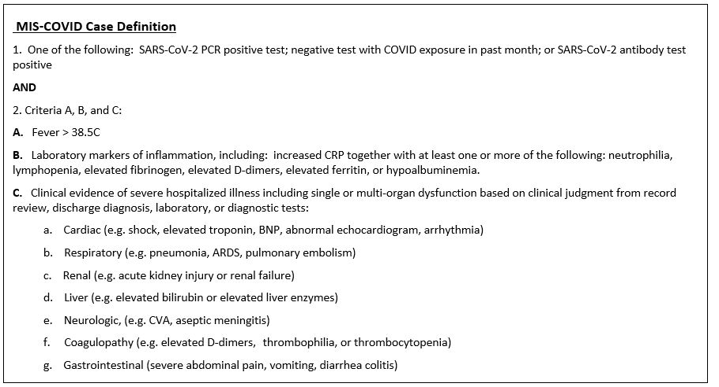
Approach to Coagulation Testing
All patients admitted with confirmed/suspected COVID-19 infection should have the following coagulation labs obtained – (i) on admission; (ii) with any change in clinical status or level of care and (iii) at discharge
- CBC with differential (including nucleated RBC if available)
- BUN/Cr
- Fibrinogen
- D-dimer
- PT/INR
- aPTT from non-heparinized line (or with heparin neutralization if heparin-exposed line is utilized)
- LDH
- Ferritin
- History of remote or recent thrombotic events
- History of acquired or inherited thrombophilia
- Family history of any inherited thrombophilia
Optional labs that have been shown to provide some utility in assessing hypercoagubility include:
- VonWillibrand Factor antigen (generally elevated)
- Thromboelastography (TEG) or ROTEM - specifically looking for elevated clot strength/MA suggestive of hypercoagulability (MA>75mm)

Thromboprophylaxis Treatment Options
If on antiplatelet and/or anticoagulation for pre-existing condition (thromboprophylaxis or treatment)
  - Do not interrupt antiplatelet or anticoagulation therapy unless otherwise specified by your clinical care team

- Screen all patients at time of admission and daily for any of the following:
- Documented thrombosis
- Moderate to severe ventricular dysfunction
- Increasing vasoactive infusion requirement
- Sedated and/or paralyzed
- Coronary dilation/aneurysm
- D-dimer >3mcg/mL (or up-trending D-dimer)
- Any rhythm abnormalities: heart block, etc.
- TEG clot strength >80
If any of the above, then consider the following:
- Low molecular weight heparin (LMWH) titrated to treatment goals (LMWH level=0.5-1 units/ml)
- If hemodynamically unstable (concern for need of mechanical circulatory support), and/or concern for risk of bleeding, and/or severe renal dysfunction:
- Unfractionated heparin (UFH) titrated to institutional goals for treatment (~aPTT 60-80s, 70-90s or anti-Xa/HAL of 0.35-0.7units/mL)
  - Bivalirudin as alternative option to UFH if unable to achieve therapeutic and/or stable levels with UFH (bivalirudin goal 1.5-2.5x baseline PTT or direct thrombin inhibitor (DTI) assay of 60-90s)
- For all other PMIS-T/MIS-C patients who do not have any of the above features at time of assessment then consider the following treatment:
- Low molecular weight heparin (LMWH) titrated to institutional prophylactic goals (generally 0.2-0.4units/ml)
- With initiation of anticoagulation consider additional use of aspirin therapy (5mg/kg/day with a maximum of 81mg daily) in the following PMIS-T/MIS-C patients:
- Kawasaki disease (if fulfills criteria for KD, then follow AHA recommendations for antiplatelet and anticoagulation therapy)
- KD features with coronary dilation
- Elevated clot strength (MA>75mm) in the setting of anticoagulation
- Elevation in troponins
- Change in ECG QRS with ST segment elevation
  - Consider one-time dose of 10 mg/kg/dose (max=325mg) followed by 5 mg/kg/day (max=81mg/day)
- Consider TEG with platelet mapping and/or VerifyNow aspirin assay to ensure adequate platelet inhibition (AA inhibition >70% on TEG or ARU<550 on VerifyNow)
- Aspirin non-responders based on AA inhibition or VerifyNow may use clopidogrel (Plavix); however, there isn’t data available to support the use of this medication in PMIS-T / MIS-C. Usual dose is 0.2-0.5mg/kg/day (max=75mg/day). Efficacy may be assessed with VerifyNow P2Y12 assay (goal PRU<300).
- For all PMIS-T/MIS-C patients ready for discharge with any remaining elevation of D-dimer, LDH, ferritin and/or CRP
- Low-molecular weight heparin (LMWH) prophylactic dosing
- Apixaban prophylactic dosing (0.05 mg/kg/dose BID rounded to nearest 0.625mg, 1.25mg, 2.5mg, 3.125mg, 5 mg)
- And/or ASA 5 mg/kg/day (max=81mg/daily)

Recommend follow up via virtual visit or in clinic within 1 week of discharge with the following:
- Repeat ECHO if any abnormality documented at any time during admission
- Repeat ECG if any conduction or rhythm abnormality documented at any time during admission
- Repeat D-dimer, LDH, ferritin, CRP, CBC+diff, (BUN/Cr if discharged on LMWH), liver function tests (if discharged on apixaban), and TEG with platelet mapping or VerifyNow if discharged on aspirin with or without anticoagulation.

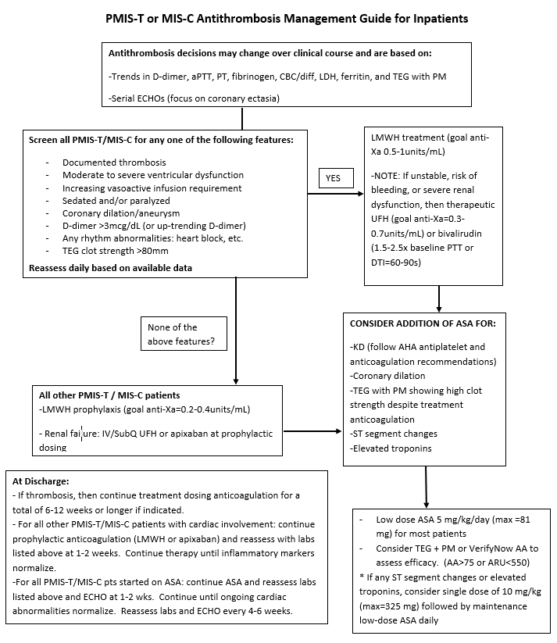
AUTHORS
Christina VanderPluym, MD, Neha Bansal, MD, John Kim, MD, Cindy Neunert, MD, Jenna Murray, NP, Estela Azeka, MD, Lindsay May, MD, Arushi Dhar, MD, Asma Razavi, MD, Mary Mehegan, RN, Christa Kirk, PharmD Angela Lorts, MD, & David Rosenthal, MD

CONTRIBUTING CENTERS
Boston Children’s Hospital, Children’s Hospital at Montefiore, Seattle Children’s Hospital, Primary Children’s Hospital, Children’s Hospital of Colorado, Cincinnati Children’s Hospital, Morgan Stanley Children’s Hospital of New York Presbyterian, Lucile Packard Children's Hospital, Texas Children's Hospital, St. Louis Children’s Hospital, & Heart Institute (InCor) University of São Paulo Medical School

Disclaimer: The ACTION network is focused on quality improvement efforts such as harmonizing best practice protocols, disseminating them among institutions, and helping centers to improve care practices at the local level. This protocol was developed as a consensus tool for pediatric VAD programs. The information in the protocols are based on center practices, individual opinions, experiences, and, where available, published literature. Centers may choose to adapt this protocol to include in their center-specific protocols with reference to ACTION with the understanding that these are meant as guidelines and not standard of care. (Revised: 06/26/2020)

