ECHOCARDIOGRAPHY PROTOCOL for Children with Implantable Continuous Flow Ventricular Assist Devices

BACKGROUND
This ACTION harmonization document provides recommendations based on shared practices across ACTION centers and available guidelines on the use of transthoracic echocardiography (TTE) in children with left ventricular assist devices (LVADs).

ACTION REVISED DATE: 6/21/24

OBJECTIVES
To provide guidance on how to use TTE in the management of implantable continuous flow LVADs (Heartmate 3) in children and to suggest a standardized protocol for surveillance.

PROTOCOL
Overall LVAD goals to be assessed by echo:
- Decompression of left ventricle and left atrium
- Maintain neutral and rounded interventricular spectrum (avoid septal bowing into left ventricle)
- Minimize mitral regurgitation
- No more than trivial aortic insufficiency

Key echo findings:
- LV internal dimension at end-diastole (LVIDd)
- LV function
- RV function
- Tricuspid regurgitation
- Aortic insufficiency
- Aortic valve opening (number of times per 10 cardiac cycles)
- Mitral regurgitation
- Presence of pericardial or pleural effusion
- Presence of thrombus (especially around inflow cannula)

The following are SUGGESTED protocols for (1) LVAD surveillance transthoracic echocardiogram and (2) LVAD speed optimization/ramp echocardiogram protocol.

LVAD Surveillance Transthoracic Echocardiogram Protocol
Document baseline blood pressure: _____
Annotate baseline RPM: _____

Parasternal Long-Axis:
- (2D, 6 beats): Sweep left ventricle
- (2D, 3 beats): Measure LVIDd x 3 beats (see figure 1)
- (2D, 3 beats): Sweep aortic root
- (M-mode, 10 beats, decrease sweep speed): Aortic valve opening (see figure 2)
- (Color, 3 beats): Sweep aortic valve for regurgitation
- (Color, 3 beats): Sweep mitral valve for regurgitation
- (2D, 3 beats): Angle to image apical inflow cannula
- (Color, 3 beats): Apical inflow cannula
- (Color, 3 beats): Sweep tricuspid valve for regurgitation
- (CW): Peak TR velocity (if present)
- (Color, 3 beats): Sweep pulmonary valve for regurgitation

Parasternal Short-Axis:
- (2D, 6 beats): Sweep left ventricle
- (2D, 3 beats): Aortic root
- (Color, 3 beats): Aortic root
- (M-mode, 10 beats, decrease sweep speed): Aortic valve opening
- (2D, 3 beats): Chordal level of LV for septal position
- (Color, 3 beats): Tricuspid valve for regurgitation
- (CW): Peak TR velocity (if present)

Right parasternal window:
- (Color, 3 beats): Outflow cannula into ascending aorta
- (PW, CW): Outflow cannula

Apical View
- (A4C, 2D, 6 beats): Sweep both ventricles
- (A4C, 2D, 3 beats): Septal position, LV function
- (A4C, Color, 3 beats): Sweep mitral valve for regurgitation
- (A4C, 2D, 3 beats): Angle to evaluate inflow cannula
- (A4C, Color, 3 beats): inflow cannula
- (A4C, PW, CW): inflow cannula
- (A4C, 2D, 3 beats): RV function
- (A4C, Color, 3 beats): Sweep tricuspid valve for regurgitation
- (A4C, CW): Peak TR velocity
- (A4C, M-mode): lateral annulus of RV for TAPSE measurement
- (A5C, Color, 3 beats): Sweep aortic valve for regurgitation

Subcostal View:
- (2D, 6 beats): RV/LV function, assess for pleural effusion
- (2D, 6 beats): IVC (with sniff if feasible to estimate CVP)

LVAD Speed Optimization/Ramp Transthoracic Echocardiogram Protocol:
- The decision to perform an LVAD ramp study should be made in conjunction with the HF/VAD, ICU and CV surgery teams
- Recommend ramp studies be performed with a member of the VAD team at bedside
- Indications for Ramp Study:
  - Evidence of right heart or left heart failure/persistent symptoms
  - Suboptimal surveillance study findings
  - Suspicion of device thrombus
  - Device speed optimization
- Safety:
  - Ensure patient is on therapeutic anticoagulation
  - Ensure the left ventricle and aortic root are free from thrombus
    - Risk of thromboembolism with reduction in pump speed
  - Allow ≥ 2-minute stabilization between speed changes
    - When decreasing RPMs: monitor for septum shifting rightward, increasing MR, increasing AoV opening, increases in estimated RV pressures, and any symptoms
    - When increasing RPMs: monitor for septum shifting leftward, impedance of flow into inflow cannula, worsening TR, AoV not opening, increase in AI, suction events, and any symptoms.
    - HeartMate3 100 RPM increments
  - Test endpoints: completion of test/desired outcome attained, suction event, hypotension, hypertension, symptoms

See attached worksheet
Annotate RPM on screen with every change (minimum 2-minute stabilization between changes)

Suggested views:
- PLAX (2D, 3 beats): LVIDd x3 beats
- PLAX or PSX (M-mode, 10 beats): Aortic valve opening (out of 10 beats)
- PLAX (Color, 3 beats): degree of AI
- PLAX or A4C (Color, 3 beats): degree of MR
- PSAX (2D, 3 beats): septal position
- A4C (2D, 3 beats): septal position
- A4C: (2D, 3 beats): RV function
- PLAX, PSAX or A4C (Color and CW Doppler, 3 beats): degree of TR
- A4C or PLAX (2D, Color Doppler, PW, CW): inflow cannula

AUTHORS
Anna Joong, MD
David M. Peng, MD

CONTRIBUTING CENTERS
Lurie Children’s Hospital, Mott Children’s Hospital, & Cincinnati Children’s Hospital

Adapted from:
Stainback RF, Estep JD, Agler DA, Birks EJ, Bremer M, Hung J, Kirkpatrick JN, Rogers JG, Shah NR and American Society of E. Echocardiography in the Management of Patients with Left Ventricular Assist Devices: Recommendations from the American Society of Echocardiography. J Am Soc Echocardiogr. 2015;28:853-909.

Disclaimer: The ACTION network is focused on quality improvement efforts such as harmonizing best practice protocols, disseminating them among institutions, and helping centers to improve care practices at the local level. This protocol was developed as a consensus tool for pediatric VAD programs. The information in the protocols are based on center practices, individual opinions, experiences, and, where available, published literature. Centers may choose to adapt this protocol to include in their center-specific protocols with reference to ACTION with the understanding that these are meant as guidelines and not standard of care. (Revised 5/30/19)

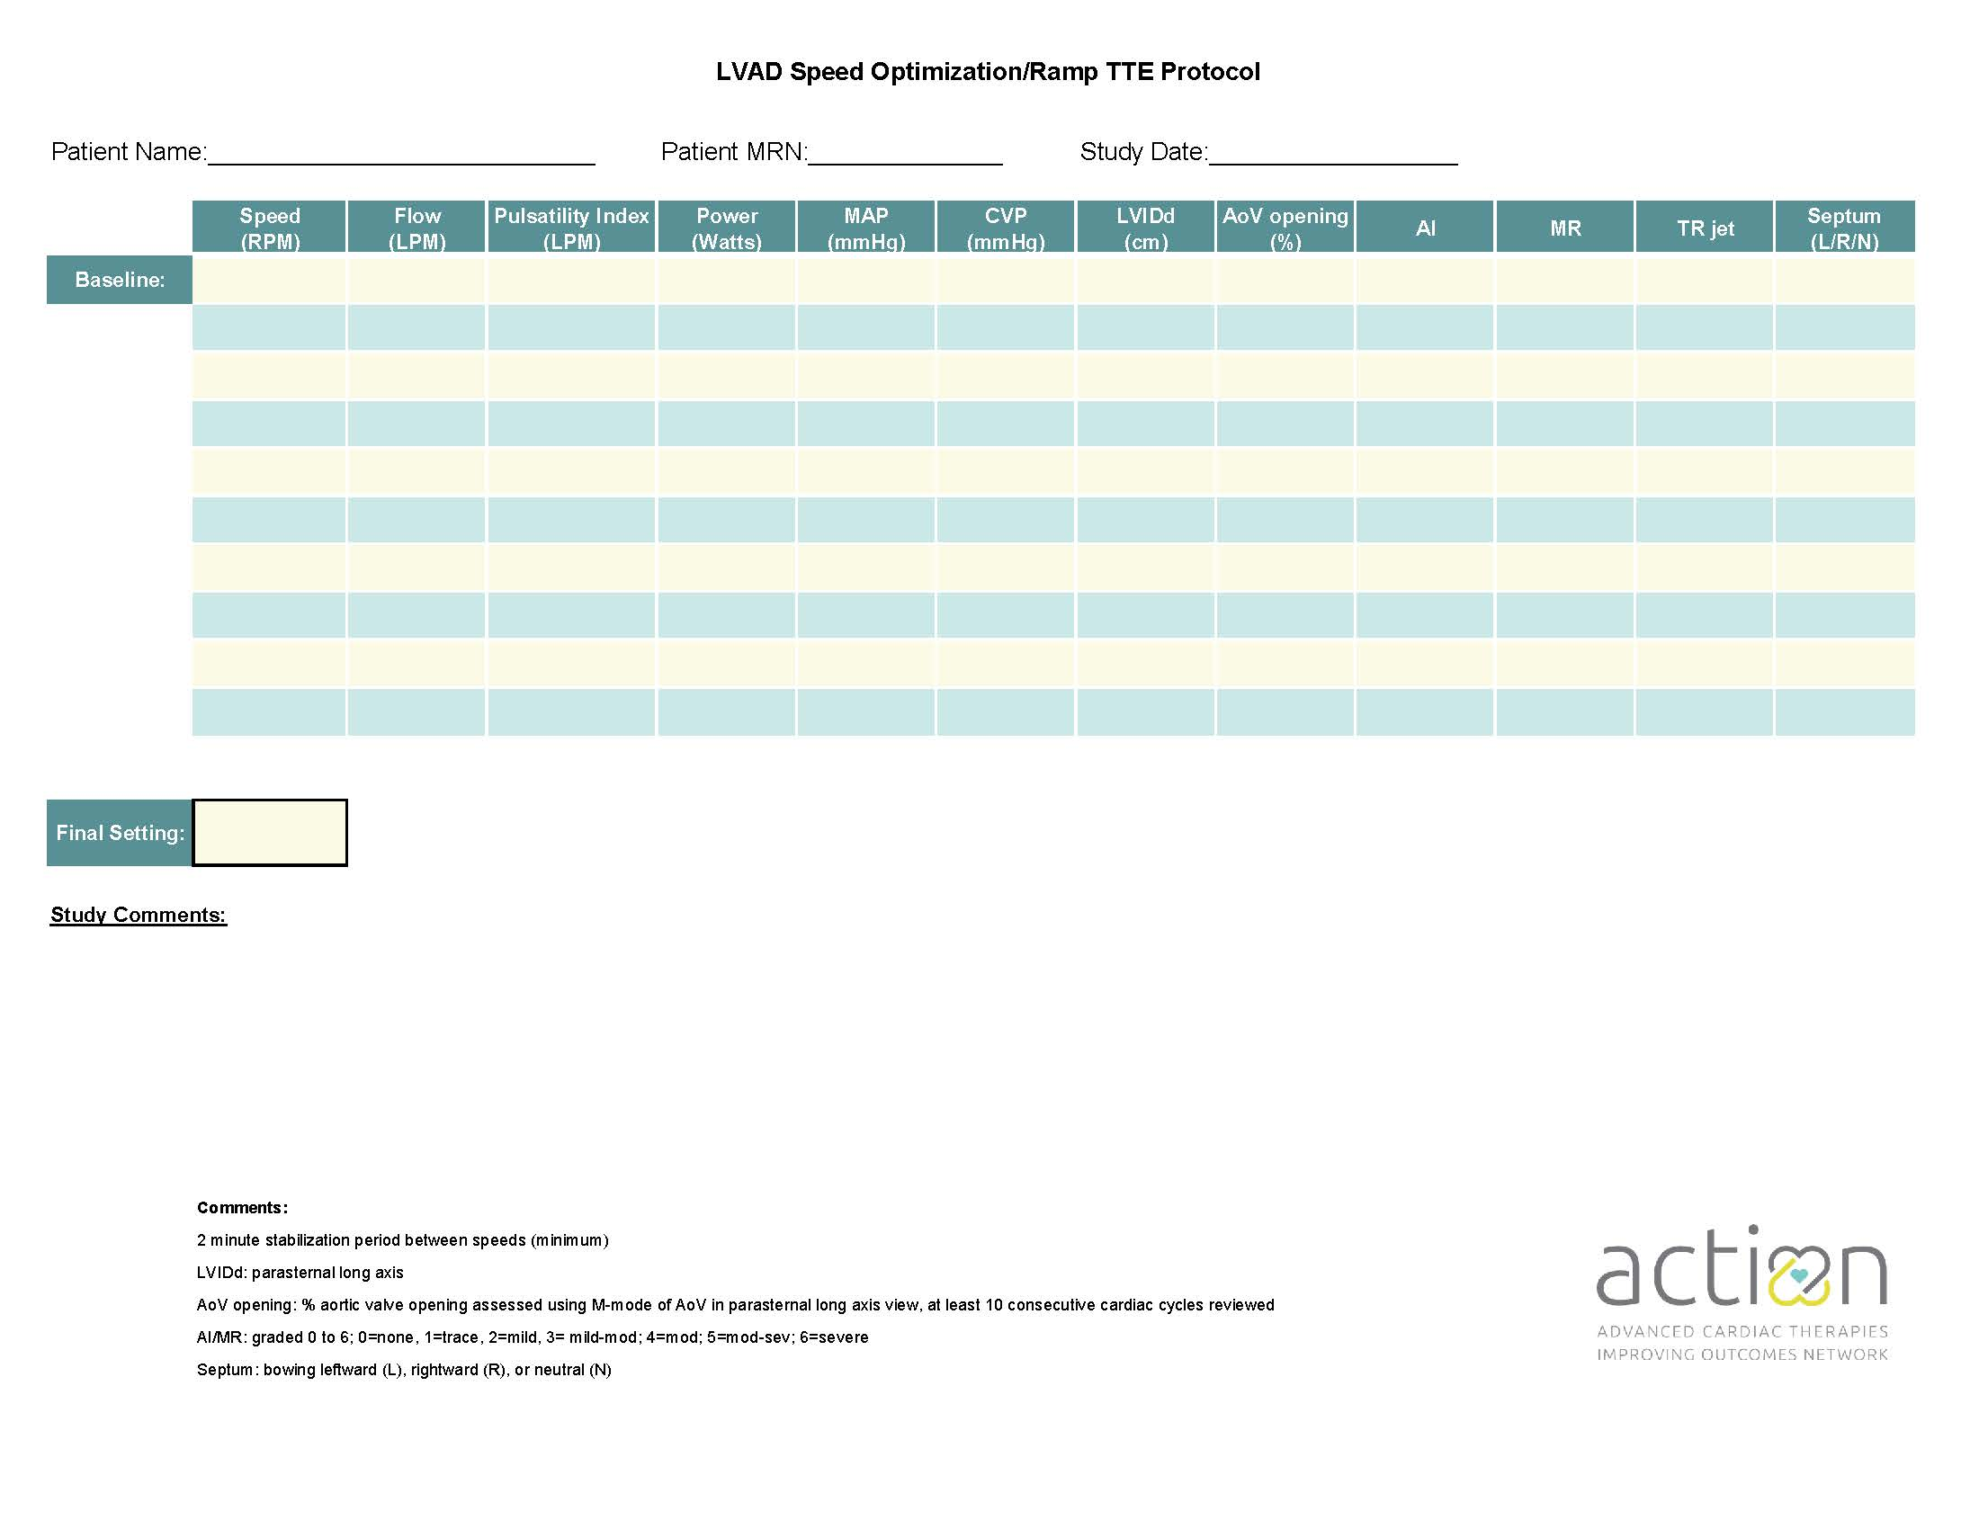

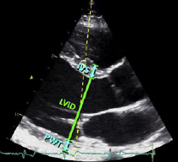

Figure 1. Measure LVIDd parallel to LV long-axis at mitral valve leaflet tips.

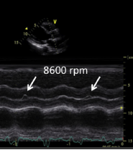

5000 RPMs

Figure 2. Measure aortic valve opening with m-mode (slow sweep speed). Arrows point to opening of aortic valve. Report number of openings/10 beats. (May be performed in paratsternal long or short axis.) (Stainback et al).

