Care of Cannula Sites for Berlin Heart Pediatric VADs

BACKGROUND
Ventricular assist device (VAD) dressing integrity is a critical factor for the prevention of device related infection. Inadequate dressing or dressing disruption is a major risk factor for bloodstream infections, device pocket infection and driveline site infections. Enhanced dressing adhesion promotes sterility and saves time as fewer dressing changes are needed.

ACTION REVISED DATE: 11/12/2024

OBJECTIVES
- Describe a detailed example of standardized VAD specific dressing change protocol for cannula sites
- Minimize risk of VAD related wound or device infection
- Promote VAD care and dressing techniques to optimize wound integrity and healing

PROTOCOL
In order to prevent infection of driveline sites, the dressing changes must be done in a sterile and consistent fashion. This is a 2-person activity. Consider a small group trained and competent (VAD dressing team) as consistency is key to optimize integrity and healing.

Dressing Frequency
Weeks 0-1 Every day
Weeks 1-2 Every other day, (consider M/W/F to keep consistency in staff changing dressing)
Above Weeks 2 Discretion of the team, (consider twice weekly)

Steps for Dressing Change:
- Perform hand hygiene and don clean gloves, hat, and mask. Mask patient if age appropriate.
- Disinfect the table surface for sterile supplies
- Assemble supplies for the procedure (This is an example, please see the end of the document for other options among the same supplies):

  - Masks, hats, clean gloves
  - Sterile gloves
  - Sterile gown
  - Sterile drapes/towel pack
  - Antiseptic solution
  - Sterile Water
  - 3 trays of sterile 4x4s
  - 4 individual 4x4s packages
  - Abdominal pad
  - Sterile scissors
  - Occlusive Sterile Dressing – One for each cannula
  - Border Dressing
  - Ace Wrap
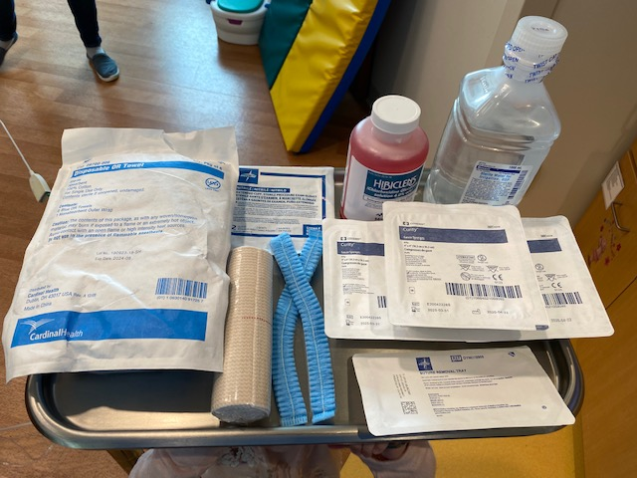
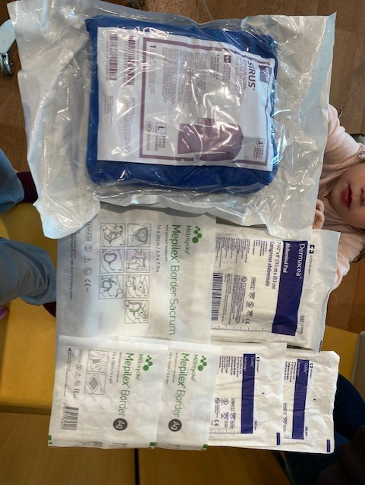
- Open sterile supplies onto table surface utilizing sterile technique
  - Set up 3 trays of sterile 4x4s
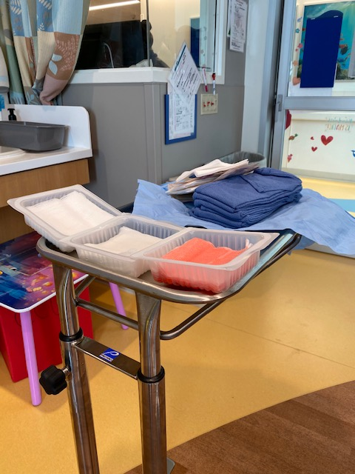
    - Antiseptic solution
    - Sterile water
    - Dry gauze
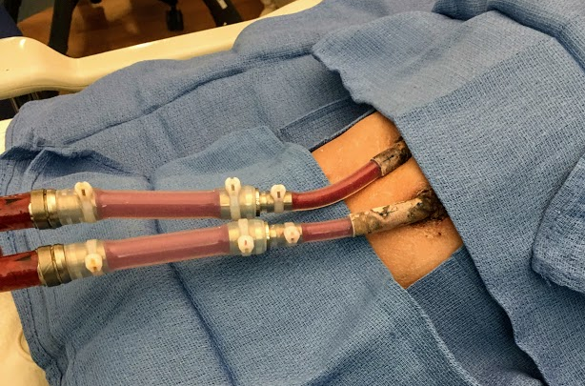
- Remove patient’s current cannula dressing and assess site. Ensure picture of wound site is uploaded into media section in EMR if available
- Doff clean gloves, clean hands, and don sterile gown and sterile gloves
- Place sterile towels around patient to create sterile field
- With antiseptic solution soaked 4x4 gauze, clean from insertion site outward using both a side to side and circular motion. Gently clean skin around 1st cannula. Discard gauze.
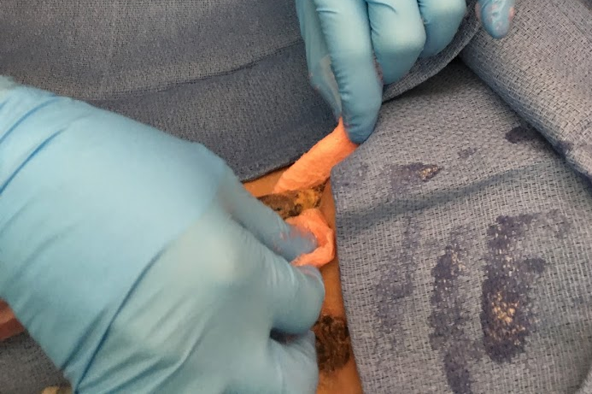
  - Repeat procedure for all subsequent cannula sites using an antiseptic solution-soaked gauze

- Clean each cannula on all sides using an antiseptic solution-soaked gauze. Thread the gauze around the cannula. Using a back-and-forth motion, shimmy the gauze up the cannula from the insertion site to where the Berlin pump attaches, ensuring you clean all sides of the cannula.
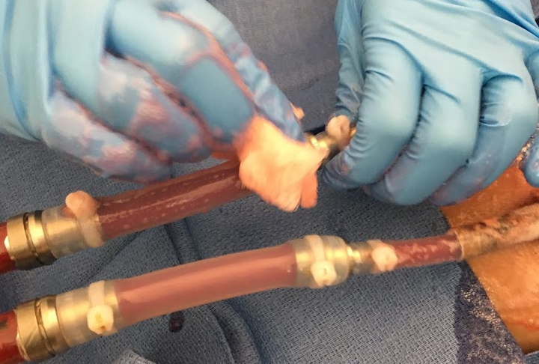
  - Repeat procedure for all subsequent cannulas using an antiseptic solution-soaked gauze
- Repeat #8 and #9 twice for each cannula site
- Rinse each site using a sterile water soaked 4x4 gauze
- Dry each site using a dry 4x4 gauze
- Prepare Dressings:
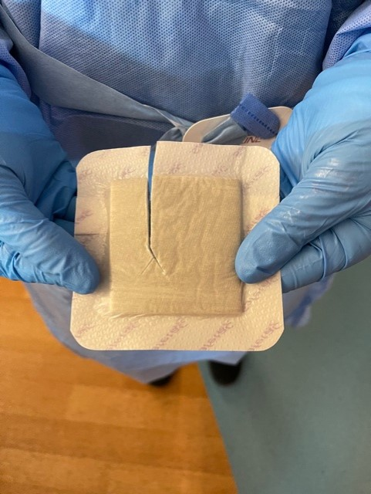
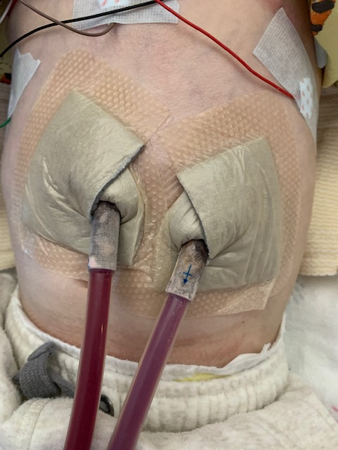
  - Cut dressing into squares big enough to fit around each cannula. Cut ½ way down the center and then make two smaller cuts to make a “Y” shape.
    - Place cut square under cannula and chevron so that the ends of the gauze cross over each other on top of the cannula. Repeat on other cannula(s).
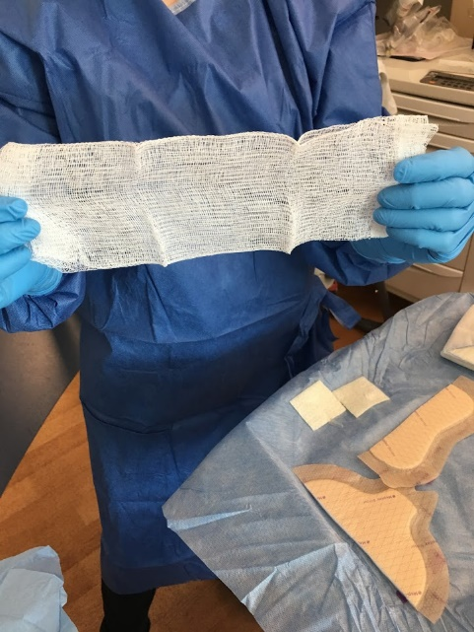
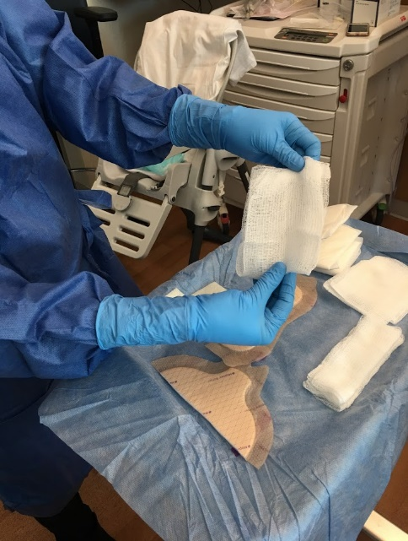
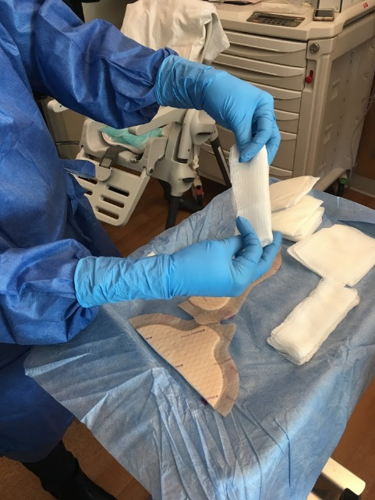
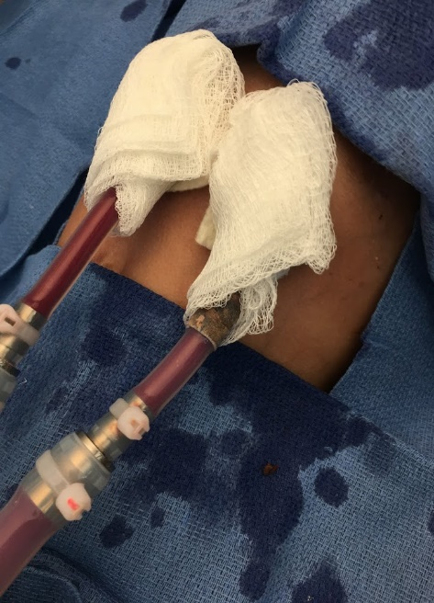
- Take one dry 4x4 gauze. Unfold it. Fold in half lengthwise. Fold in half widthwise once and chevron around cannula. Repeat on other cannula(s).

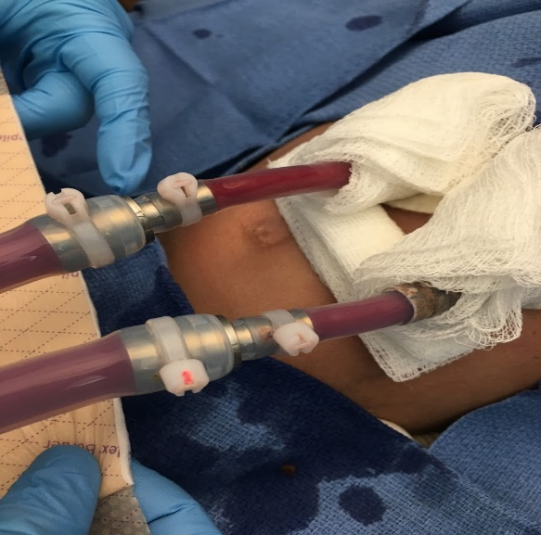
- Roll up a 4x4 and place one under both cannulas for padding
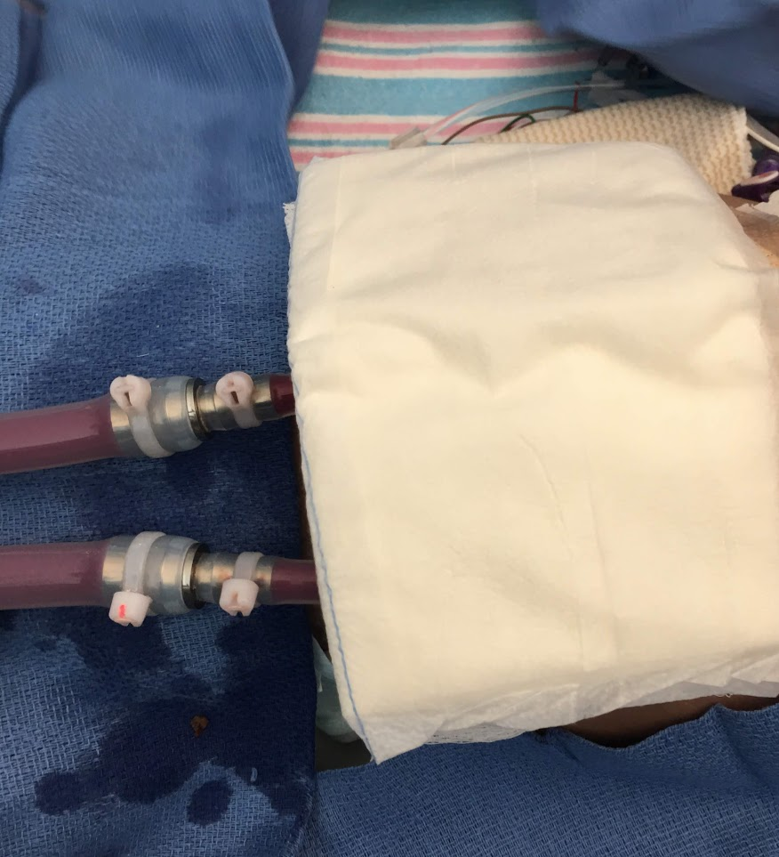
- Place abdominal pad on top of dressing
- If using border dressing cut in half horizontally. Using the rounded edge, place at lower border of rolled 4x4’s and secure to skin to create a barrier between dressing and diaper area. Place other half of border dressing on the top portion of the dressing PRN
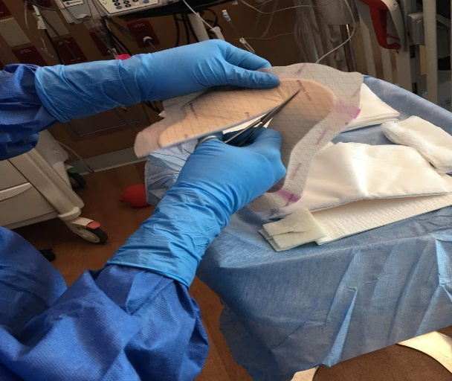
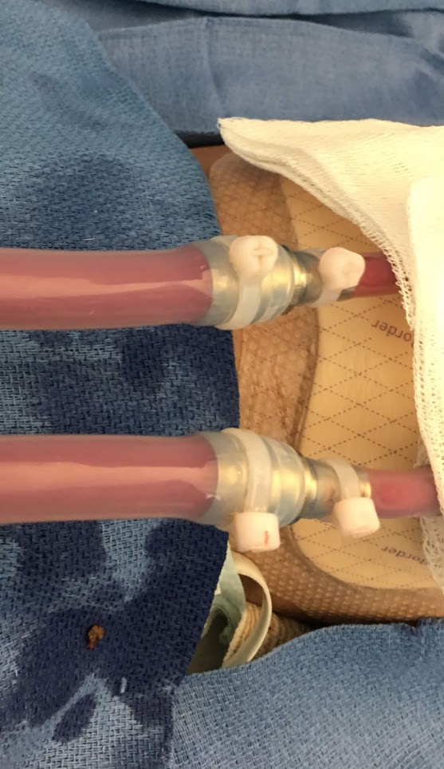
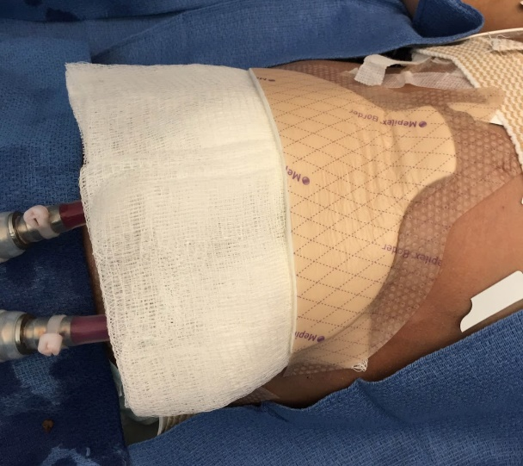
  - This is no longer part of the sterile dressing of the cannula sites, but rather an extra layer to prevent soiling of sterile dressing
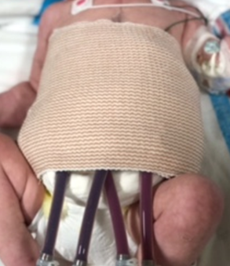
- Dressing should be secured with elastic bandage, not too tight as to prevent cannulas from kinking.
- Fold and tuck the top of the diaper downwards to help prevent the dressing from becoming soiled.

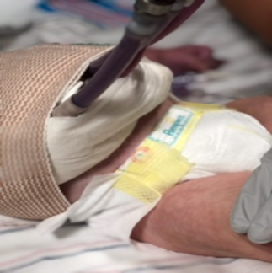
Product Considerations:
- Antiseptic solution
  - Hibiclens (more gentle for infants)
  - 2% ChloraPrep Swabstick
  - Chlorhexidine BD E-Z Scrub 4% CHG, sponge side only, bristle removed
  - Betadine (with confirmed CHG allergy)
- Occlusive VAD dressing
  - Mepilex AG
  - Aquacel AG and telfa tape
  - Gauze chevron followed by silverlon strips
  - Mepilex foam over silverlon strips
  - Telfa®
  - Mefix® 6 inch dressing tape (*since Mefix® is a silicone-based product that decreases epidermal stripping from tape
  - Covaderm
  - Primapore/Bordered Gauze
  - Silvercel and Hydrofilm
- Border dressing
  - Mepilex Sacral Border
- Securement device
  - Ace Wrap
  - Spandage Tubular Retainer Net
  - Abdominal binders
- Consider PHI compliant photo documentation in EMR of serial cannula site photos.

AUTHORS
Joseph Philip, MD, Mikayla Zamora BSN, RN, CCRN,
Allison Reichhold MSN, CPNP. Erica Mansavage MSN, RN, Katie Burnley BSN, RN, Alexa Harris PA-C.

CONTRIBUTING CENTERS
UF Health Shands Children’s Hospital, Lucile Packard Children’s Hospital Stanford, St Louis Children’s Hospital,
Boston Children’s Hospital, Cincinnati Children’s Hospital Medical Center, Stollery Children’s Hospital, &
Lurie Children’s Hospital of Chicago

Disclaimer: The ACTION network is focused on quality improvement efforts such as harmonizing best practice protocols, disseminating them among institutions, and helping centers to improve care practices at the local level. This protocol was developed as a consensus tool for pediatric VAD programs. The information in the protocols are based on center practices, individual opinions, experiences, and, where available, published literature. Centers may choose to adapt this protocol to include in their center-specific protocols with reference to ACTION with the understanding that these are meant as guidelines and not standard of care. (Revised 03/01/21)

References:
- Cannon A, Elliott T, Ballew C, et al. Variability in infection control measures for the percutaneous lead among programs implanting long-term ventricular assist devices in the United States. Prog Transplant 2012; 22:351–9.
- Yarboro LT, Bergin JD, Kennedy JL, et al. Technique for minimizing and treating driveline infections. Ann Cardiothorac Surg 2014; 3:557–62.
- J Heart Lung Transplant 2016; 35:108–14. Continuous-flow left ventricular assist devices and usefulness of a standardized strategy to reduce drive-line infections. .Cagliostro B, Levin AP, Fried J, et al.
- J Heart Lung Transplant 2016; 35:108–14. April 2016 Volume 35, Issue 4, Supplement, Page S350 Site Management Strategies in Pediatric Ventricular Assist Device (VAD) Patients. M.V. Horn et al.

