Continuous Flow Paracorporeal VAD
Circuit Change Guideline

BACKGROUND
Historically, there has been significant variability in the management of continuous flow paracorporeal ventricular assist devices (VAD) circuits. Typically, management strategies and circuit changes were based on a subjective circuit assessment, limited patient risk vs benefit analysis, and non-standardized procedure. Over the last few years, the procedure below and network learnings have been employed to standardized this practice.

ACTION REVISED DATE: 07/10/2025

OBJECTIVES
To provide a standardized approach to assessing and managing a paracorporeal continuous flow VAD circuit, to develop a risk vs benefit analysis patient algorithm, and to complete a protocol for a circuit change procedure.

PROTOCOL
The decision to change a VAD circuit in a pediatric patient is generally made by a multi-disciplinary team including CT Surgery, Cardiology (HF/VAD specialist), Cardiac Intensive Care, Perfusionists, & VAD coordinator.

Extracorporeal Centrifugal Continuous Flow Devices
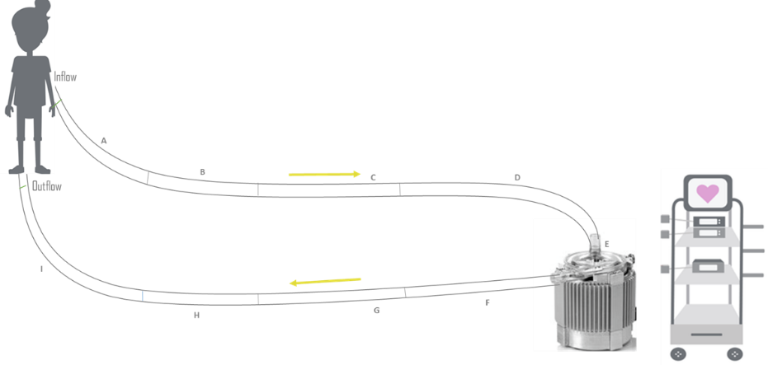
- Circuit Assessment
  - Assess circuit hourly to every four hours starting from venous cannula, pump head, and arterial cannula. Repeat for BIVAD configuration.
Inflow
  - Document clots using standardized language
    - Plaque or thrombin – small white punctate
Outflow
    - Thrombus – large dark area
- Indications for Circuit Exchange (may also consider removing an affected section if circuit change is not indicated)
  - Mobile thrombus or fibrin strand
  - Thrombus accumulation > 5mm
  - Unusual vibration or noise from pump head
  - Increased hemolysis markers
    - LDH > 1.5X baseline
    - Plasma free hgb
    - FDP
    - D-Dimer
    - Platelet decrease
    - Hemaglobinuria

- Pre Circuit Change
  - Continue bivalirudin peri – circuit change
  - Document clot status and VAD settings per protocol
  - PRN baseline labs (within 24 hours of change): CBC with diff, aPTT*, fibrinogen,
    - Optional labs: TEG with PM, CRP, LDH, HIT screen
  - Discuss NPO timing with surgical and CICU team
  - Consider respiratory support management if intubated
  - Discuss whether cardiac anesthesia consult needed
  - Consider steroids
  - Ensure adequate line access; create med line
    - Available sedation/analgesia
    - Consider inotropic support in line for labile patients
    - Volume replacement available
    - Sedate patient and remove the chest dressing (optional)
  - Equipment & Circuit Exchange Procedure:
    - Reference circuit’s IFU and institutional protocols
- Intra-op or Bedside Management
  - Circuit primed ahead of time
  - Consider ACT 30 mins prior to exchange
  - TIME OUT #1: verify patient, circuit to be exchanged
  - Skin and circuit prepped appropriately and a sterile field set up per protocol
  - TIME OUT #2: sequence for circuit(s) change and plan who is managing circuit settings will be confirmed by surgeon
  - Once circuit paused, surgeon will clamp tubing
      - Can cut tube ties during prep phase to reduce the time off support
- Old circuit will be removed
  - Once connected, surgeon will remove proximal clamp and ask for pump to be restarted
- Early post blood pump change management
  - Continue bivalirudin peri – pump change
  - Consider labs ( aPTT, PT/INR, fibrinogen, BMP, CBC, ACT) within 2 hours of change
  - Correct with blood product replacement as needed, being mindful of risk of dilutional coagulopathy with multiple PRBC transfusions
  - Sterile dressing placed per dressing change guidelines
  - Monitor neurologic status closely
  - Document VAD settings, clot status per protocol
  - Restart feeds
  - Monitor patient’s temperature closely after circuit exchange. If patient becomes hypothermic due to heat loss through circuit, consider applying external heat (like barehugger) source to gently rewarm patient.
- Bivad Considerations
  - Monitor the risks and benefits of changing one or both circuits.
  - If changing a single circuit is determined to be the best course of action, be mindful of how the exchange will temporarily affect the flow to the alternate circuit.
    - If changing the circuit supporting the left side, temporarily decreased the flow of the right circuit to prevent pulmonary edema.
    - If changing the circuit supporting the right side, monitor the left side performance and decrease RPMs if the left side begins to chatter or suction.

AUTHORS
Beth Hawkins, RN, MSN, FNP-C, Katrina Fields, BSN, James Reagor, MPS, CCP, FPP, John Lombardi, CCP, Zach Wilkes, CCP, Kerry Schindler, BSN, Mary Mehegan, BSN, Michelle Ploutz, MD, Madeleine Townsend, MD, Stephanie Hope, BSN, & David Peng, MD

CONTRIBUTING CENTERS
Boston Children’s Hospital, Cincinnati Children’s Hospital Medical Center, Morgan Stanely Children’s Hospital of New York, St. Louis Children’s Hospital, Primary Children’s Hospital, Cleveland Clinic Children’s Hospital, Rady Children’s Hospital San Diego, & C.S. Mott Children’s Hospital

Disclaimer: The ACTION network is focused on quality improvement efforts such as harmonizing best practice protocols, disseminating them among institutions, and helping centers to improve care practices at the local level. This protocol was developed as a consensus tool for pediatric VAD programs. The information in the protocols are based on center practices, individual opinions, experiences, and, where available, published literature. Centers may choose to adapt this protocol to include in their center-specific protocols with reference to ACTION with the understanding that these are meant as guidelines and not standard of care. (Revised: 07/10/2025)

